데이터베이스 리포트#3

기능 추가한 게시판 만들기

24.11.24.일

20233078 정세진

데이터베이스 테이블 구성

testboard – 게시판 글 & 그 답글

boardfile – 파일 정보

comment – 댓글

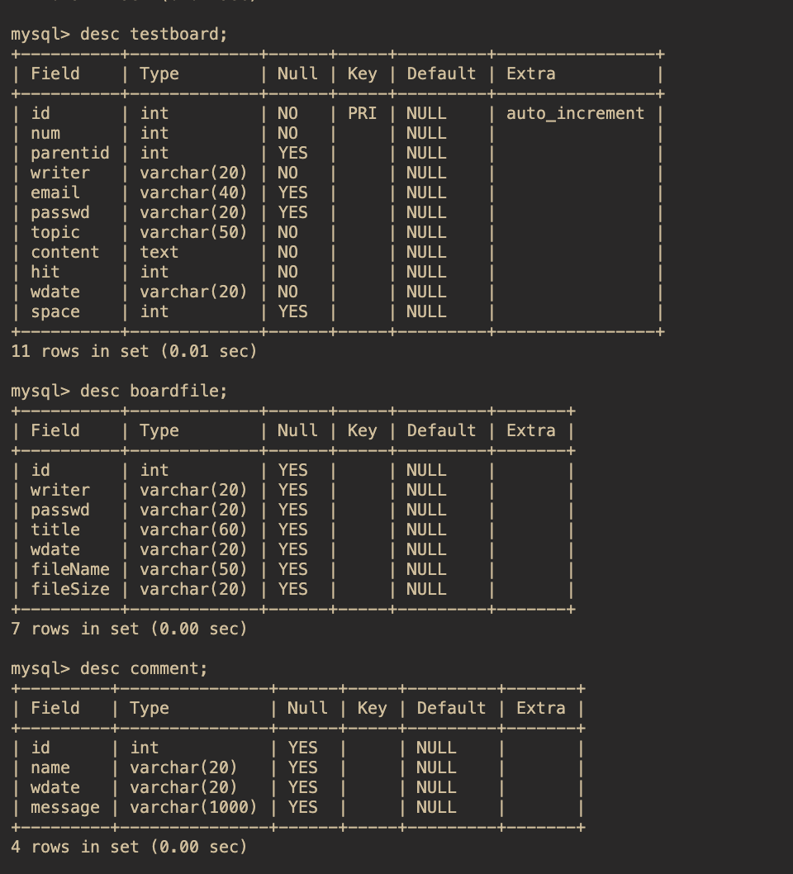

show.php 게시판 글 출력

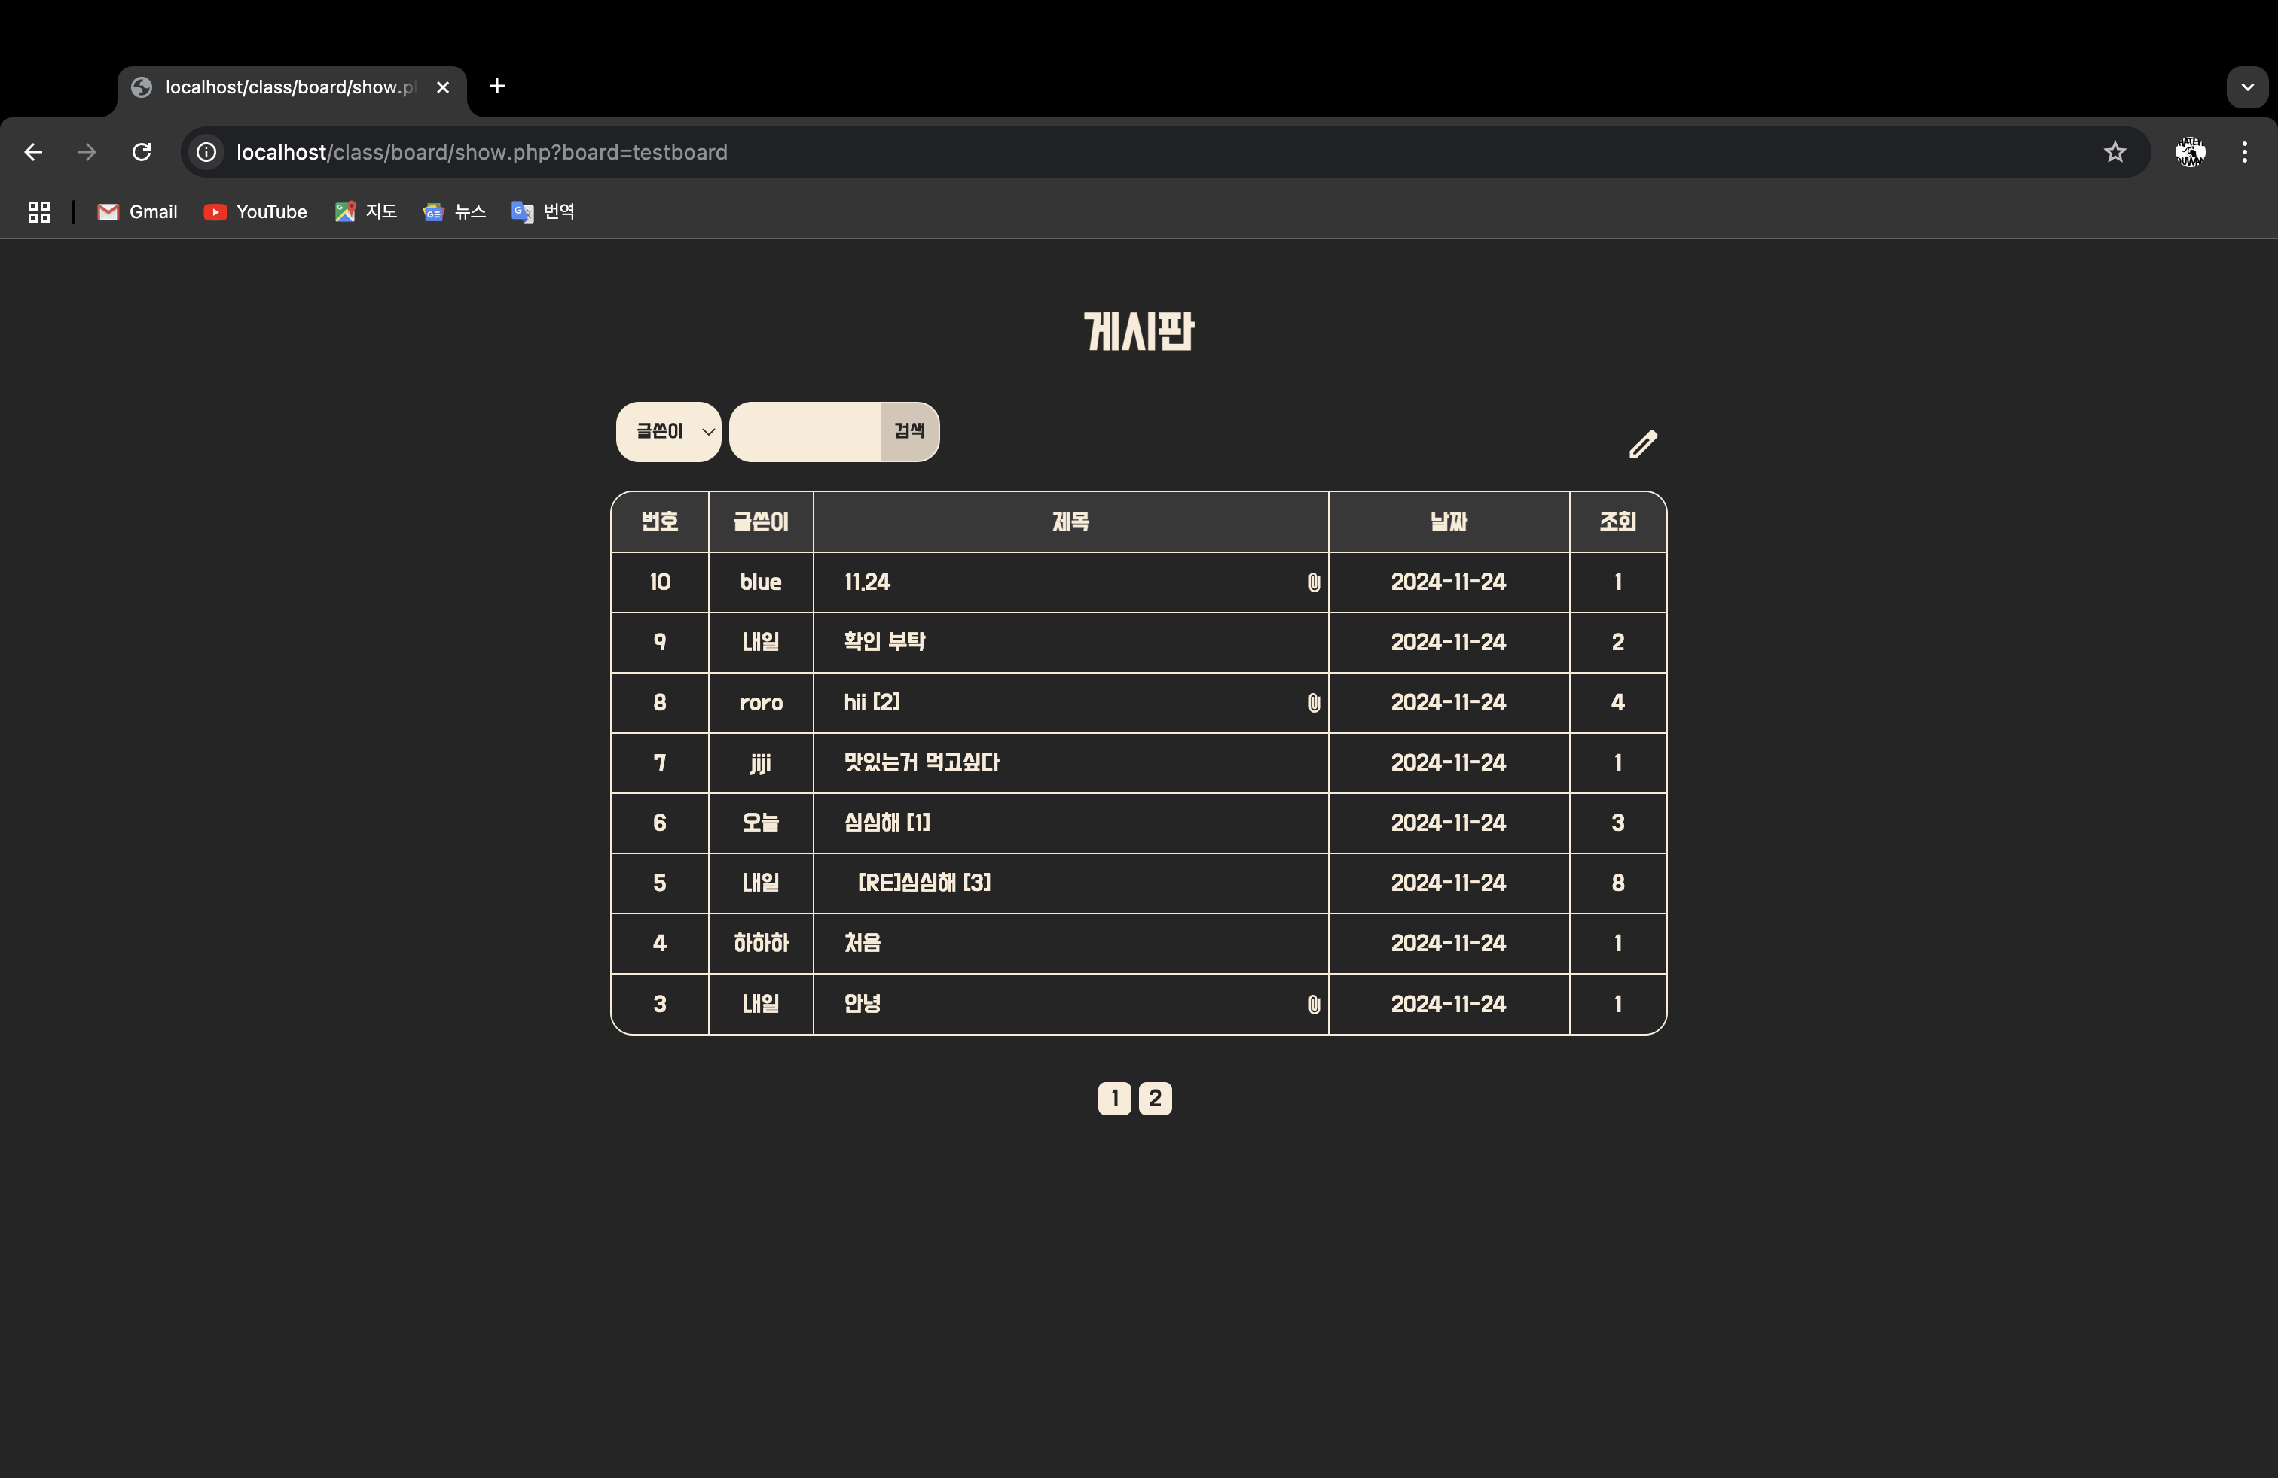

댓글 수 나타내기, 파일 유무 아이콘

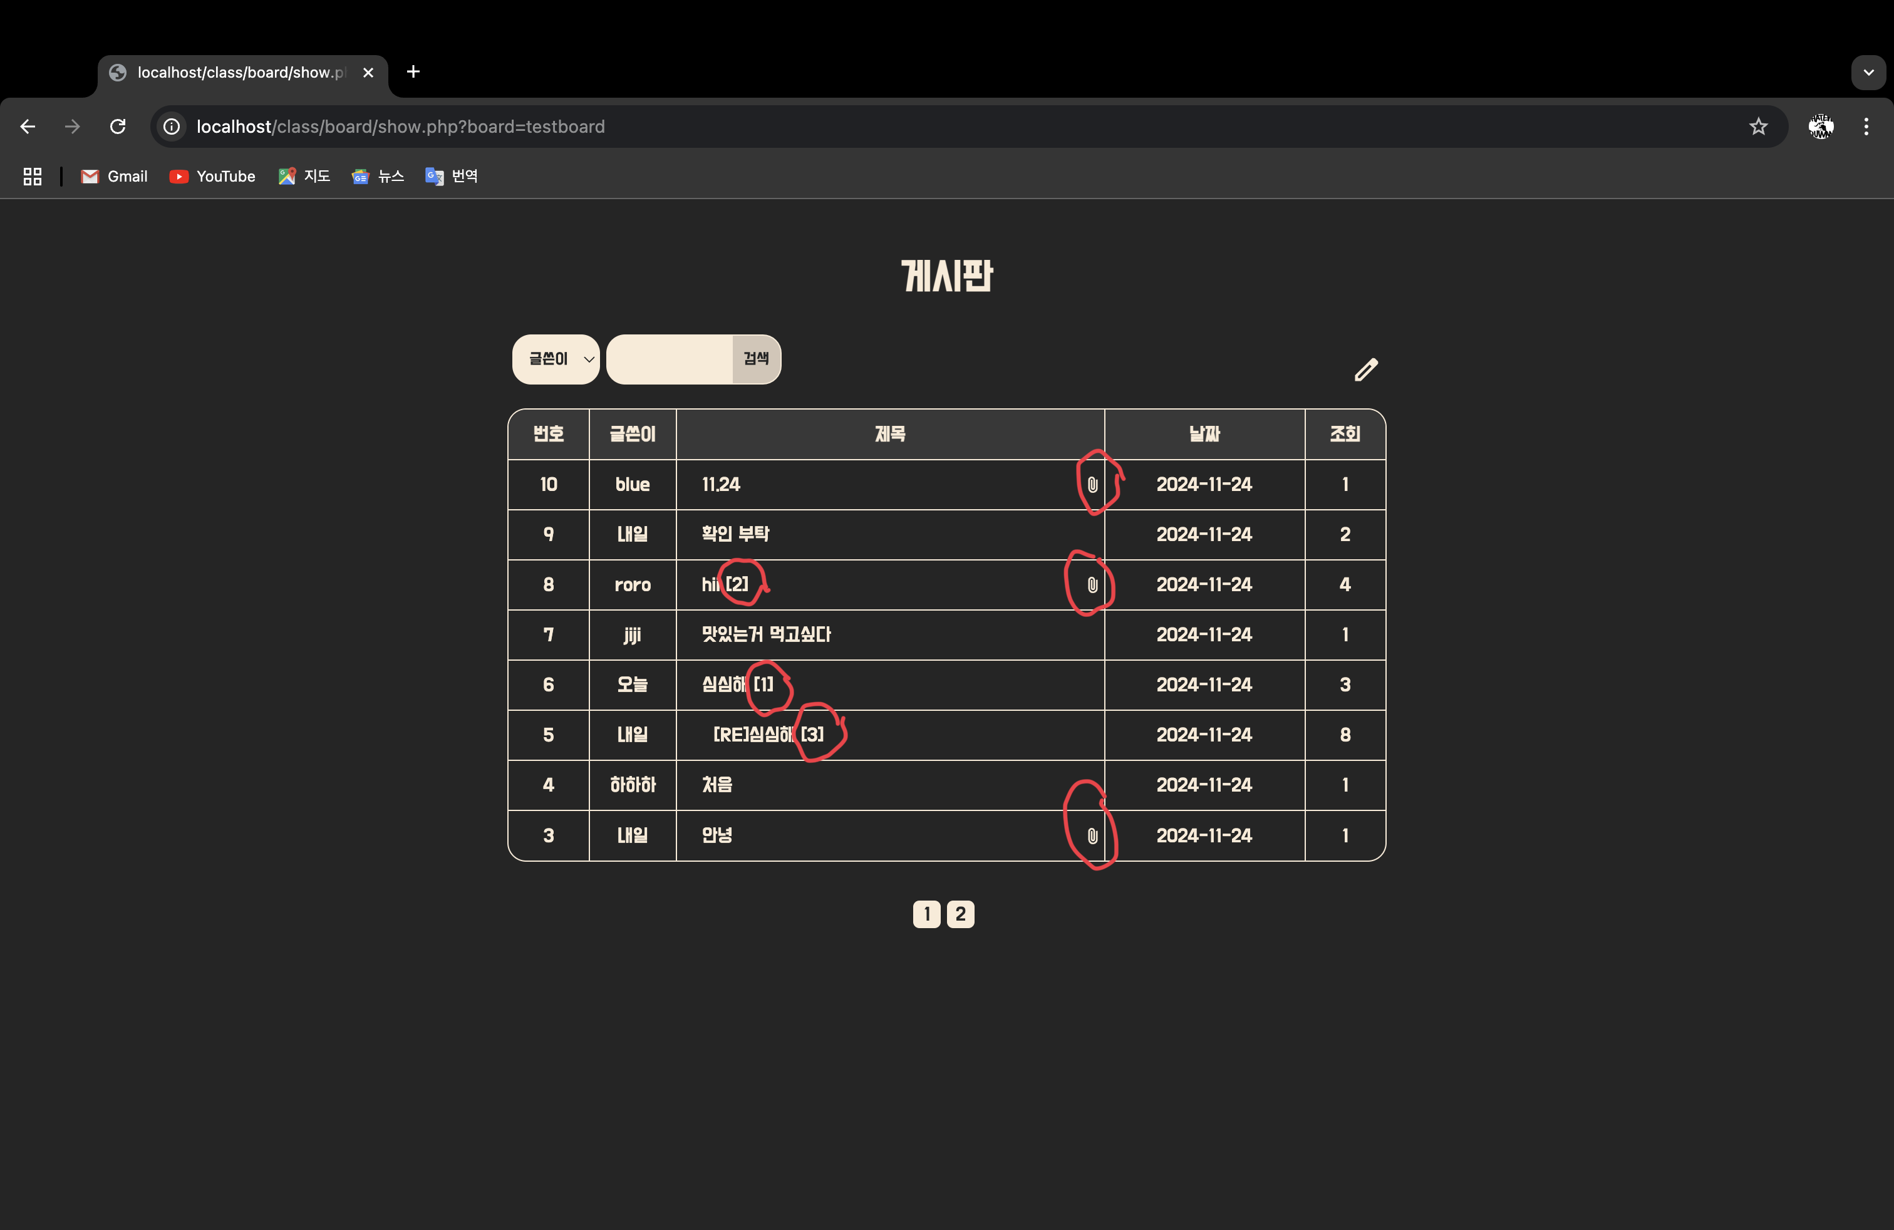

마우스 hover 효과 (차례로 페이지 전환, 글 쓰기 버튼, 해당 게시물로 전환)

페이지 전환 (19페이지 이동)

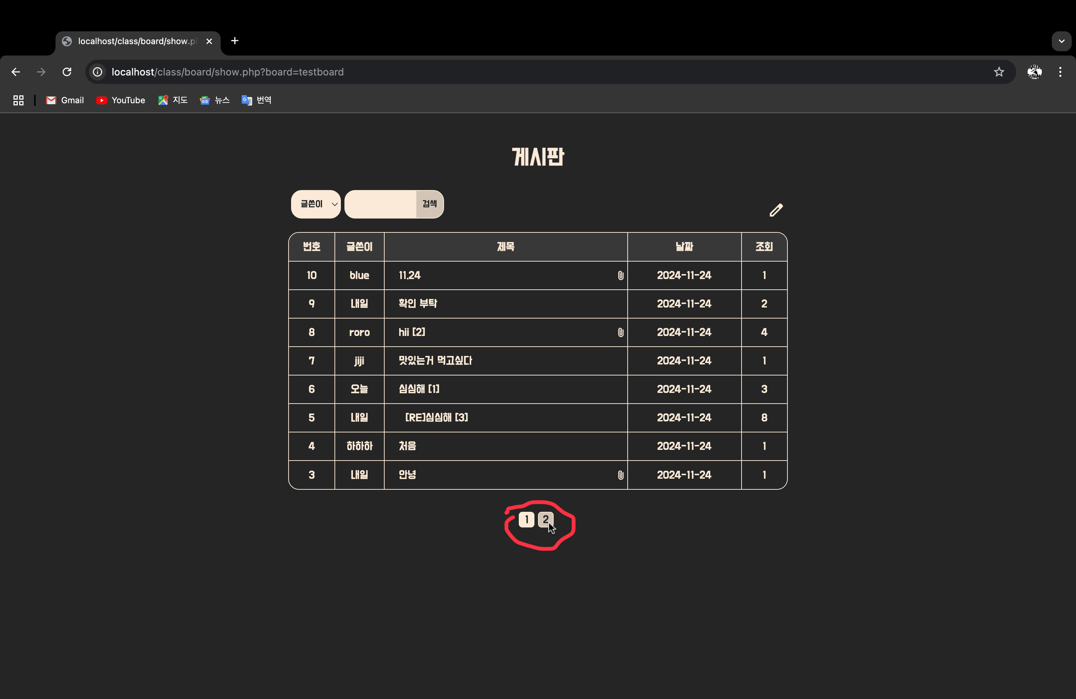

글 쓰기 버튼 (5페이지 이동)

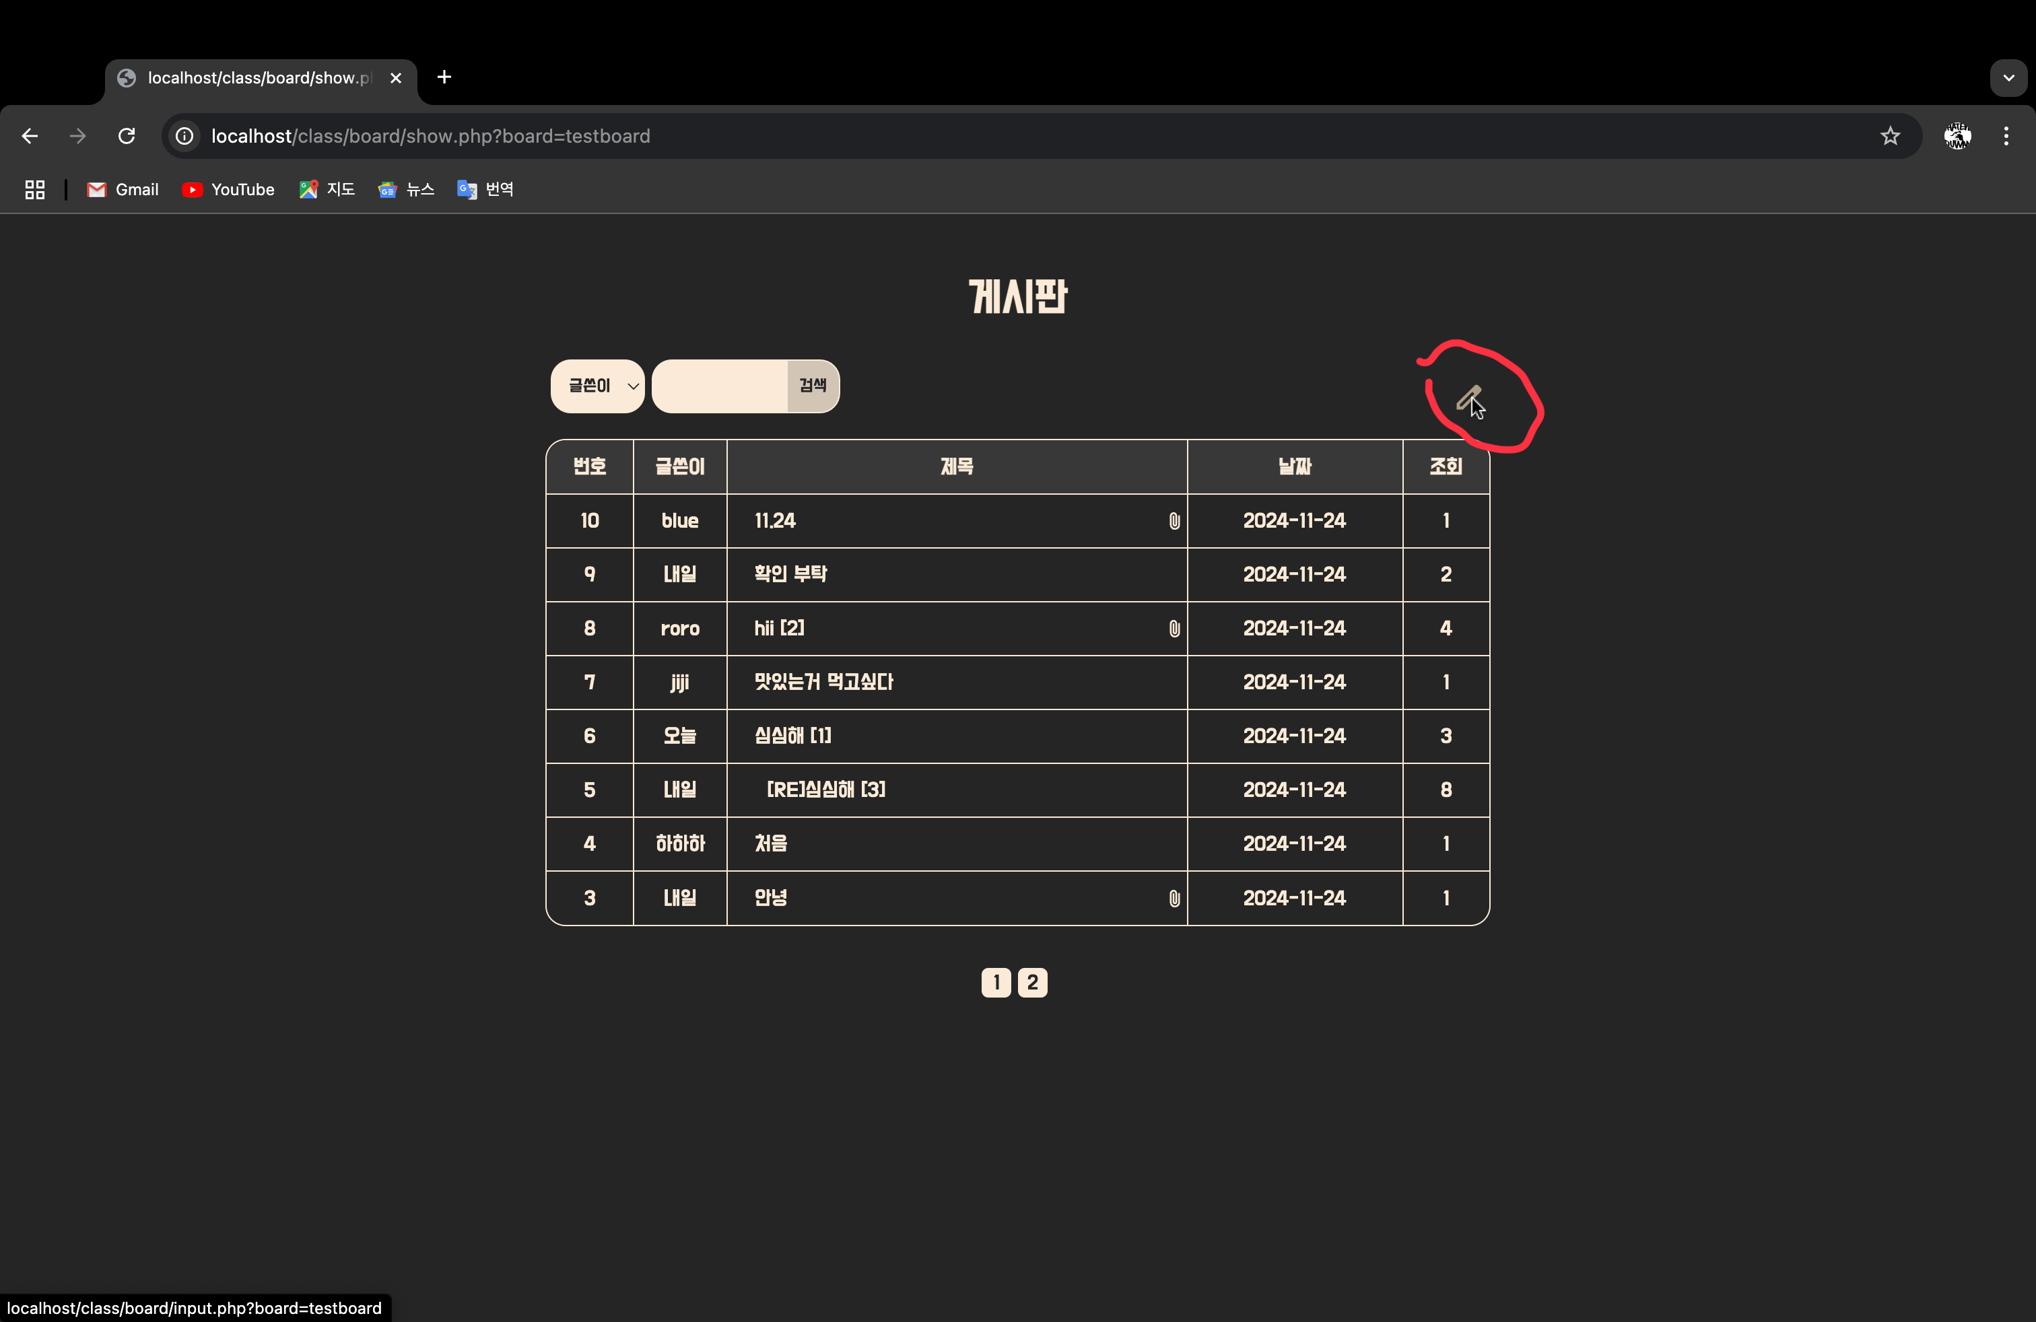

해당 게시물로 이동 (7페이지 이동)

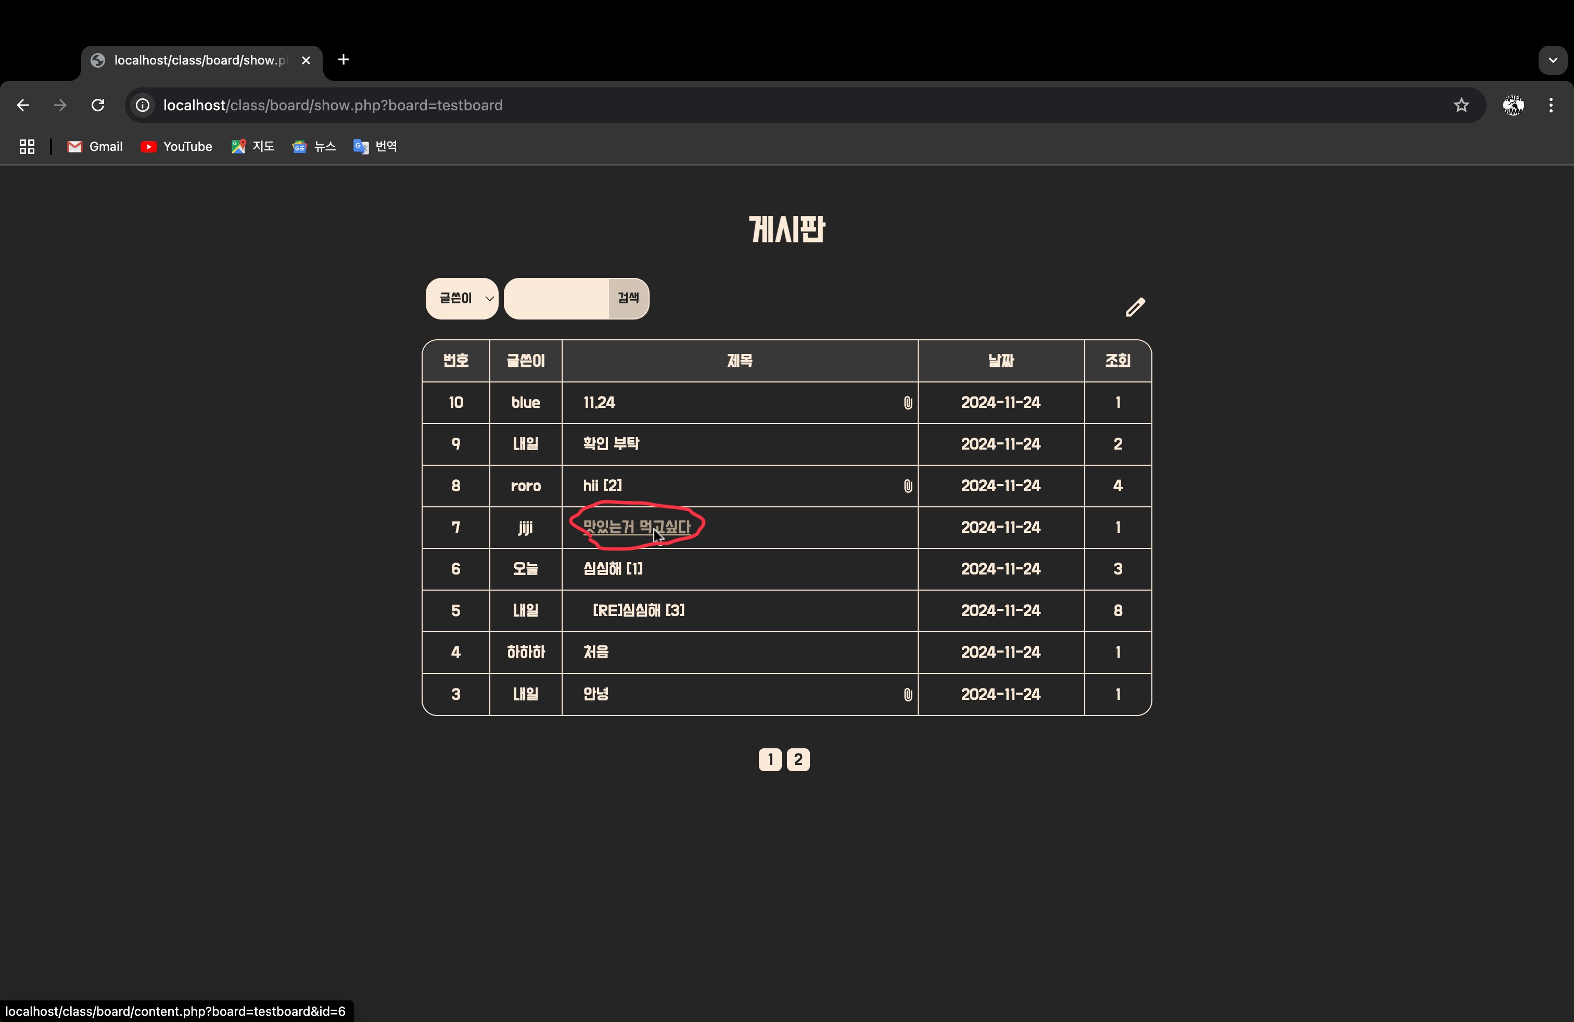

게시물 작성 후 등록 기능

마우스 hover효과 모든 버튼

왼쪽 상단 버튼 – 목록으로 이동

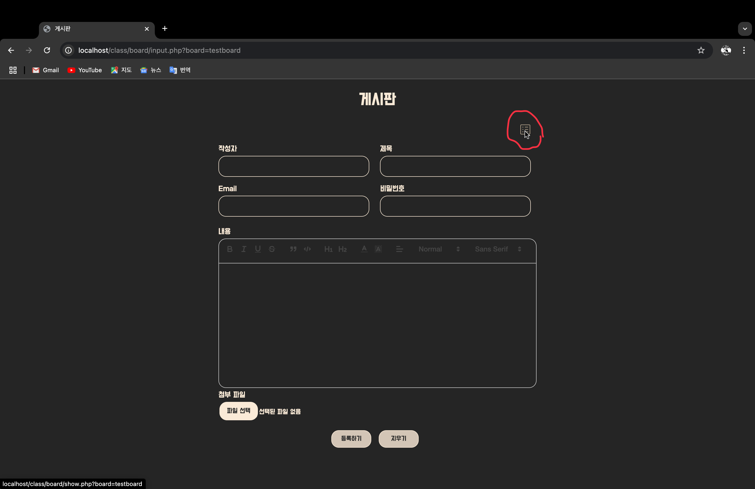

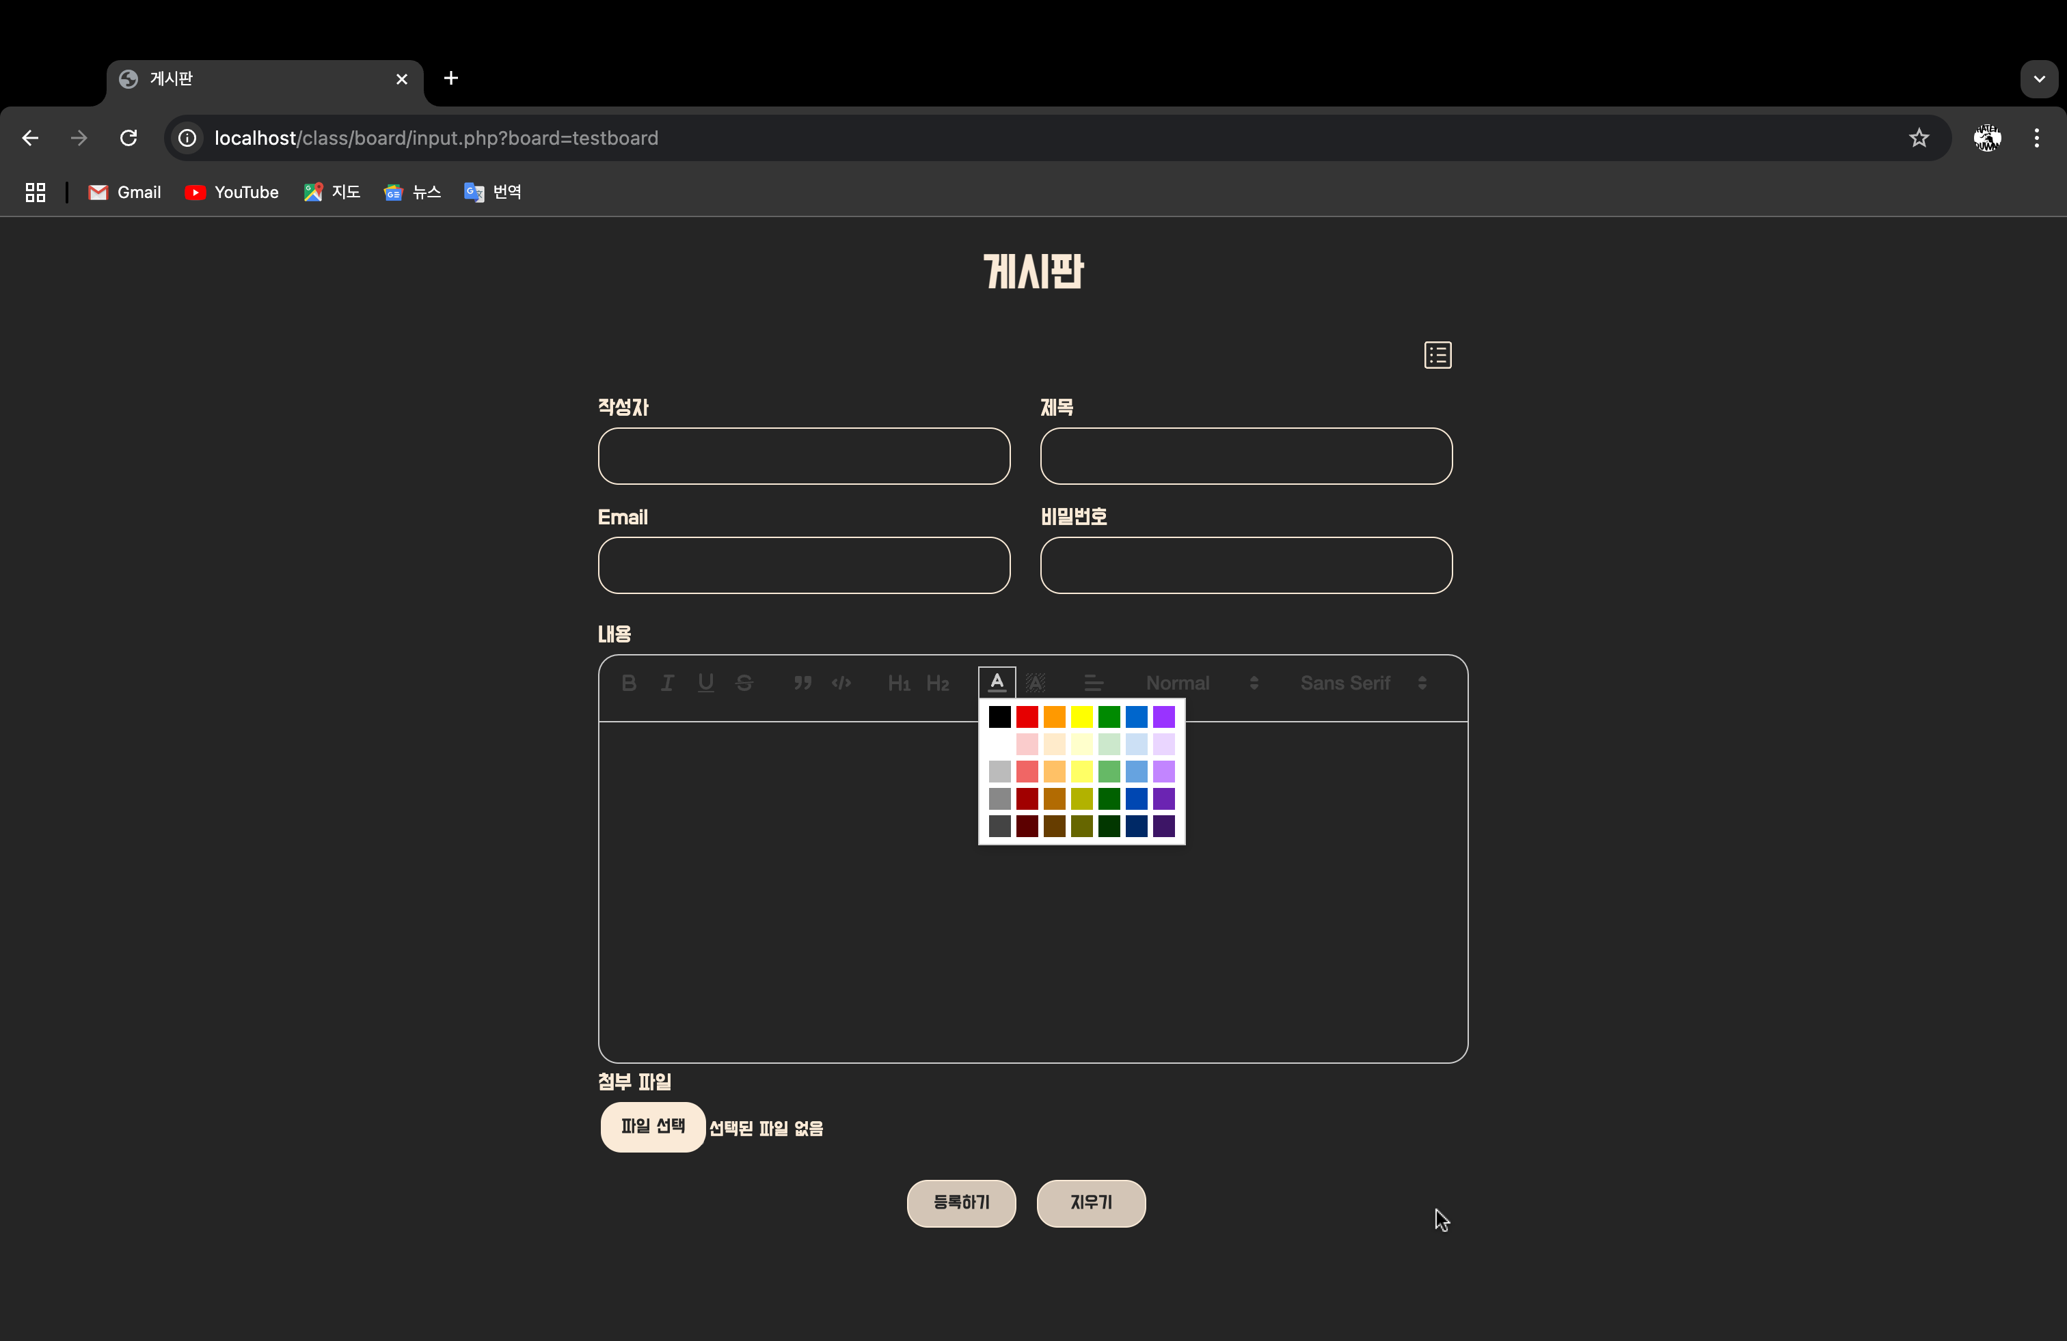

WYSIWYG기능으로 글 작성

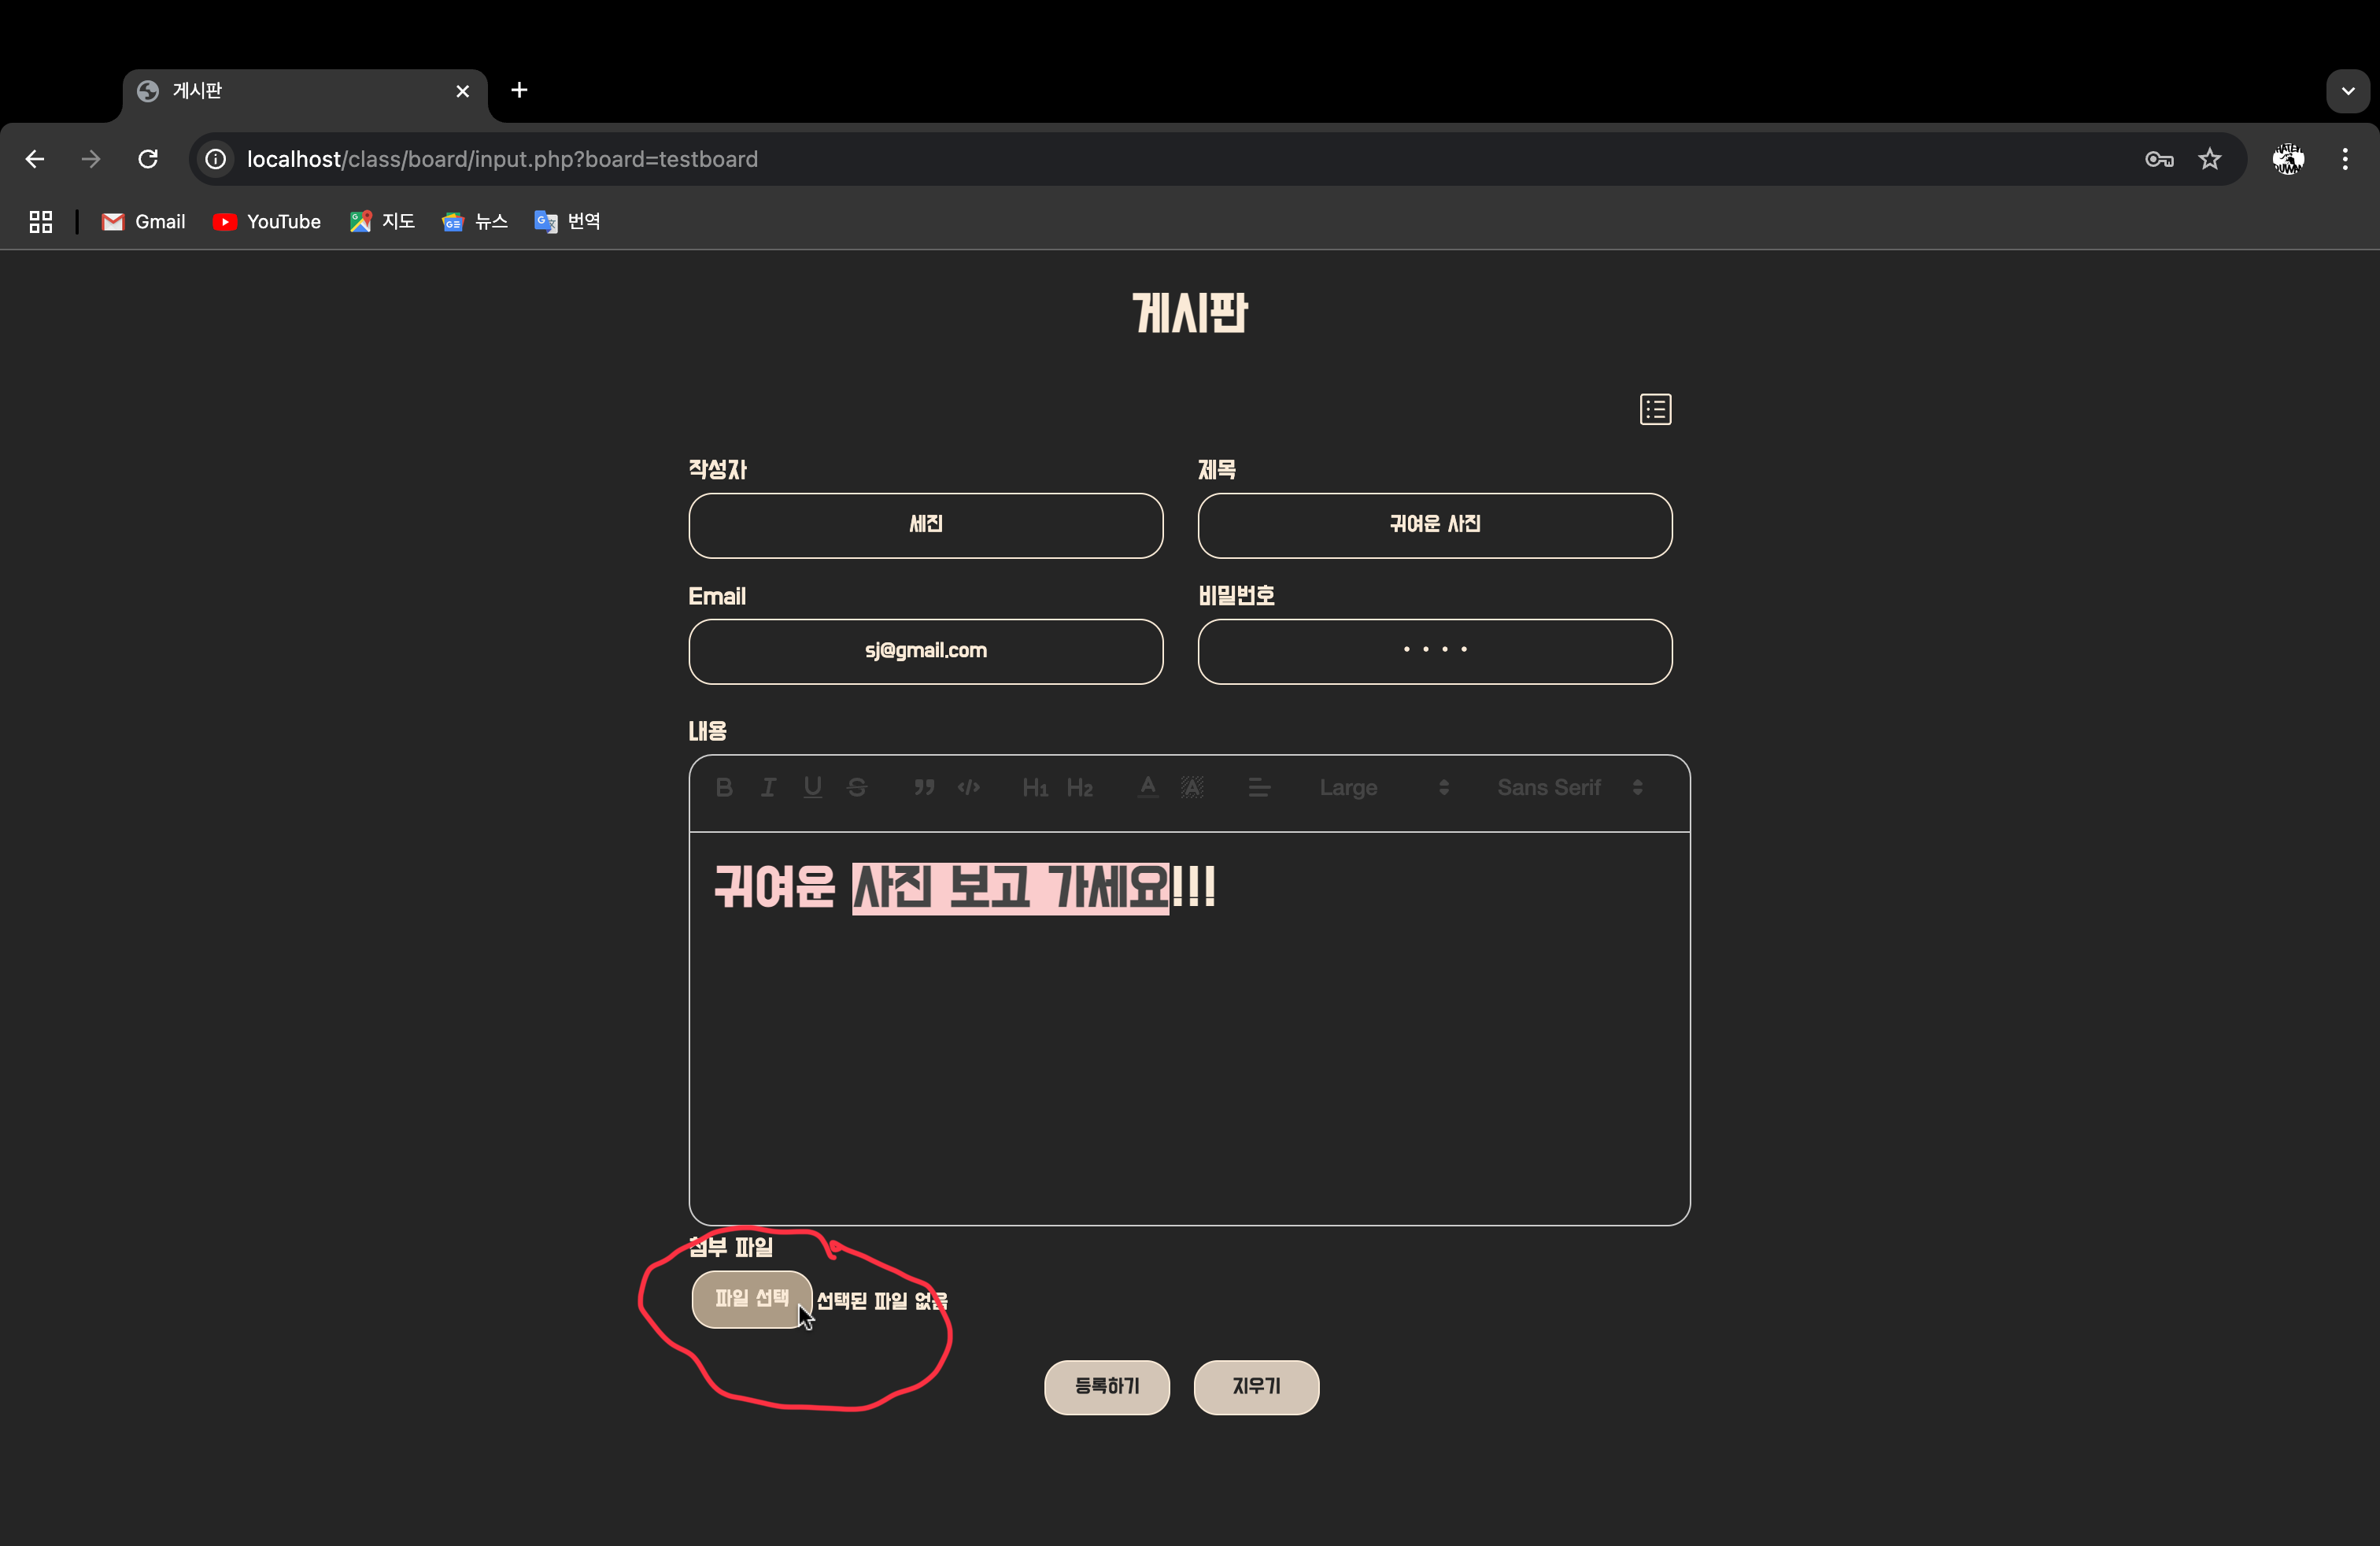

파일 선택버튼

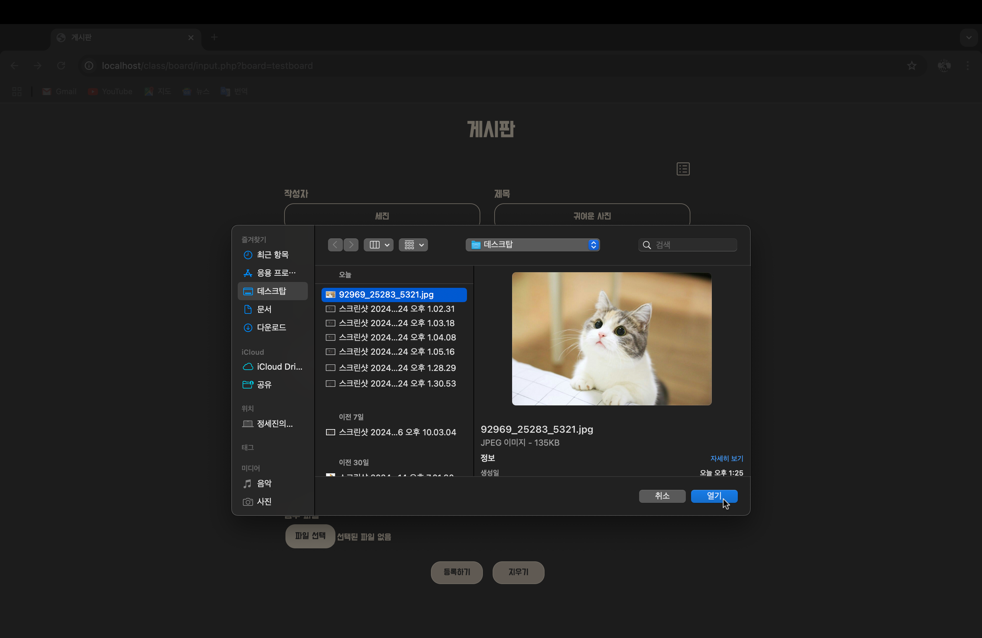

등록 버튼

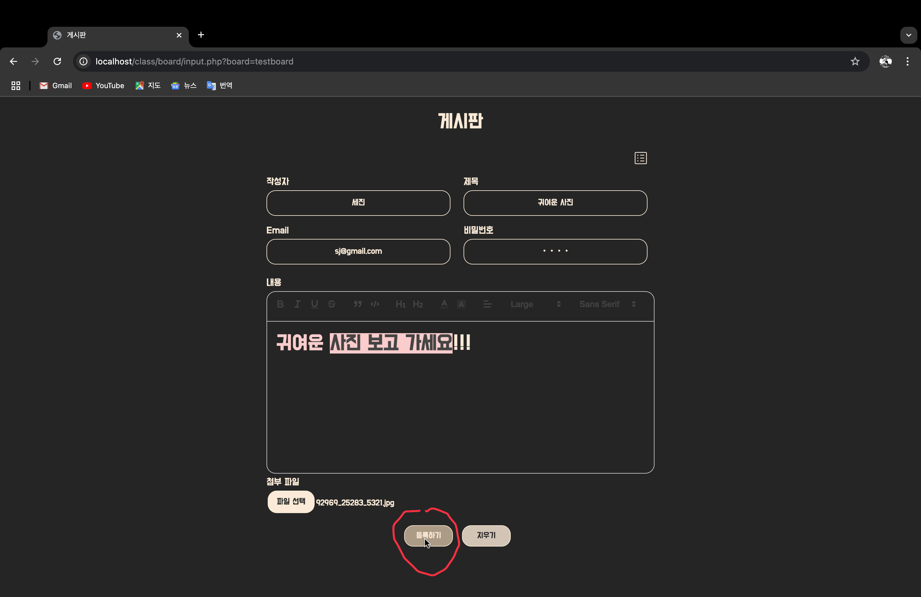

글 추가되고 파일 첨부한 글은 아이콘 표시

게시글 제목 클릭시 해당 게시물로 이동

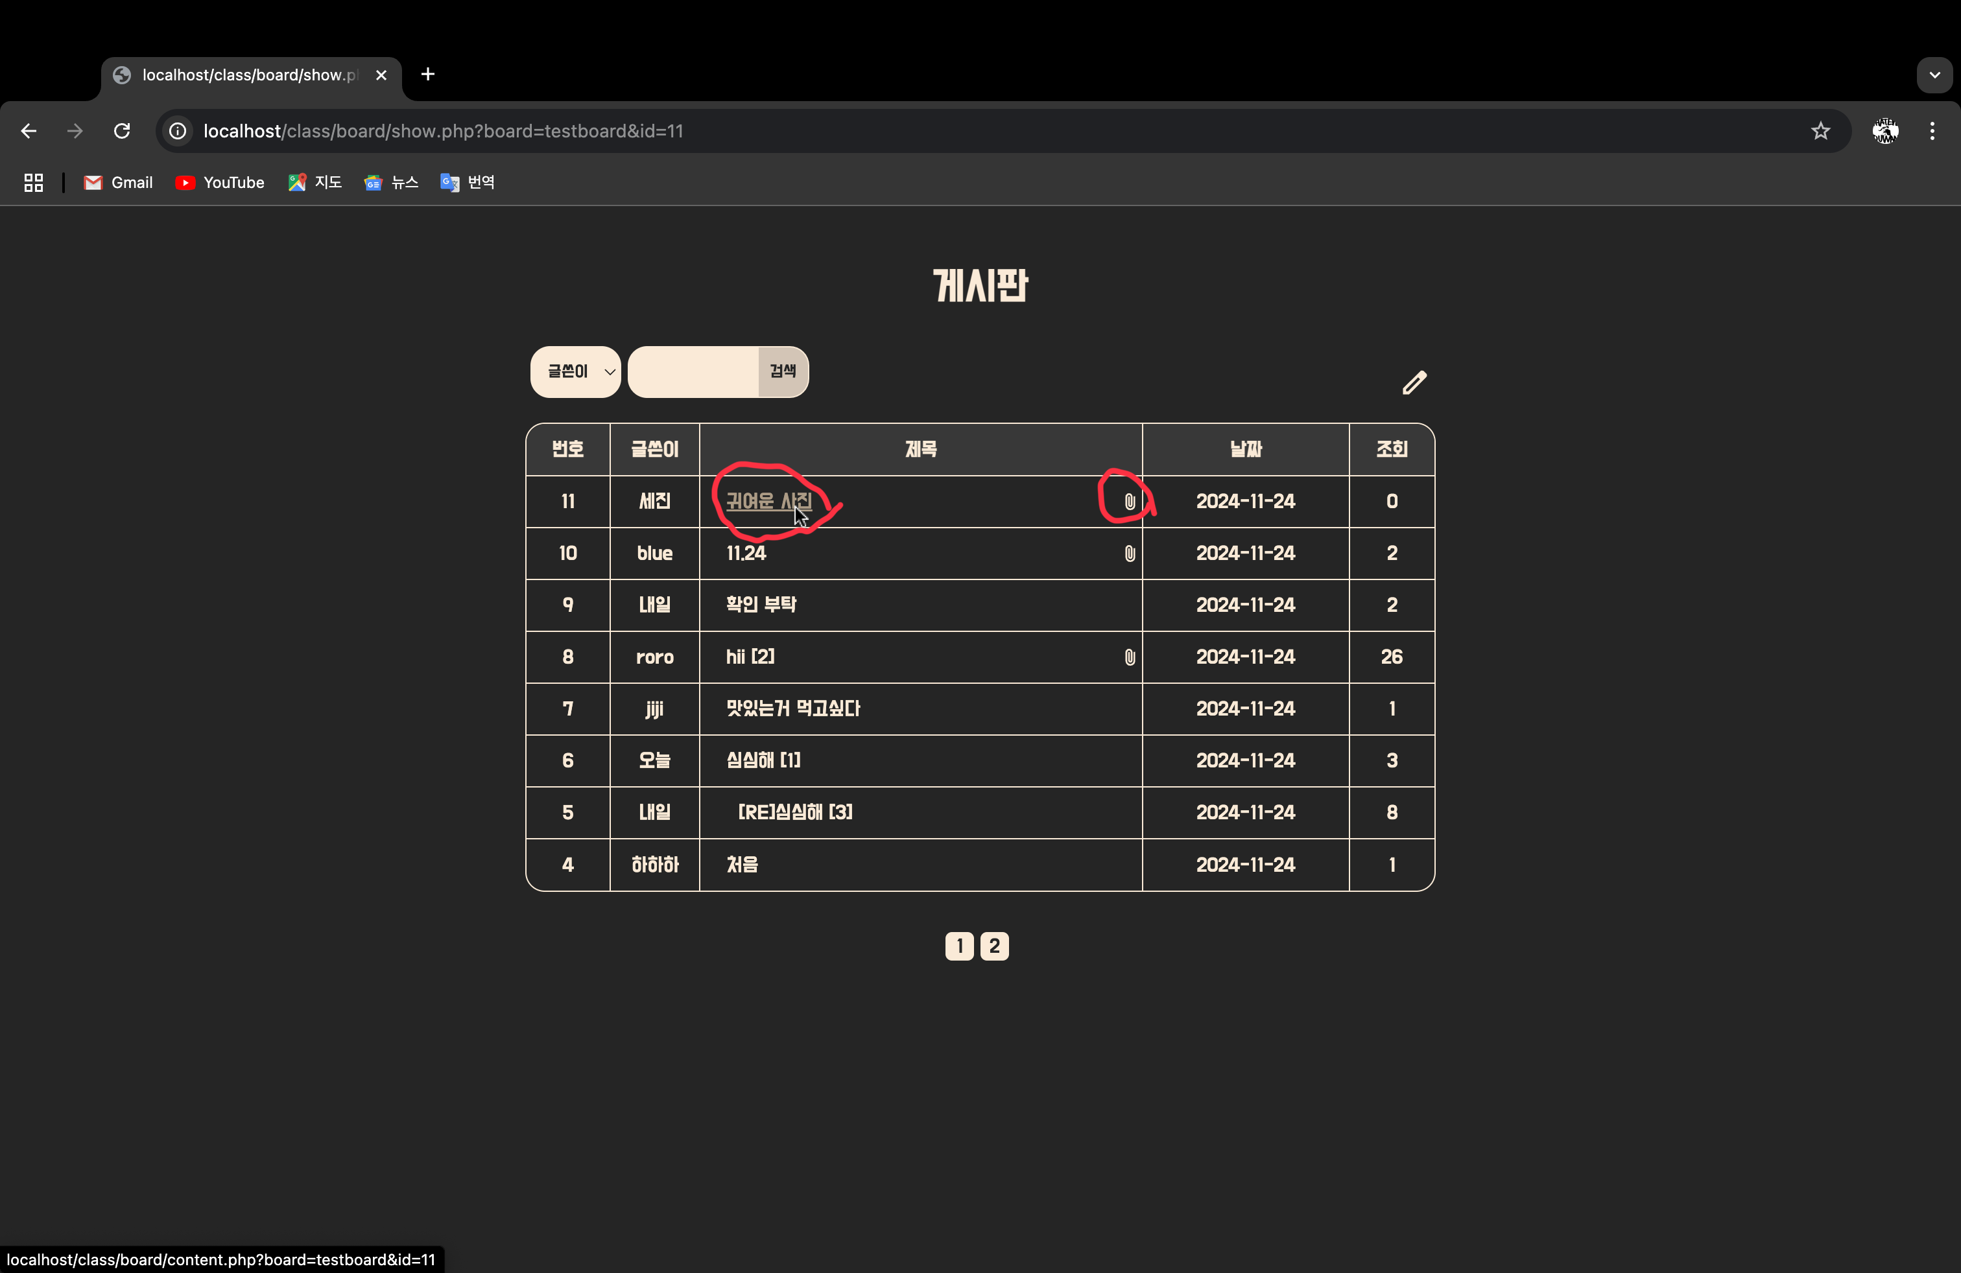

게시글 상세보기

댓글 등록 창 고정, 아래로 스크롤하면 따라옴. 항상 사용자 화면에 떠있음

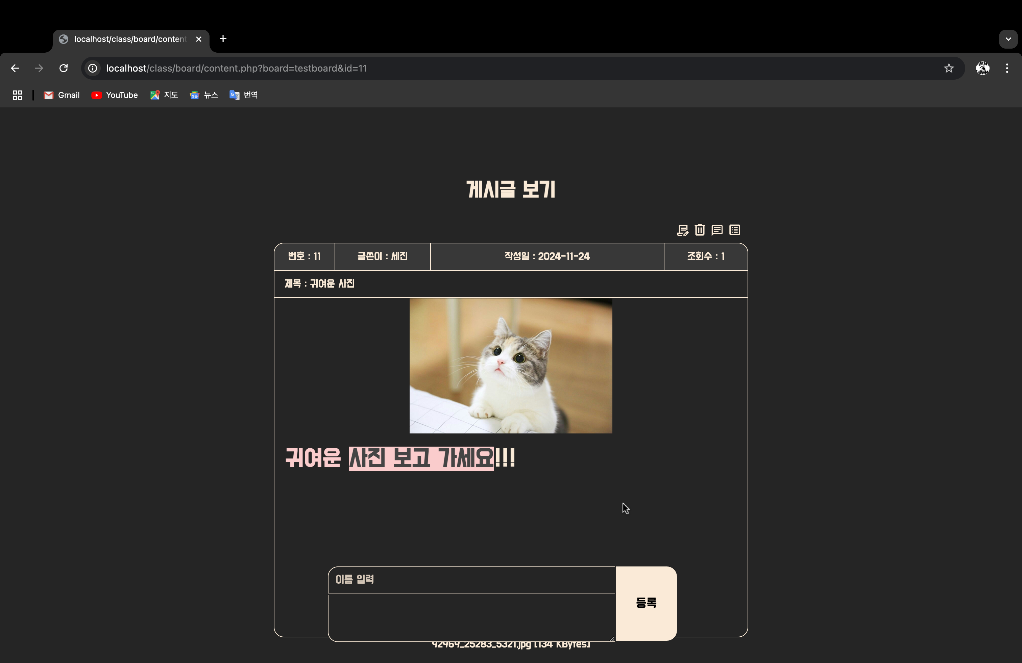

아래로 스크롤/ 댓글 있을 경우 출력, 없을 경우 댓글이 없습니다 출력

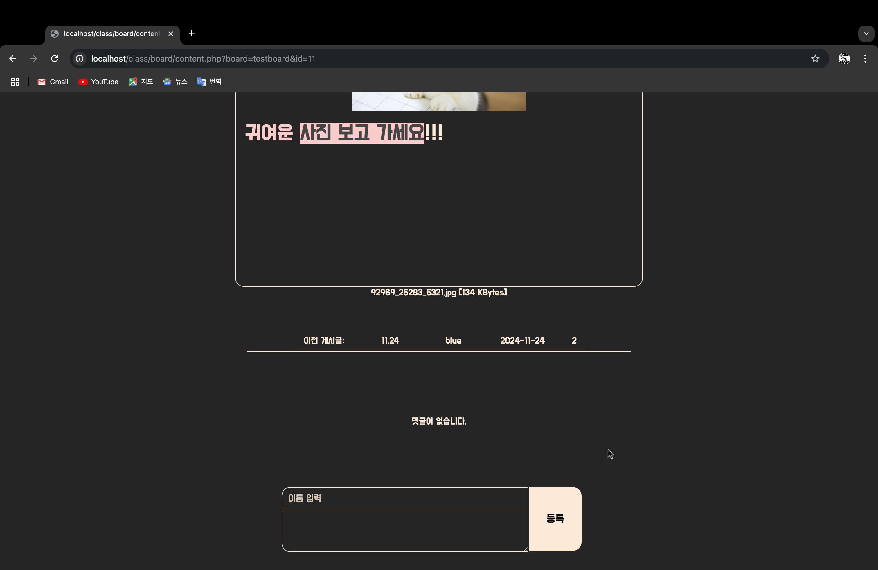

왼쪽 상단 버튼 4개 차례로 수정, 삭제, 답글, 목록으로 이동 버튼

모두 마우스 hover 효과 적용

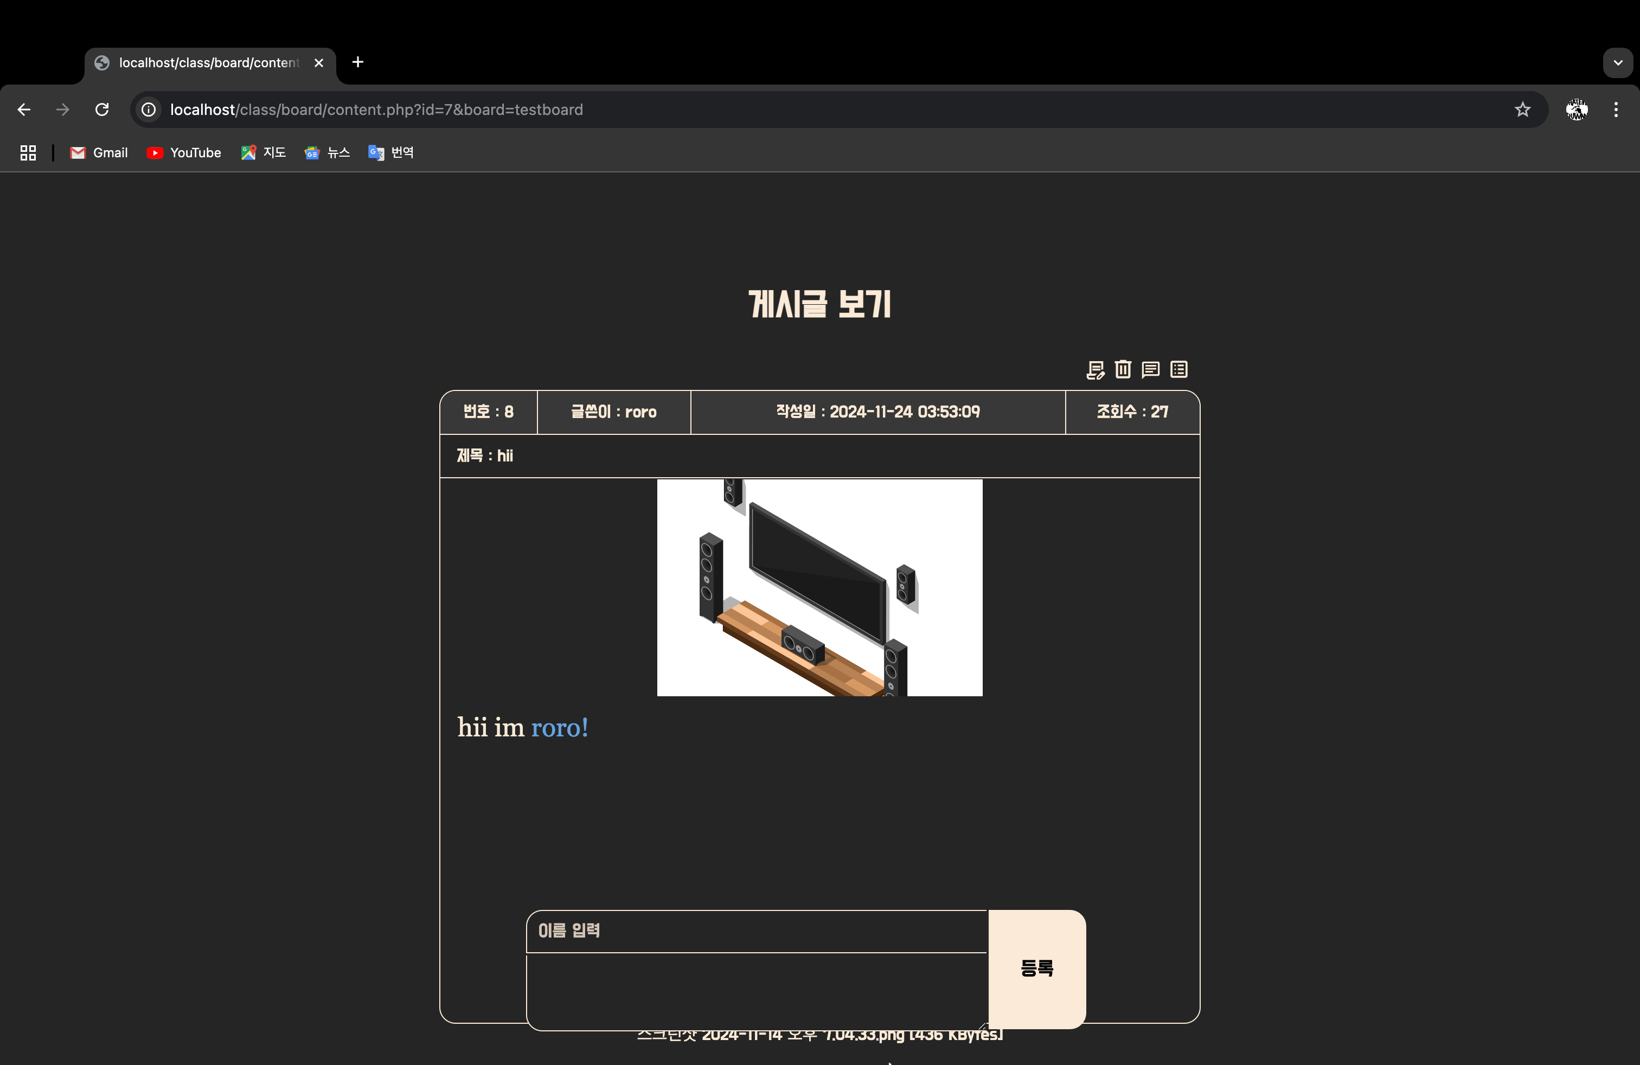

게시글 수정 기능

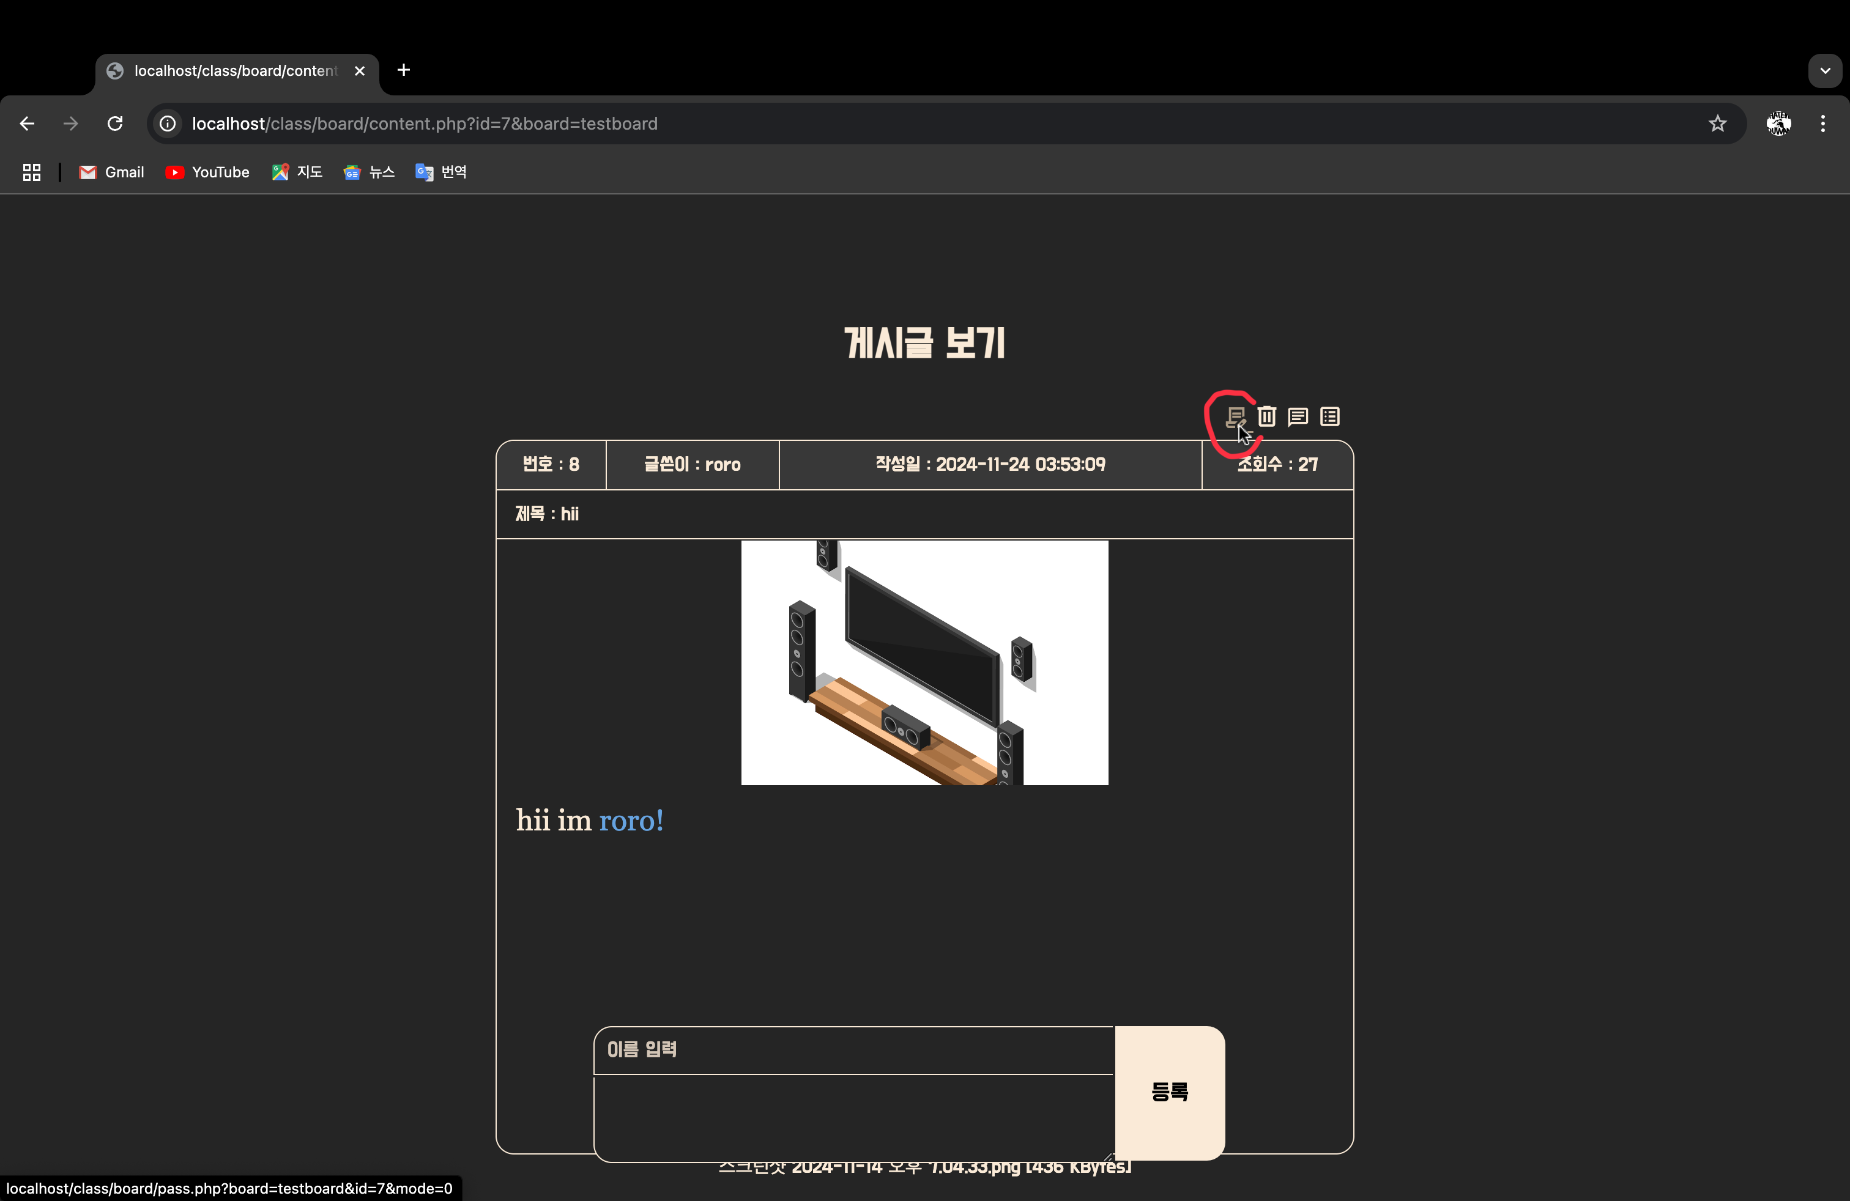

비밀번호 확인

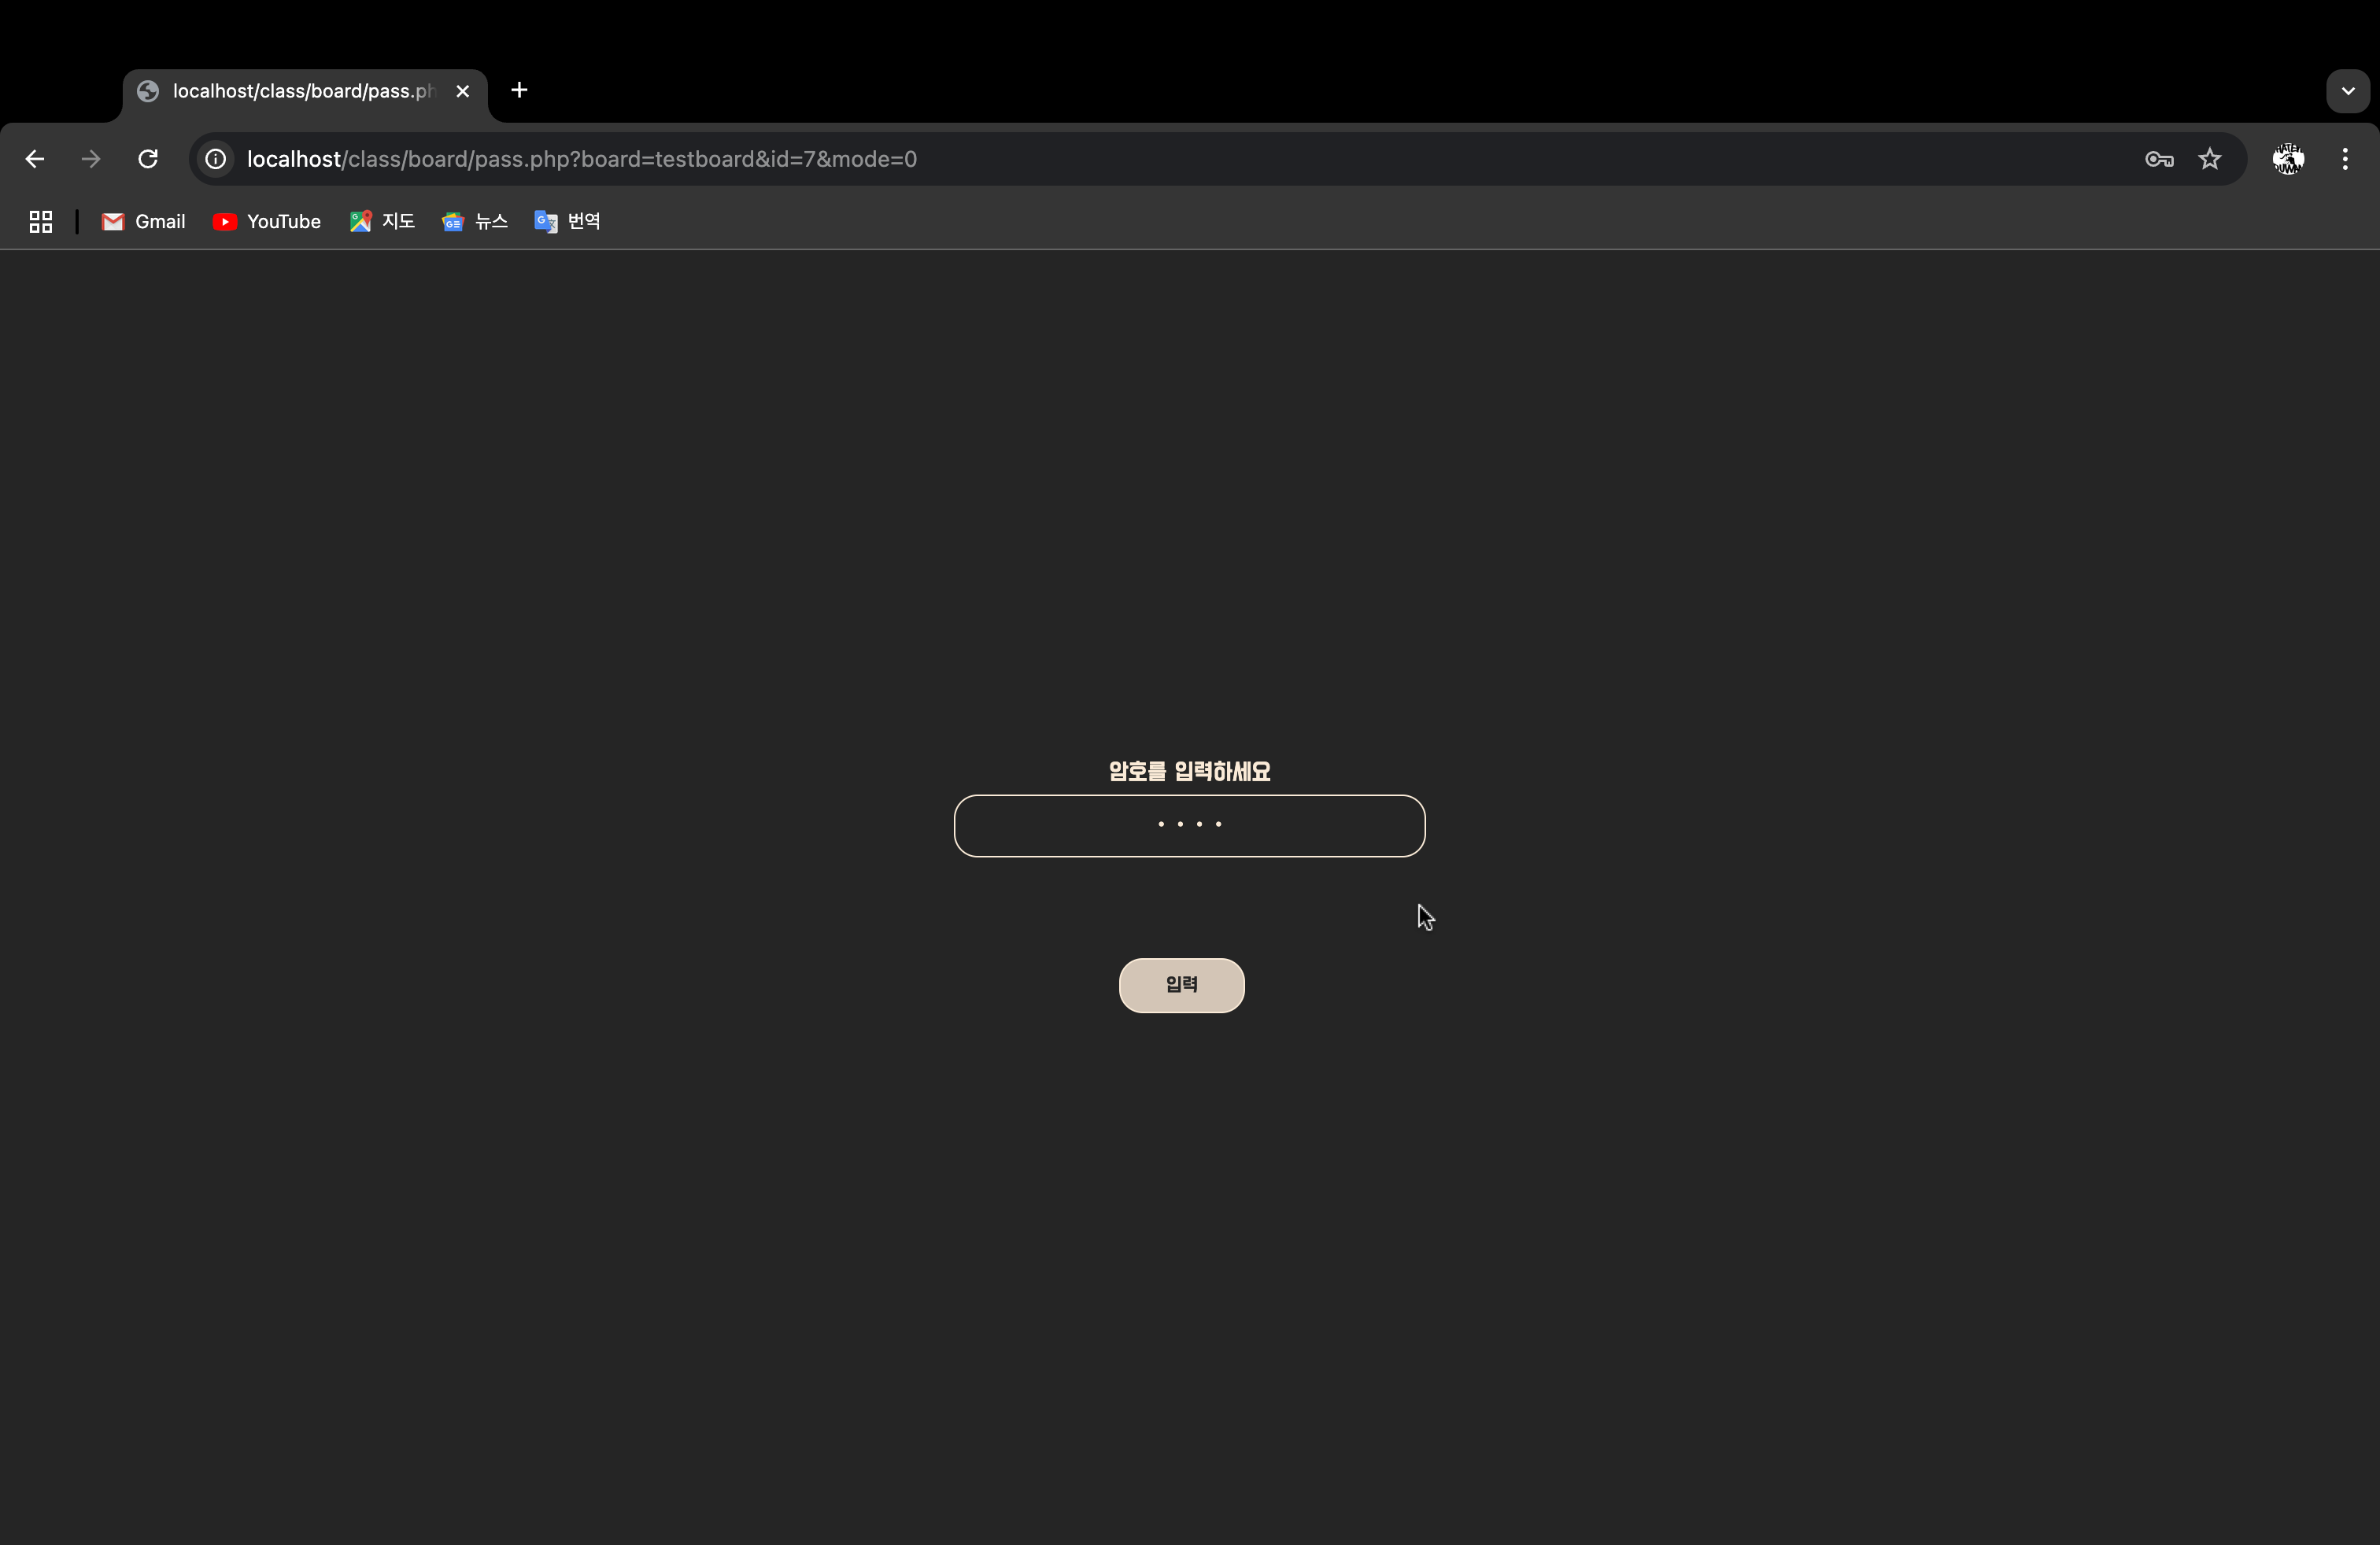

일치 시 수정 페이지로 이동

게시글 수정 및 파일 삭제 기능

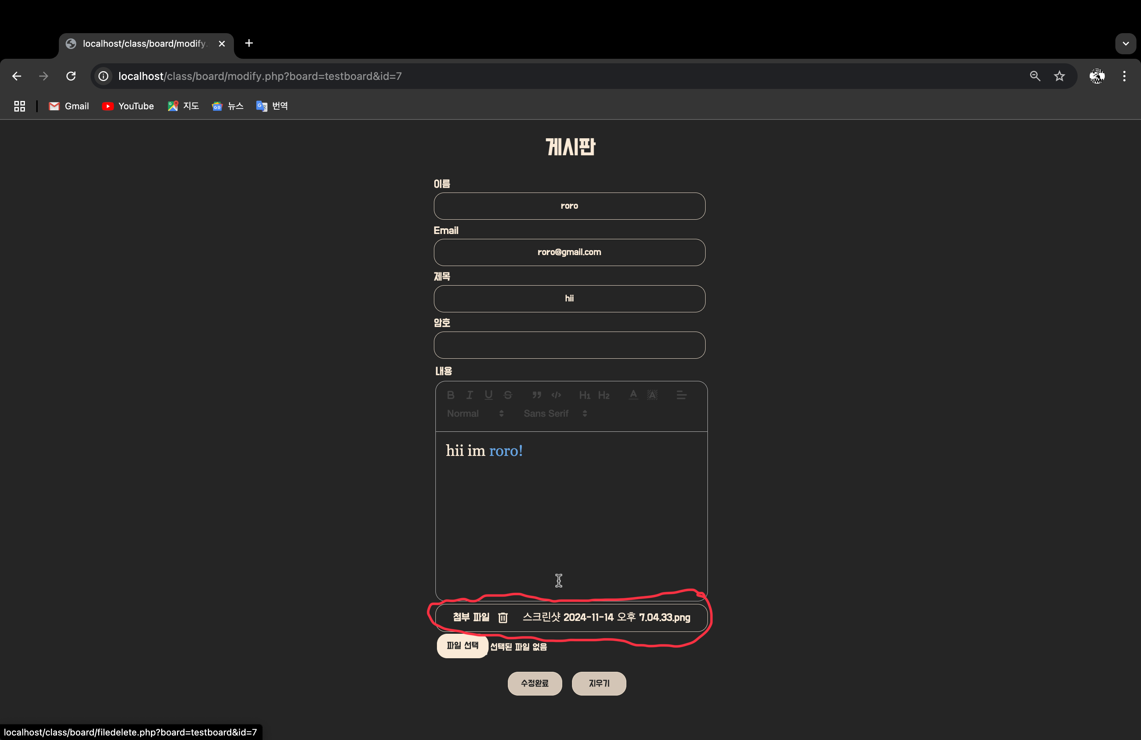

파일 추가

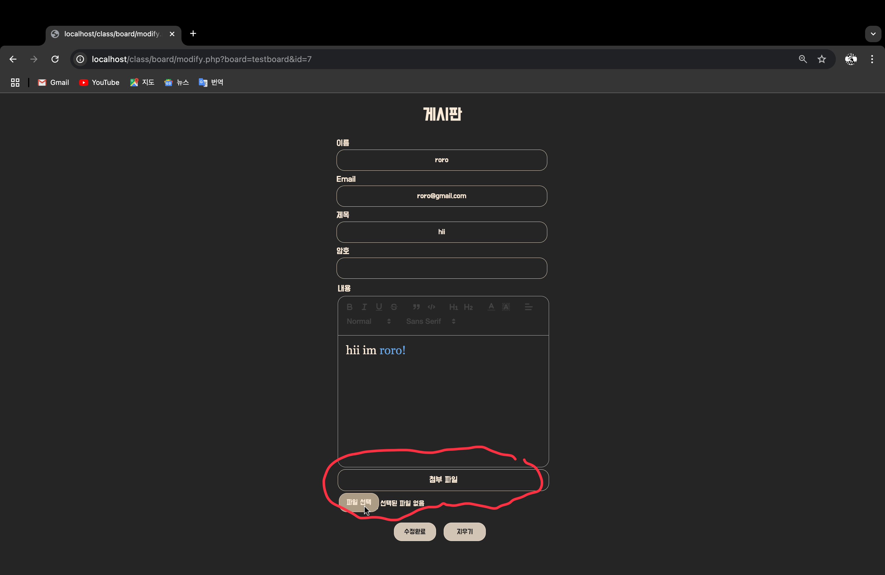

내용 수정, 파일 수정 모습

수정 완료 버튼, 지우기 버튼

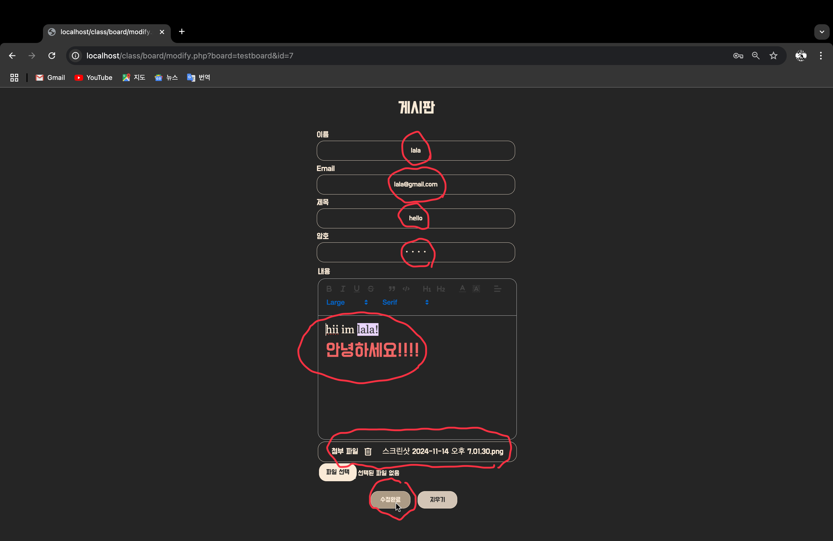

수정된 모습

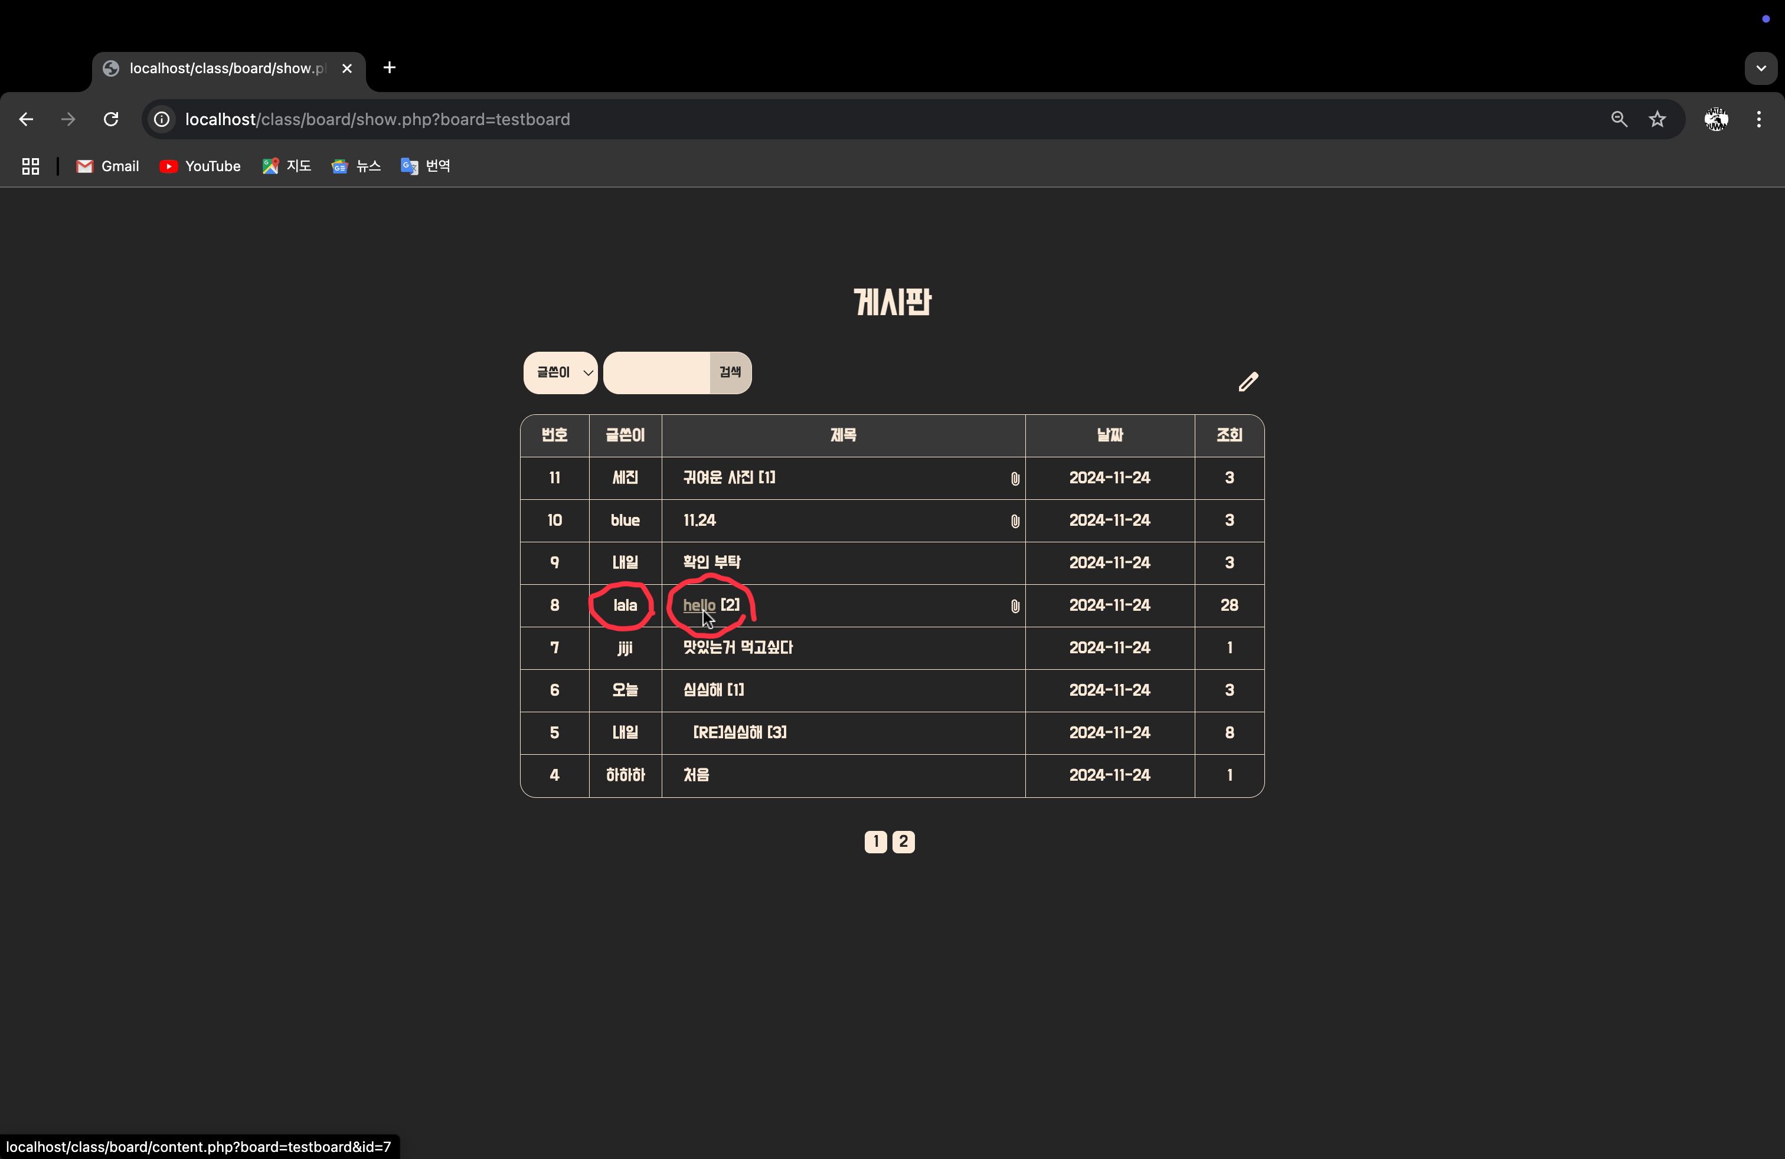

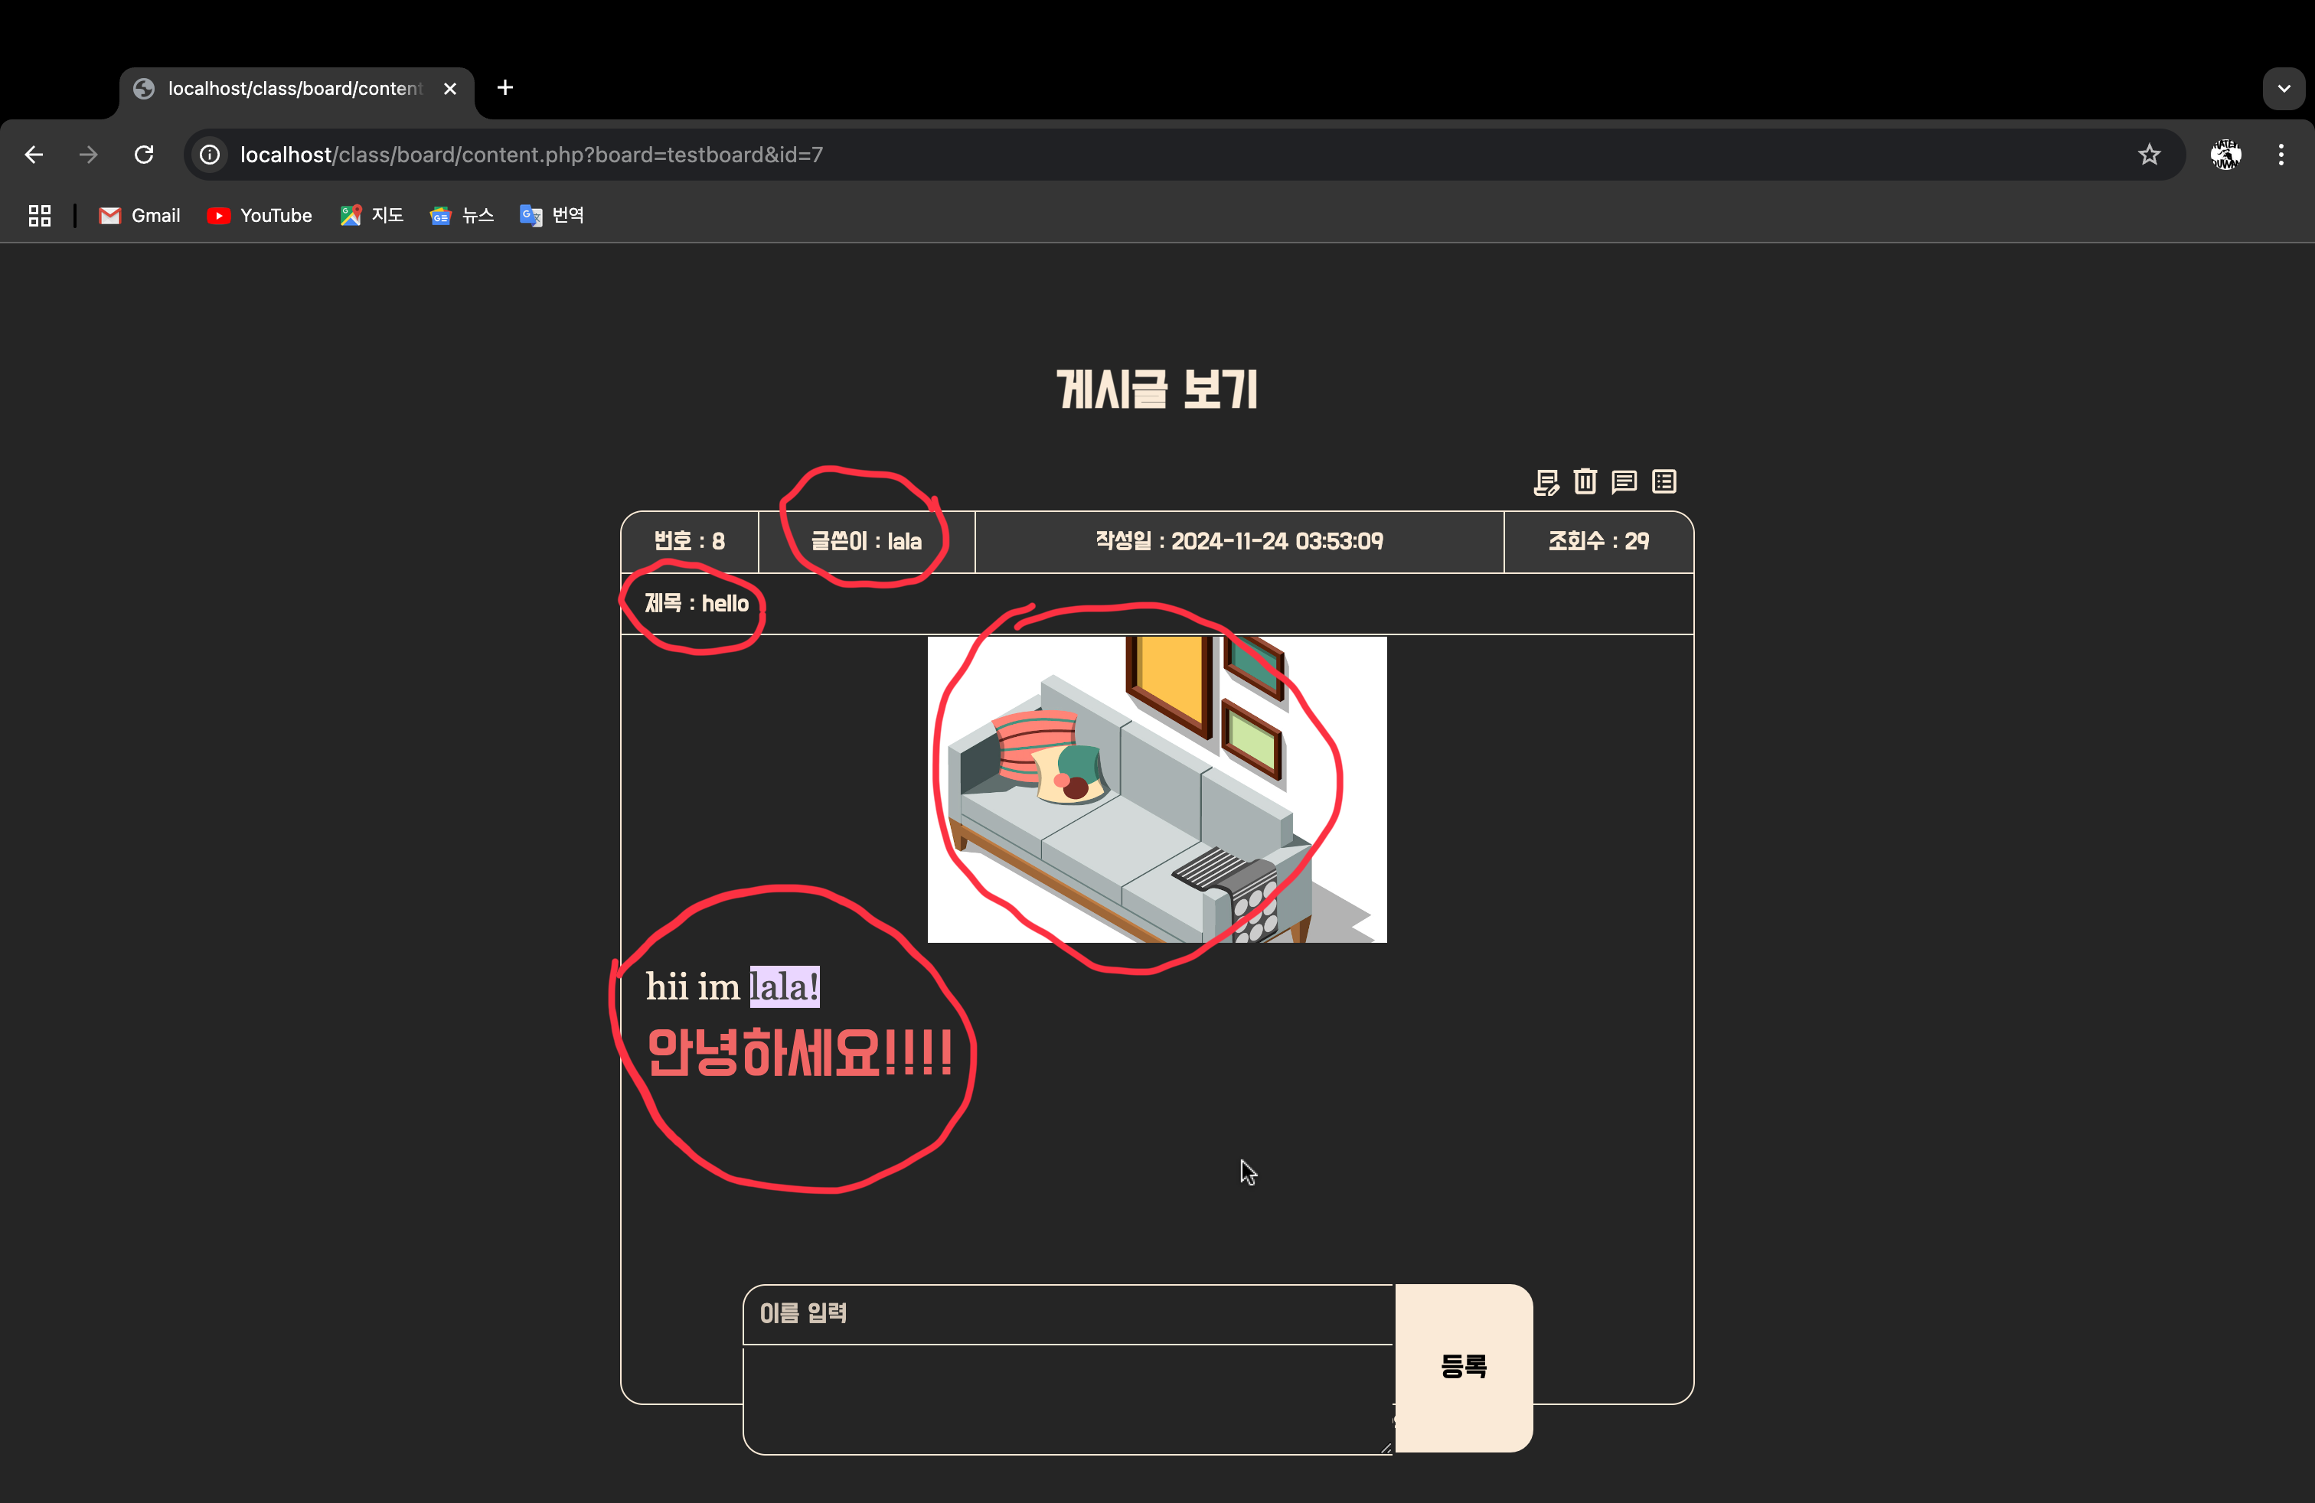

게시글 삭제

삭제 버튼

삭제 시 게시글 뿐만 아니라 게시글 댓글, 파일 모두 삭제

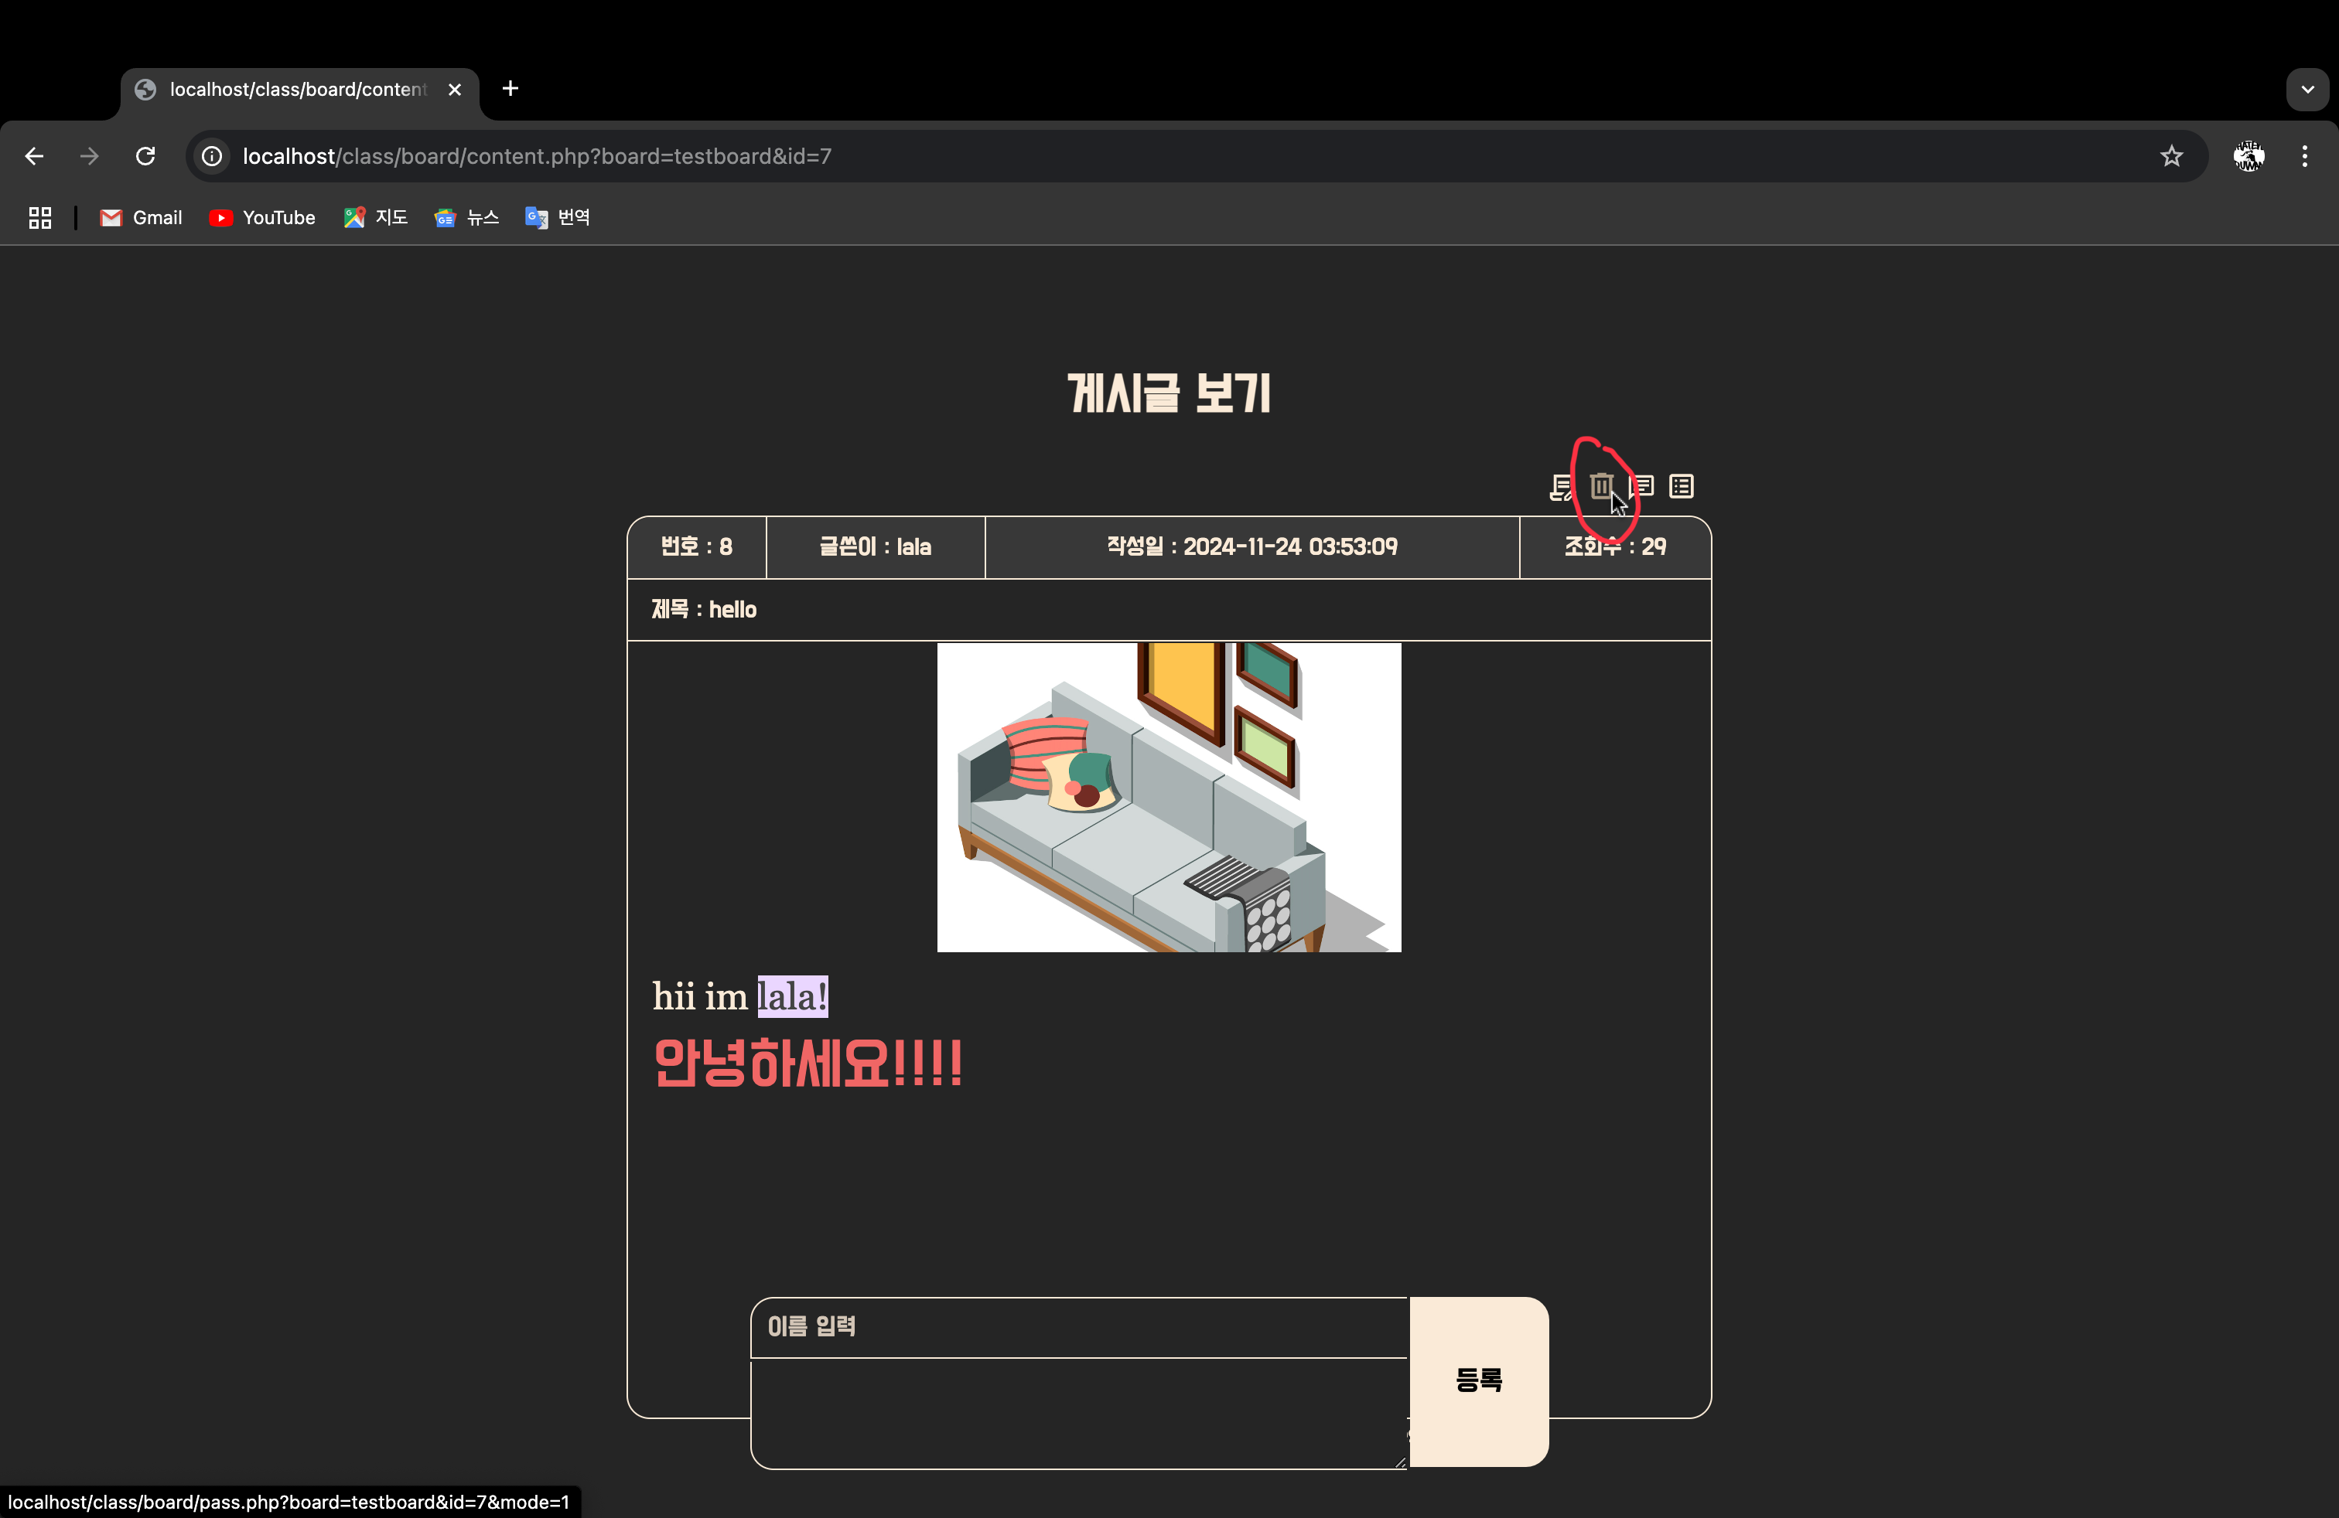

댓글과 파일 테이블

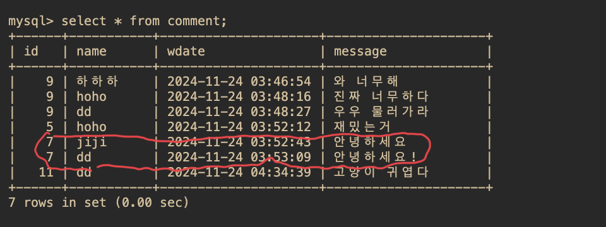

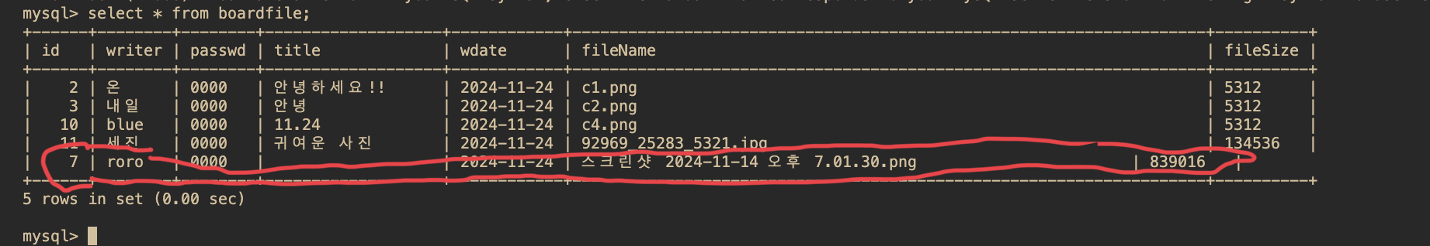

삭제 버튼 클릭 시 비밀번호 확인

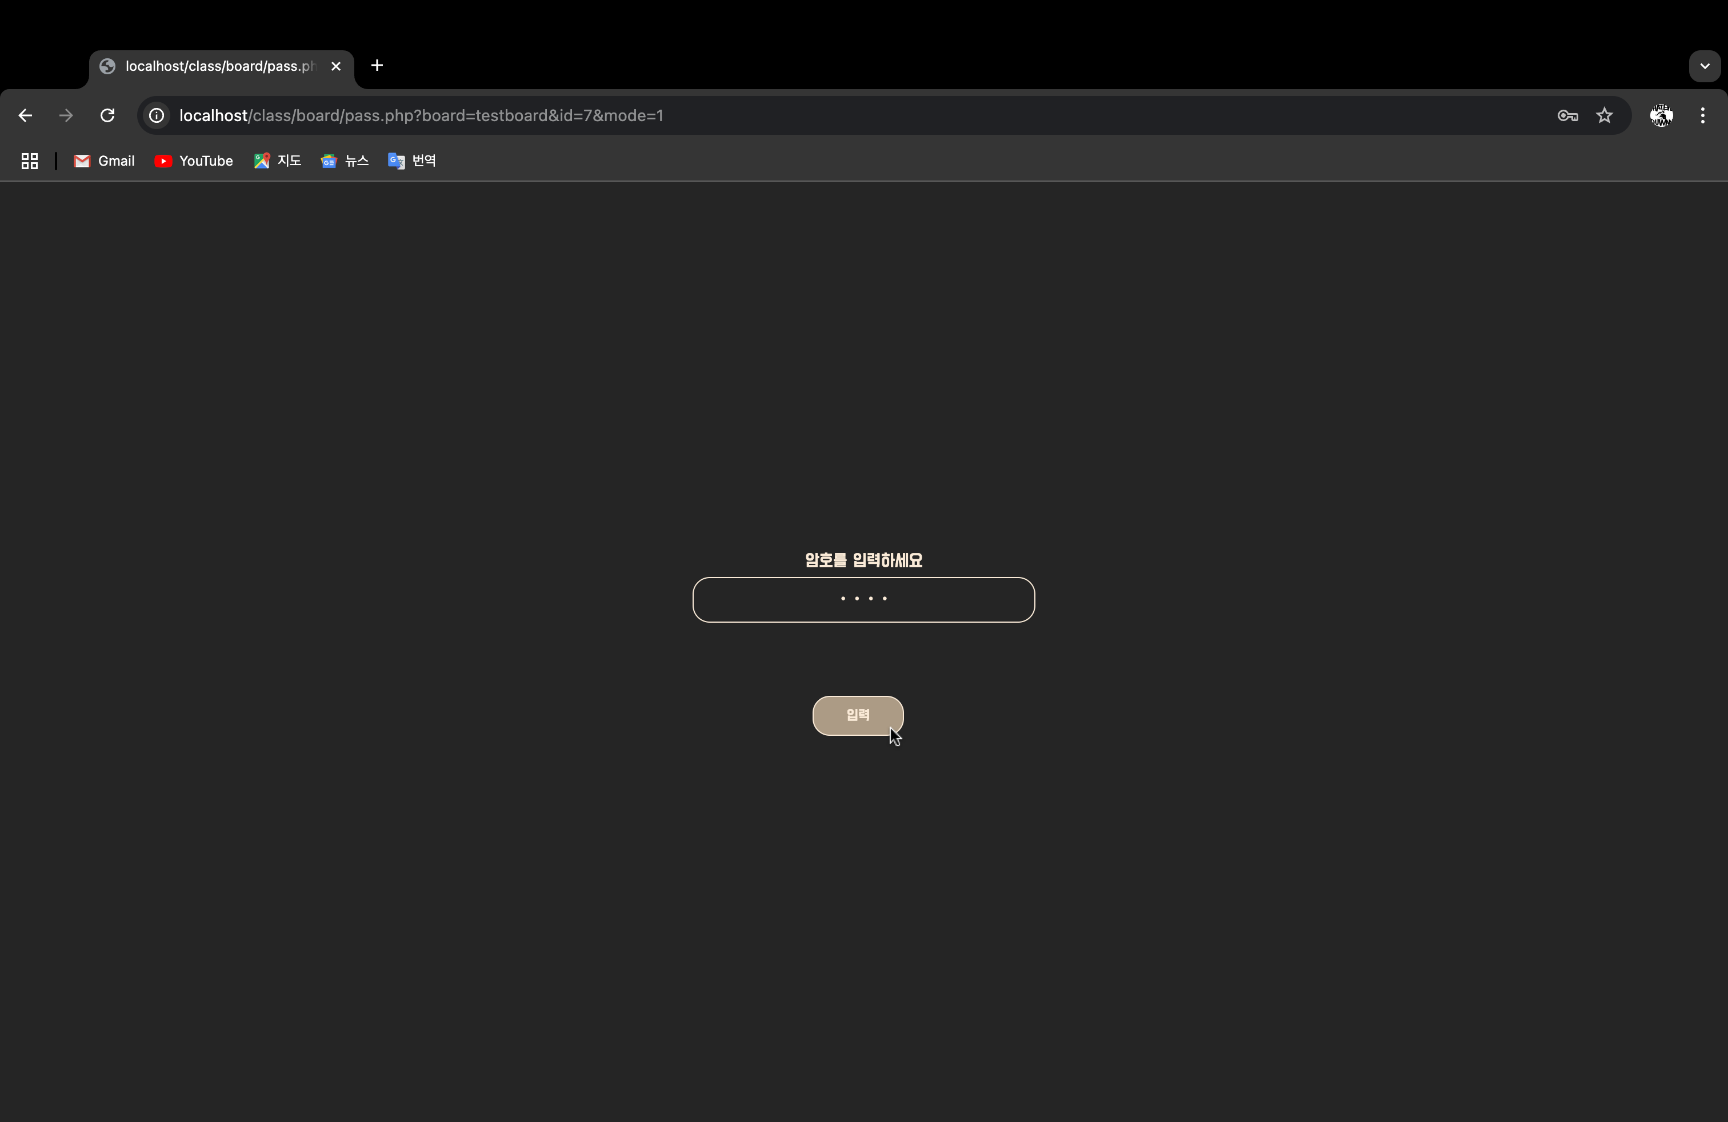

글 삭제 완료 알림창

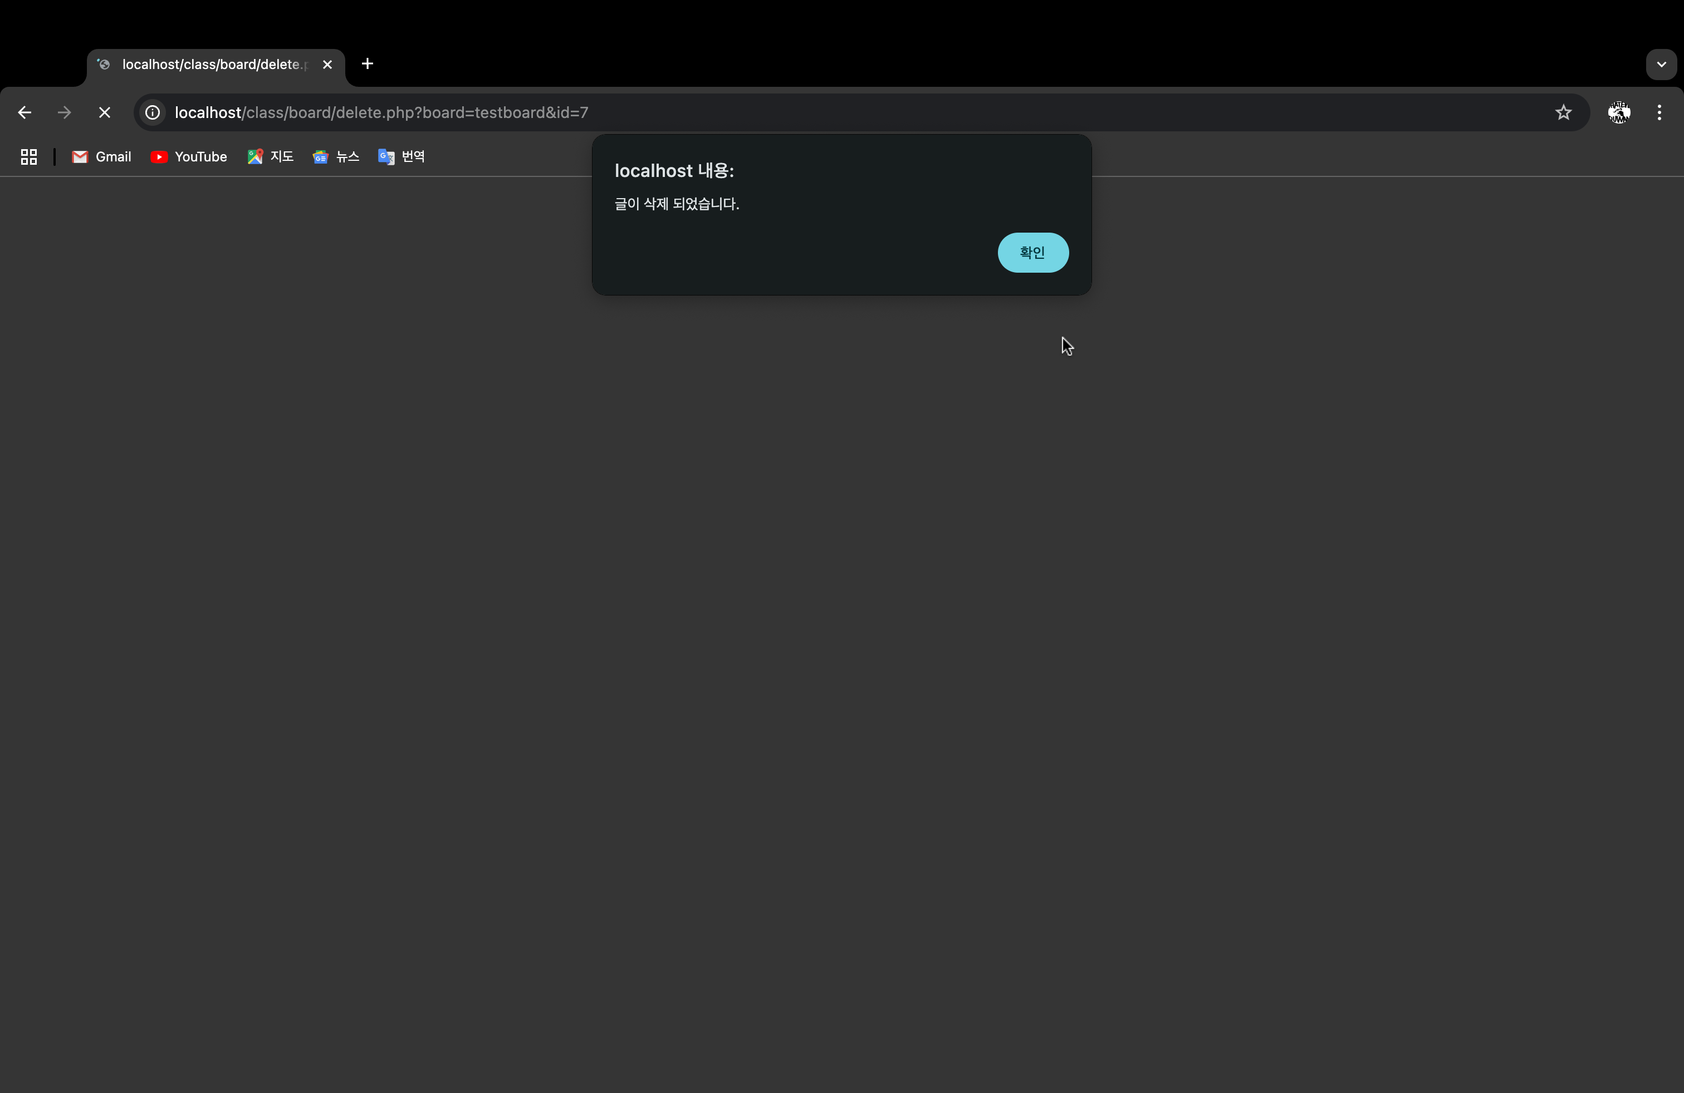

게시글과 그 댓글, 파일이 삭제된 모습

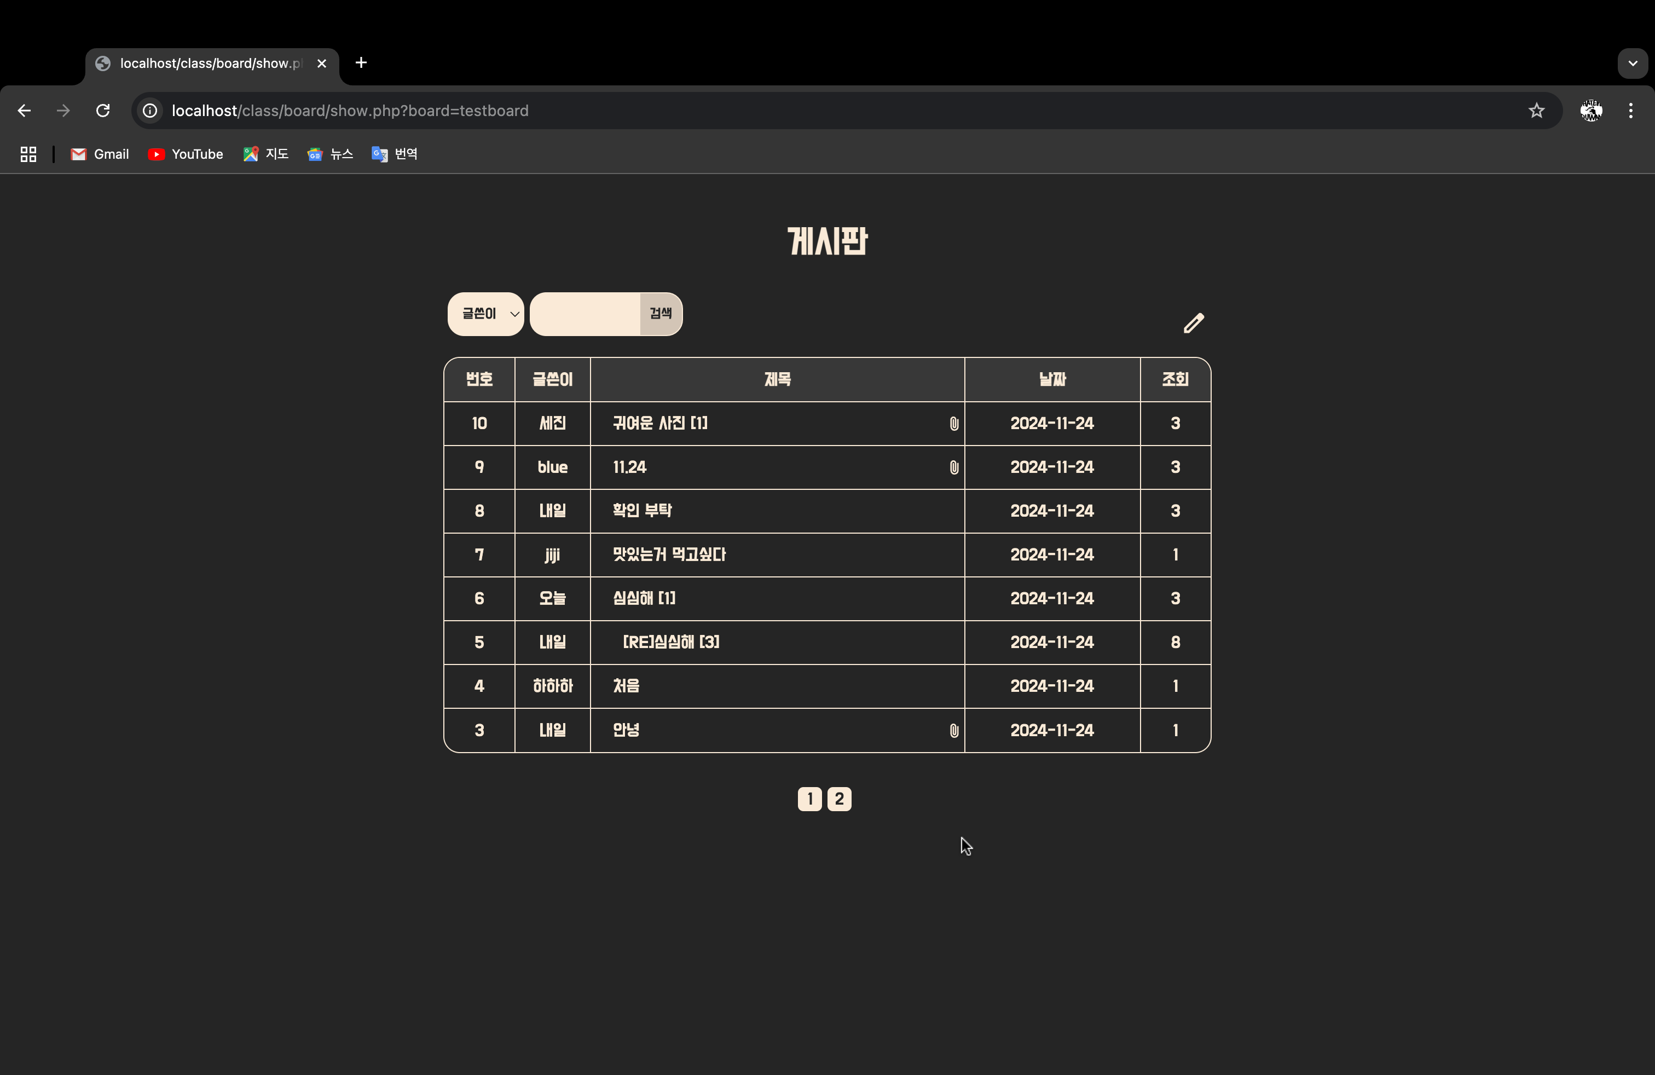

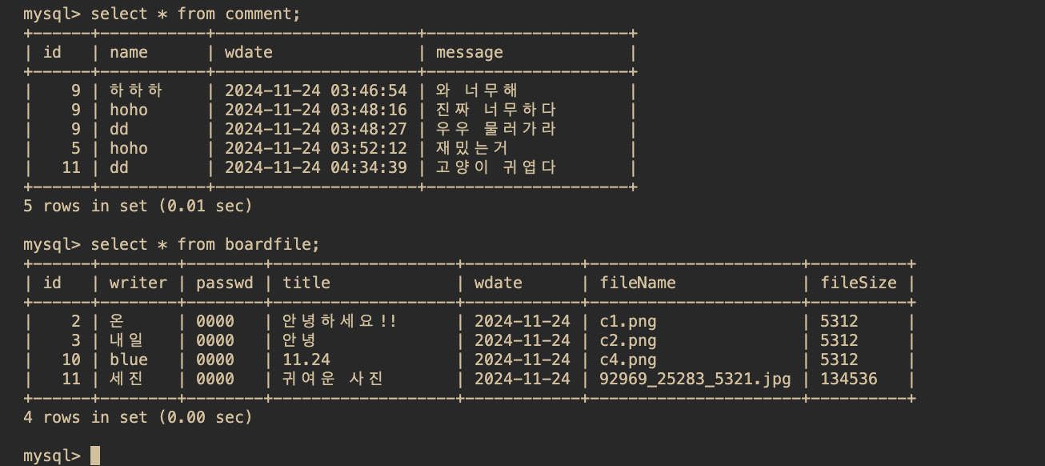

답글 기능

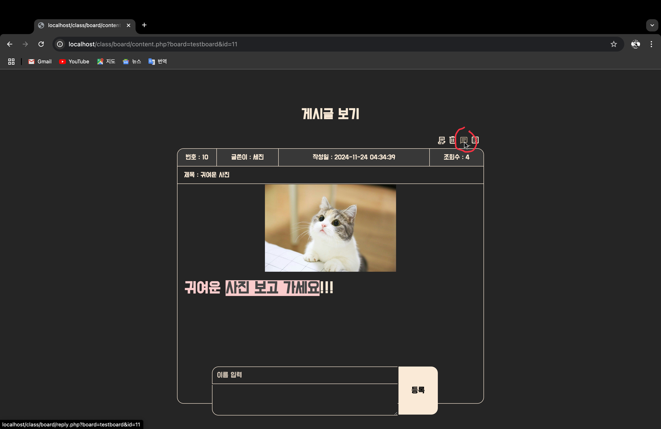

답글 수정 페이지

원본글 출력 & 제목 – [RE]원본글

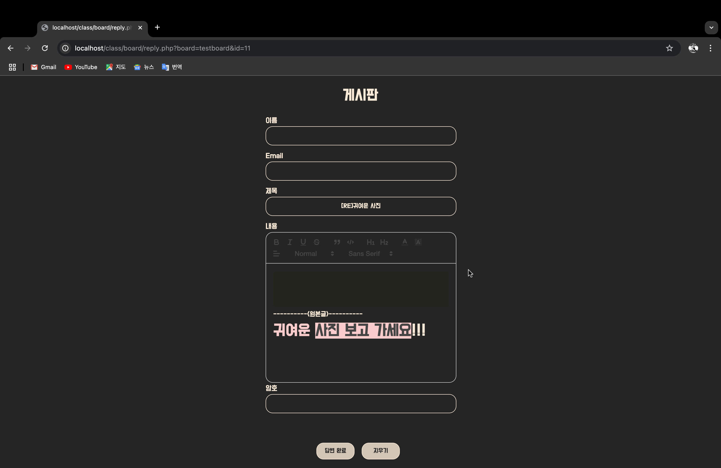

작성 후 답변 완료 버튼 클릭

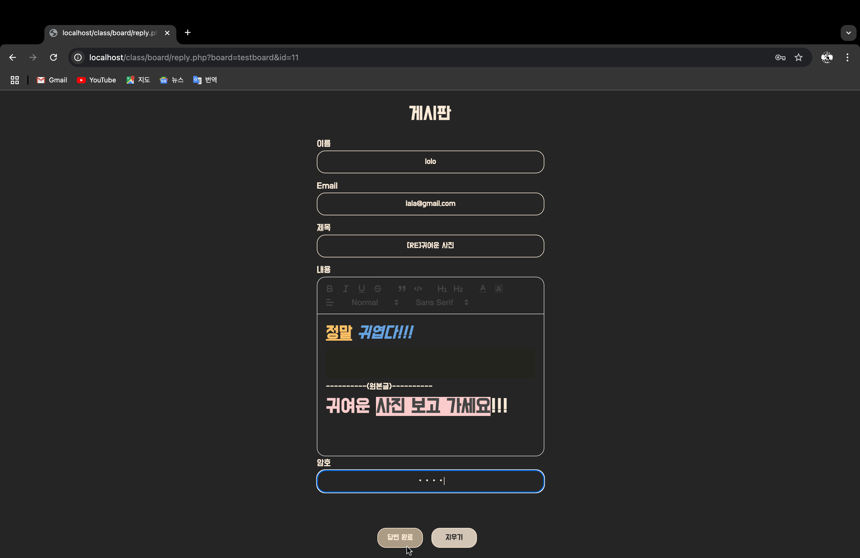

원본 글 밑에 추가, 번호 재정렬

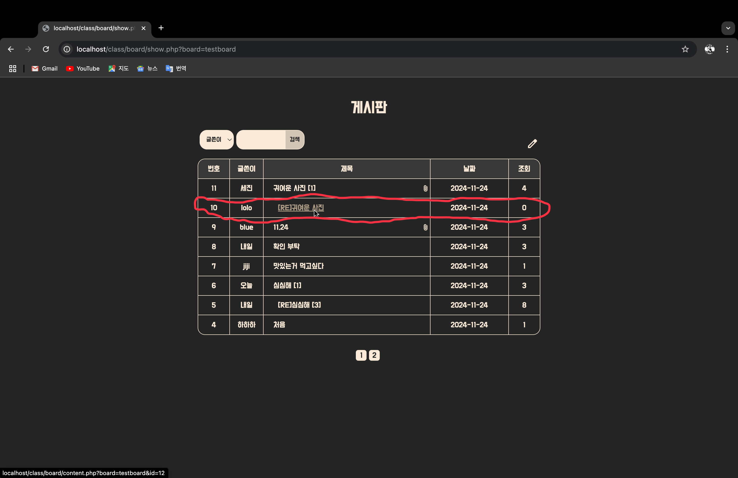

답글 클릭시 원본 글과 함께 출력

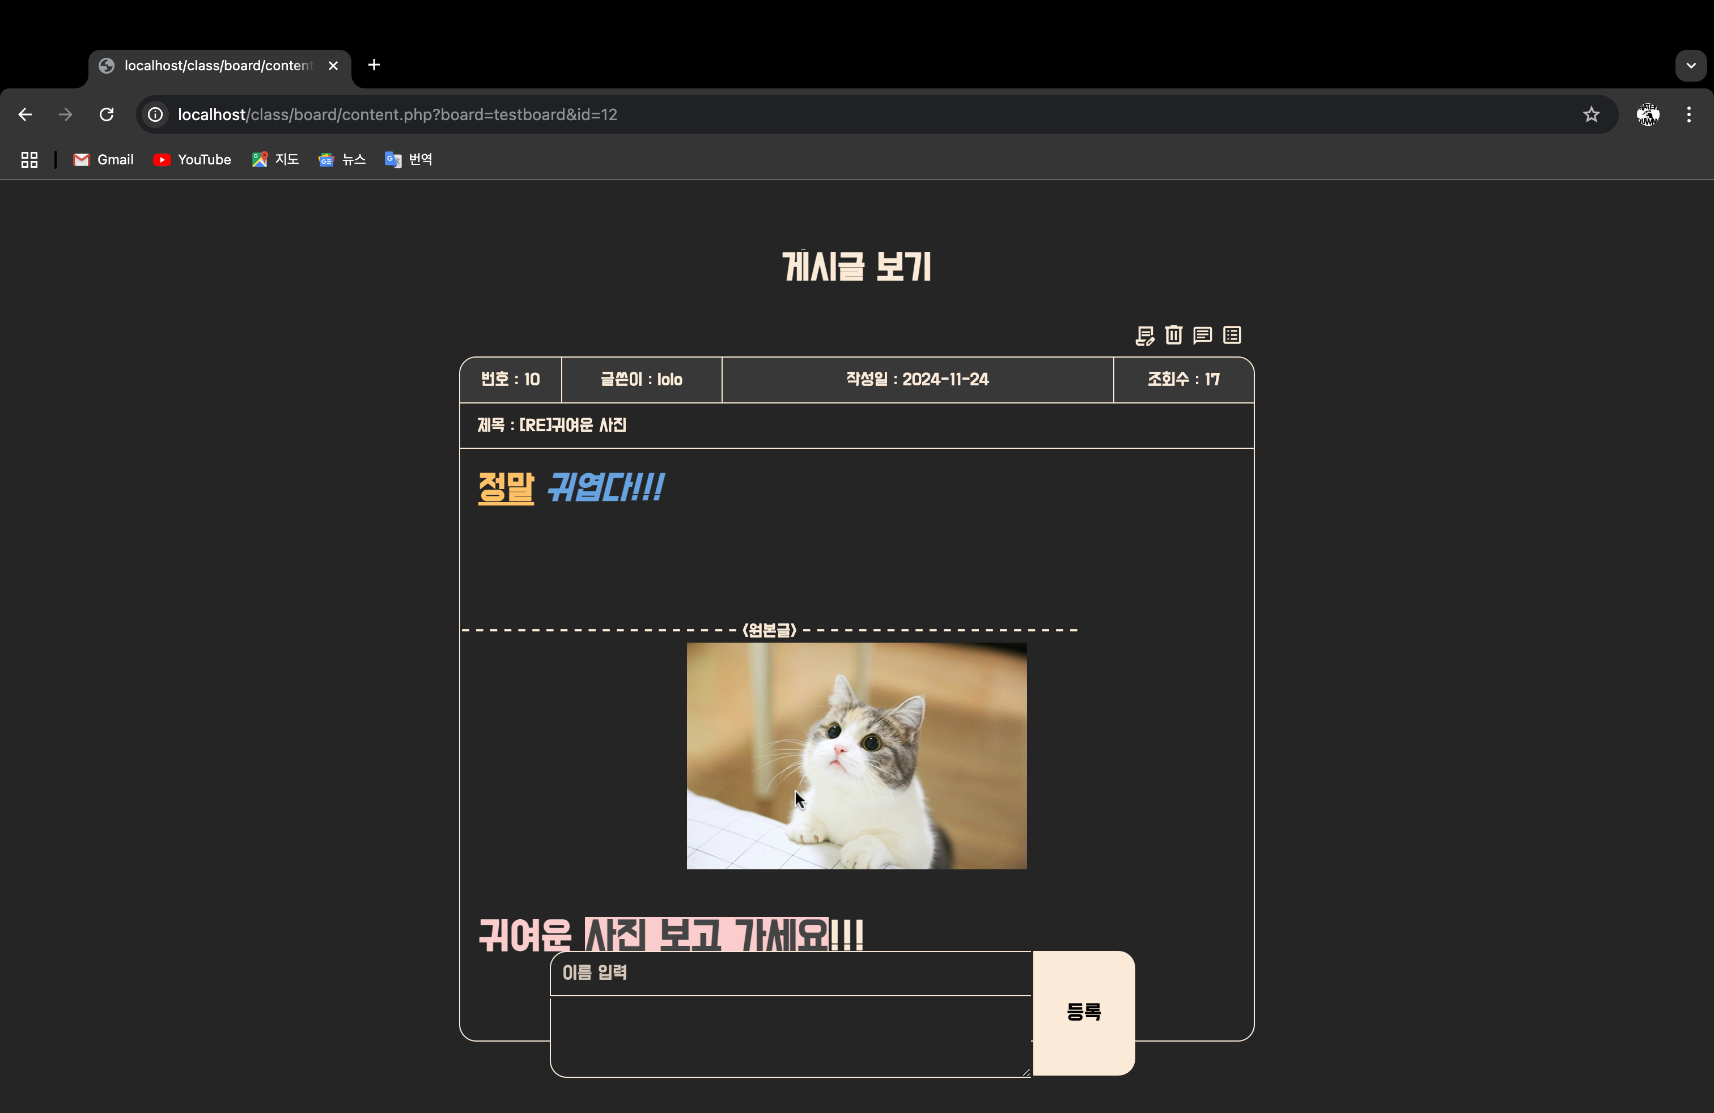

화면 전환

마우스 hover효과 적용

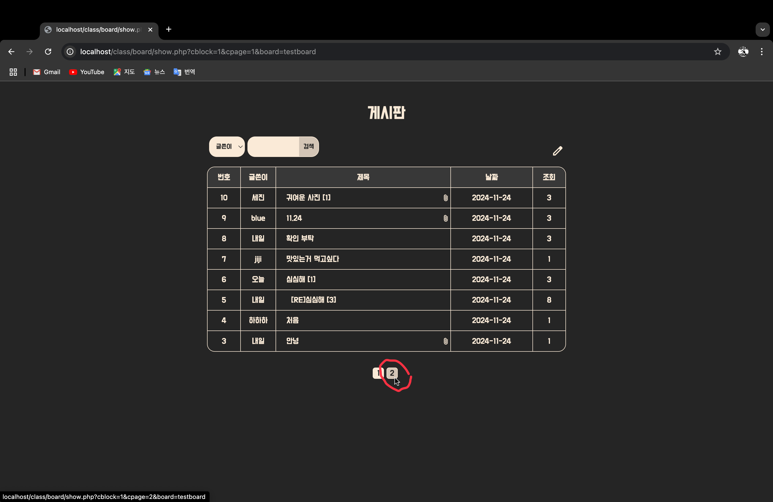

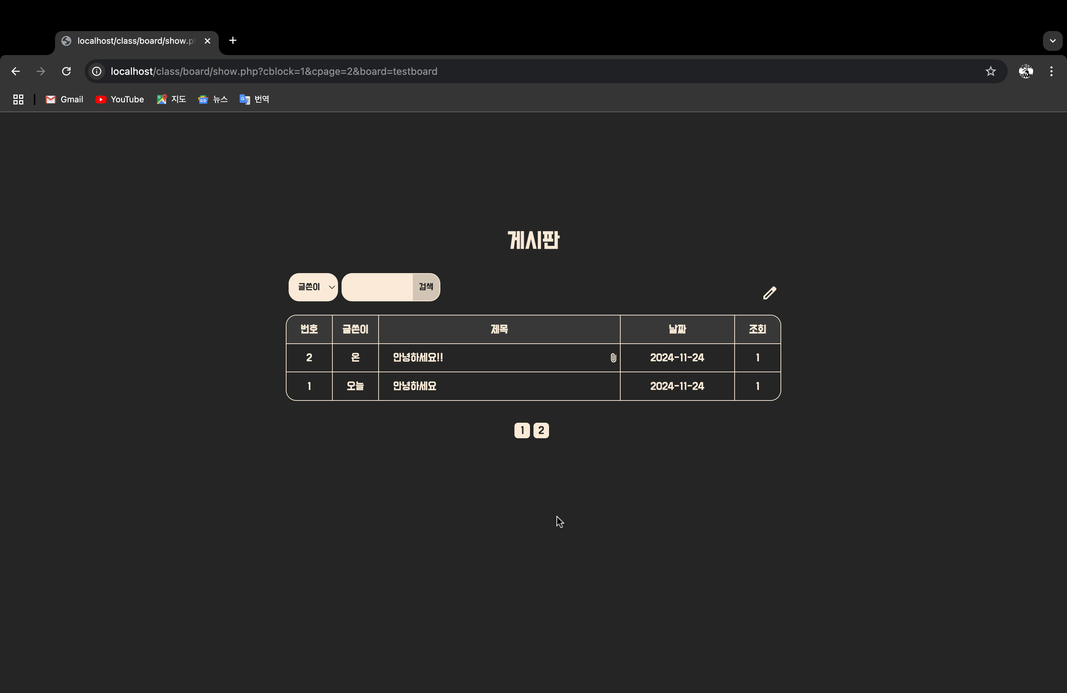

댓글 등록 기능

글 상세페이지 아래로 스크롤

댓글 수, 댓글 출력 왼쪽 끝 버튼 두 개 차례로 댓글 수정, 댓글 삭제

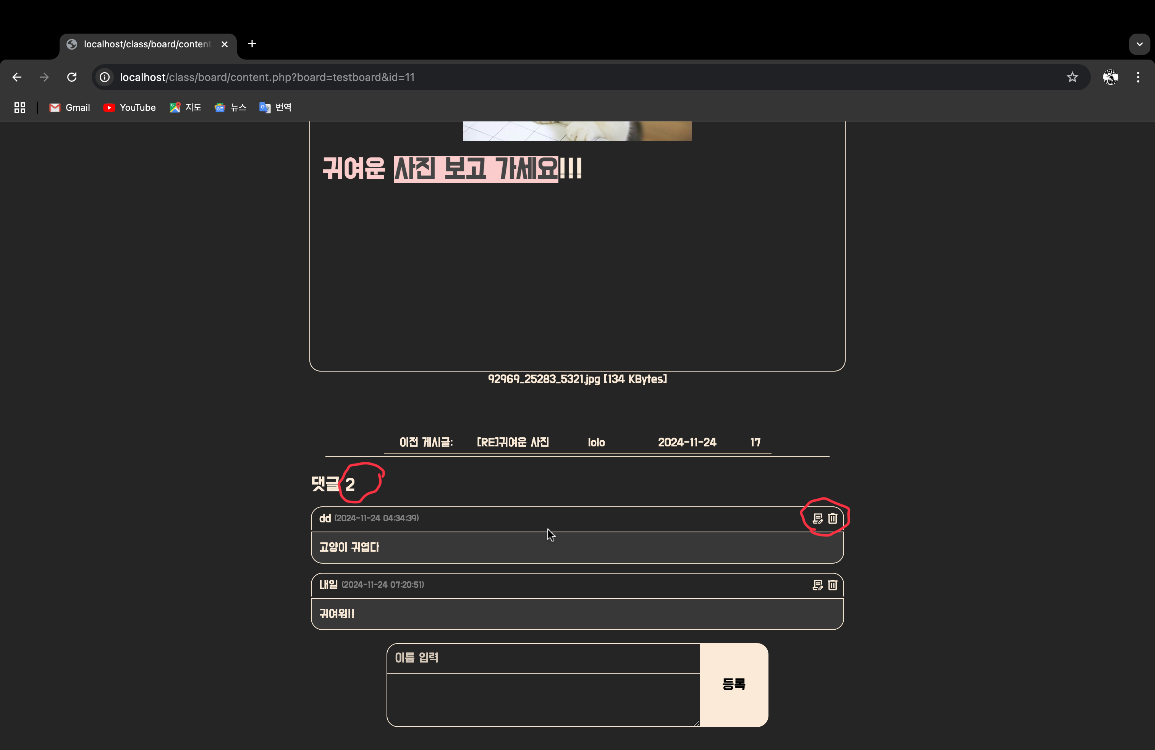

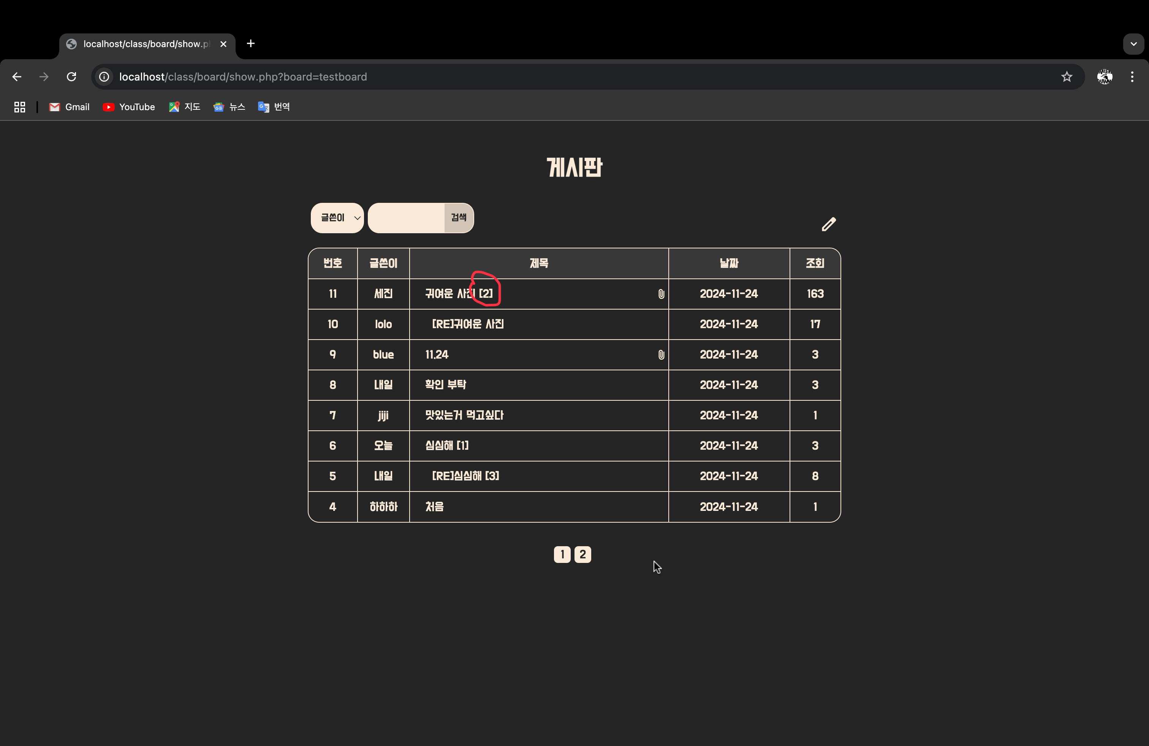

댓글 작성 후 등록 버튼 클릭

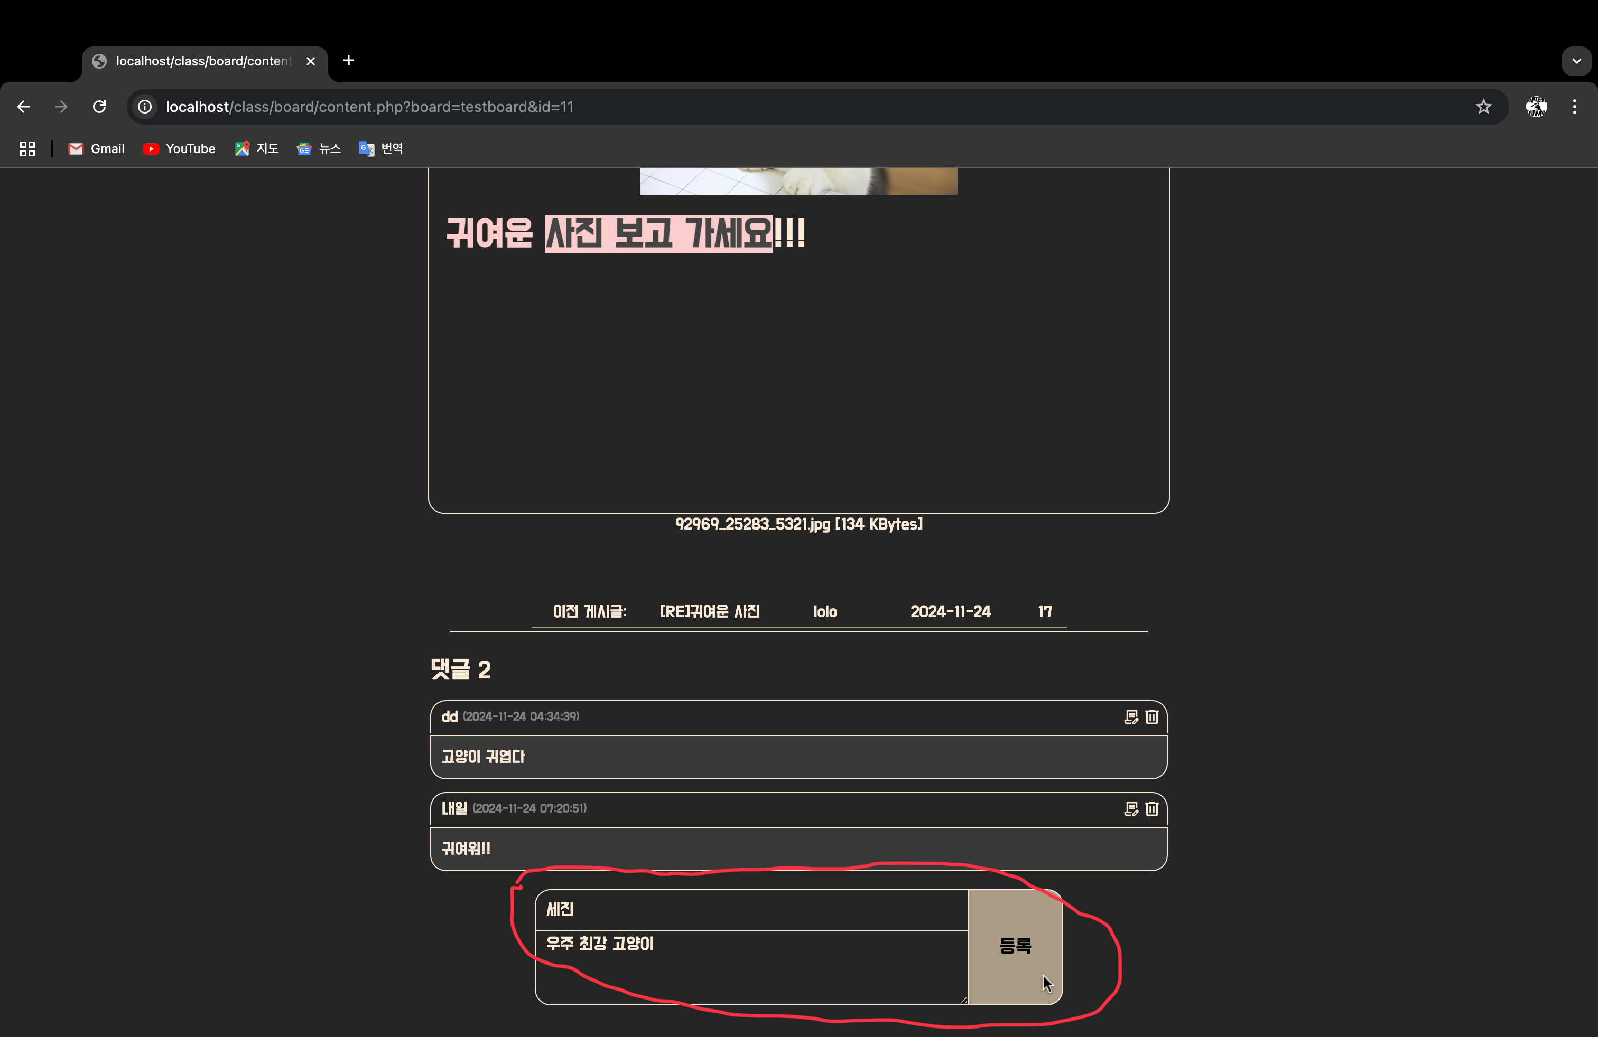

댓글 등록, 댓글 수

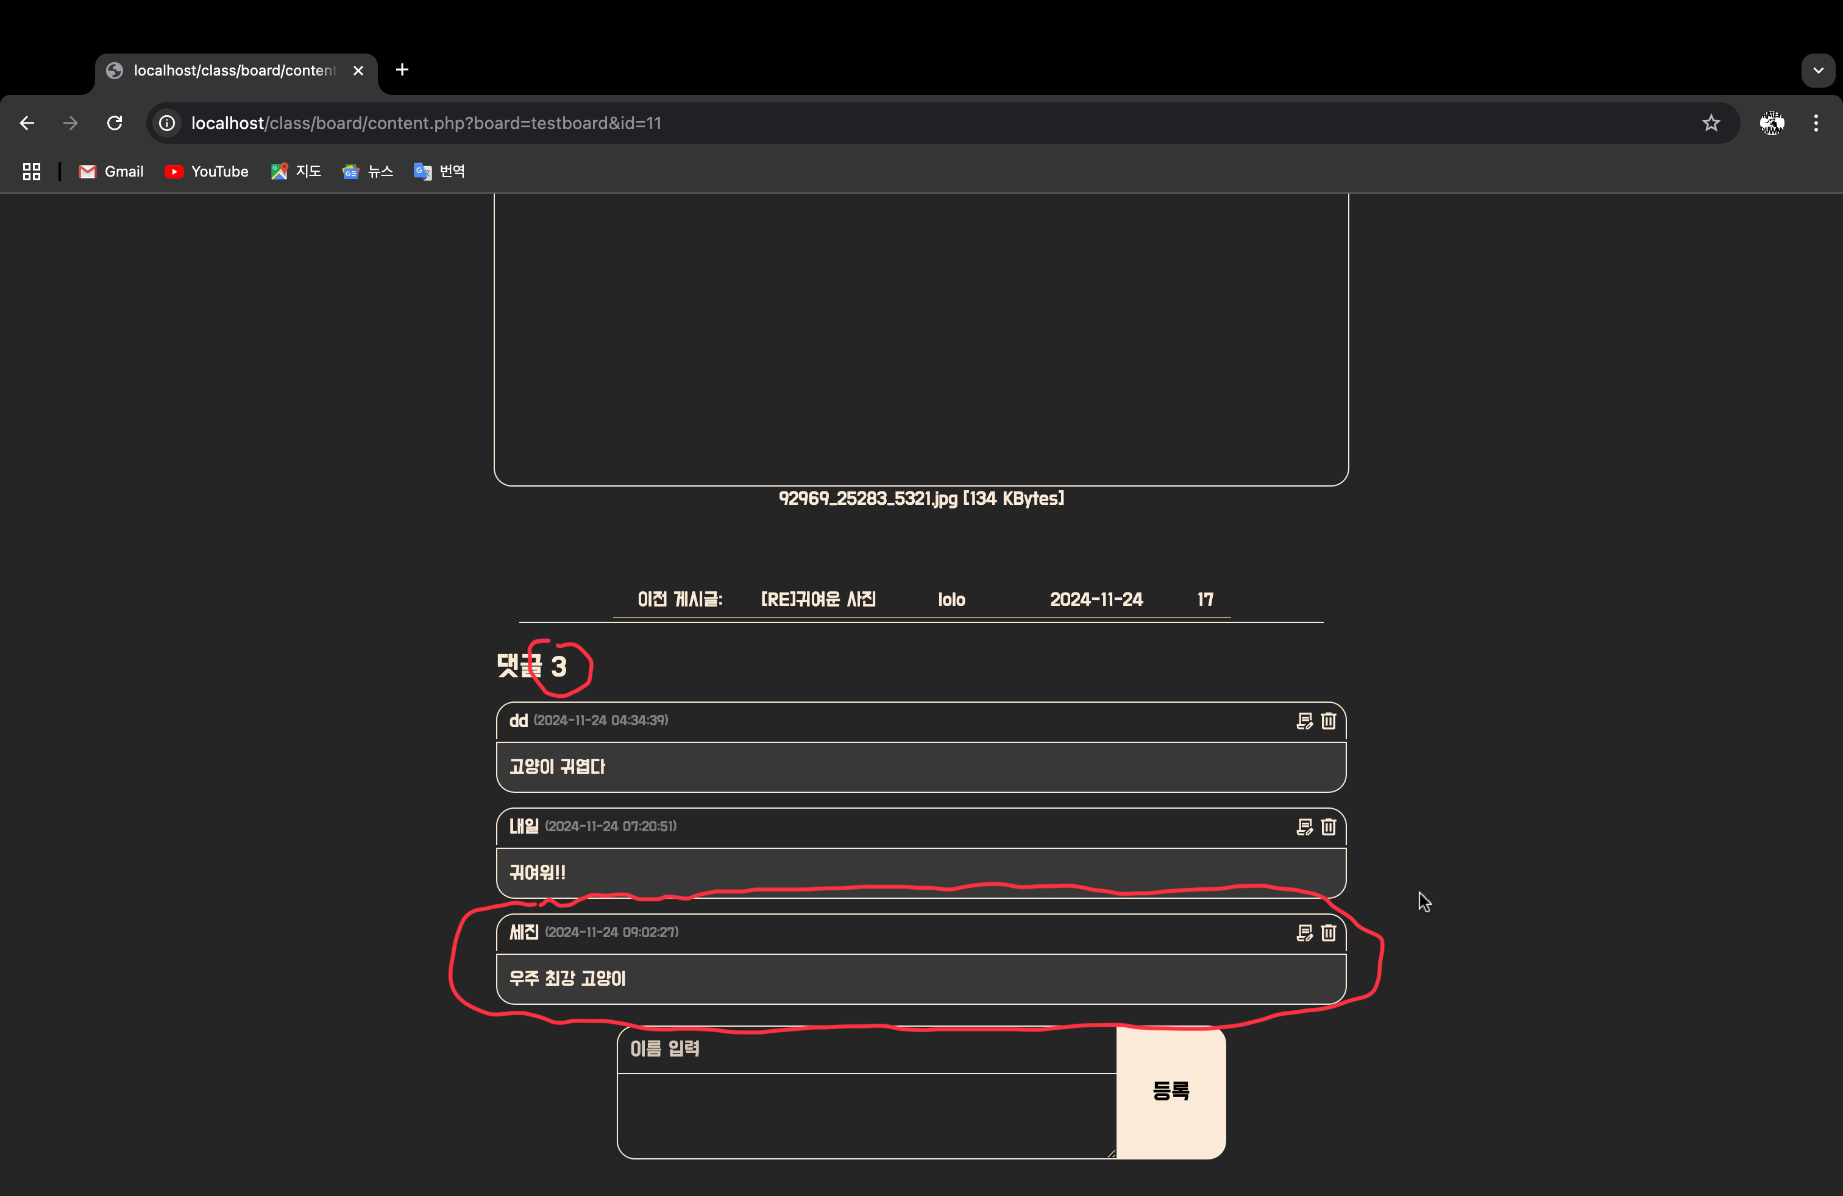

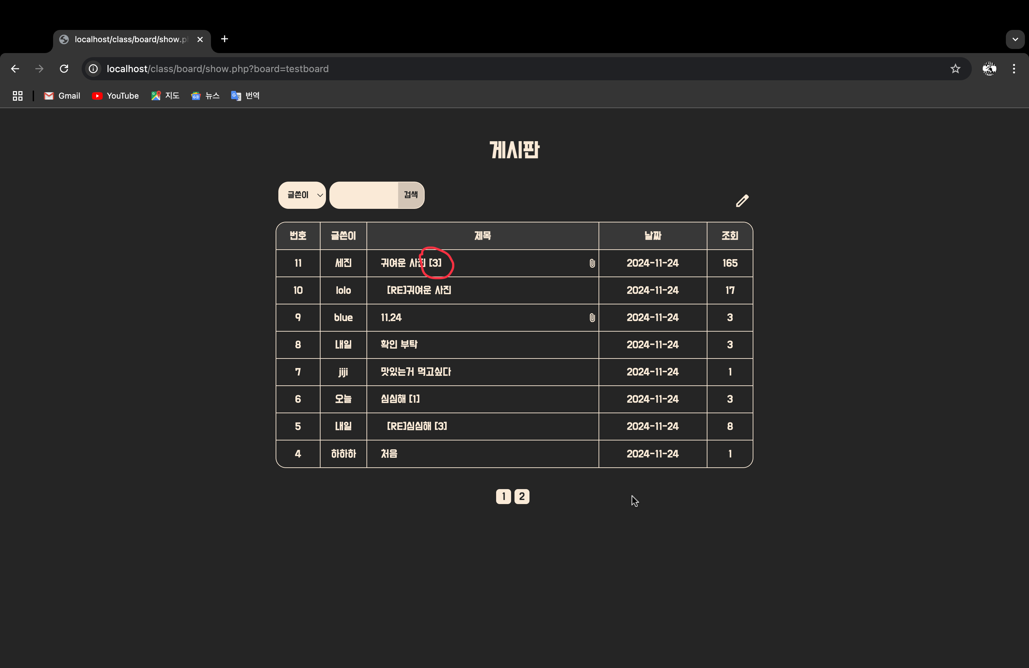

댓글 수정 기능

수정 버튼 클릭

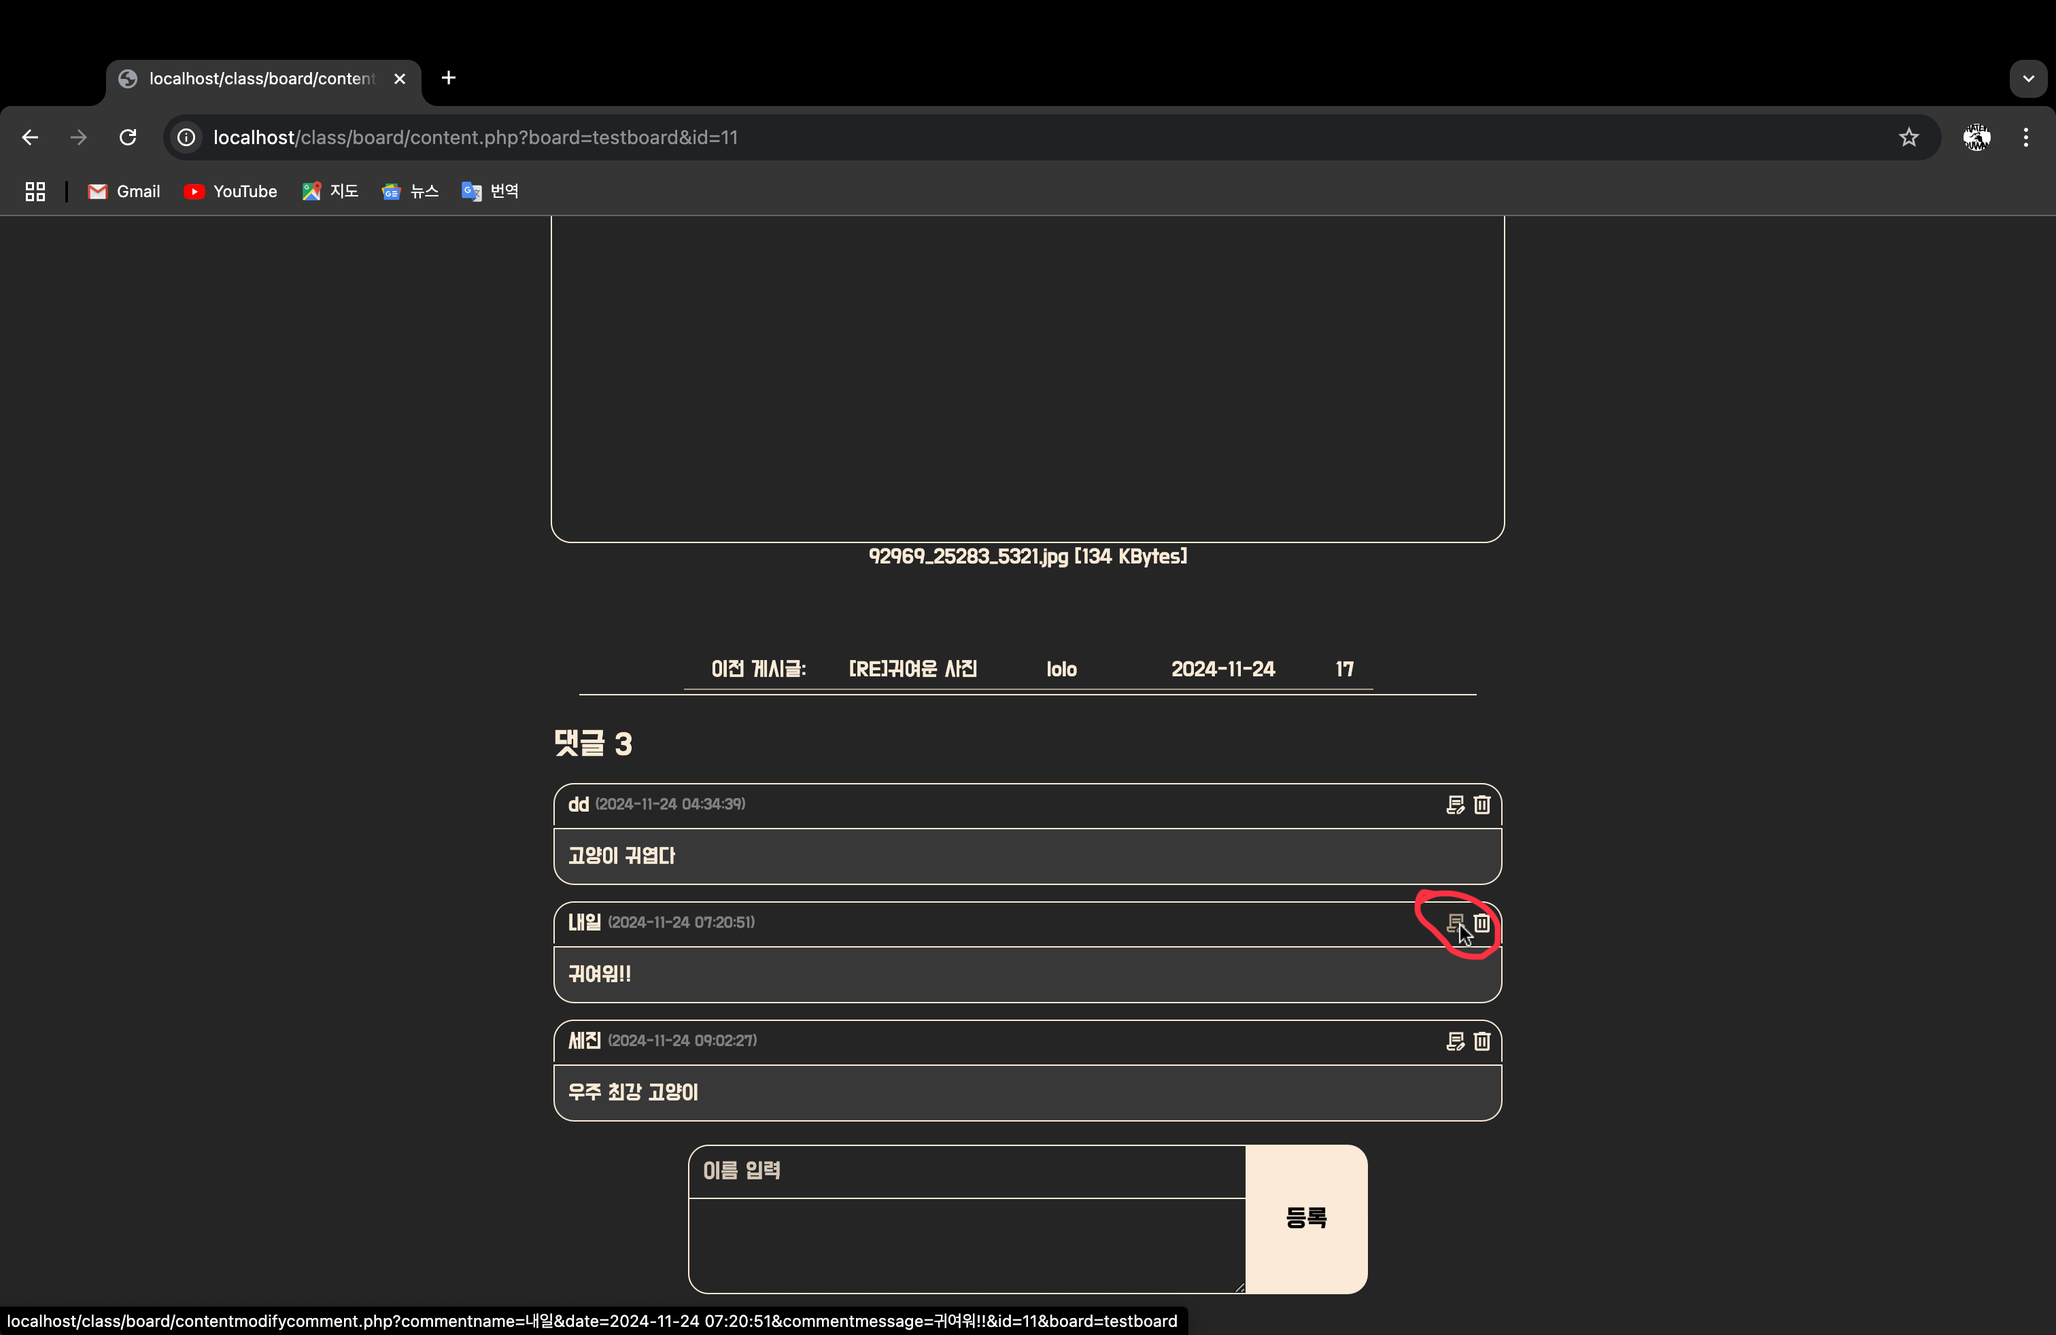

내용 수정, 수정버튼 클릭

댓글 수정 시 수정하고있는 댓글 출력 안됨

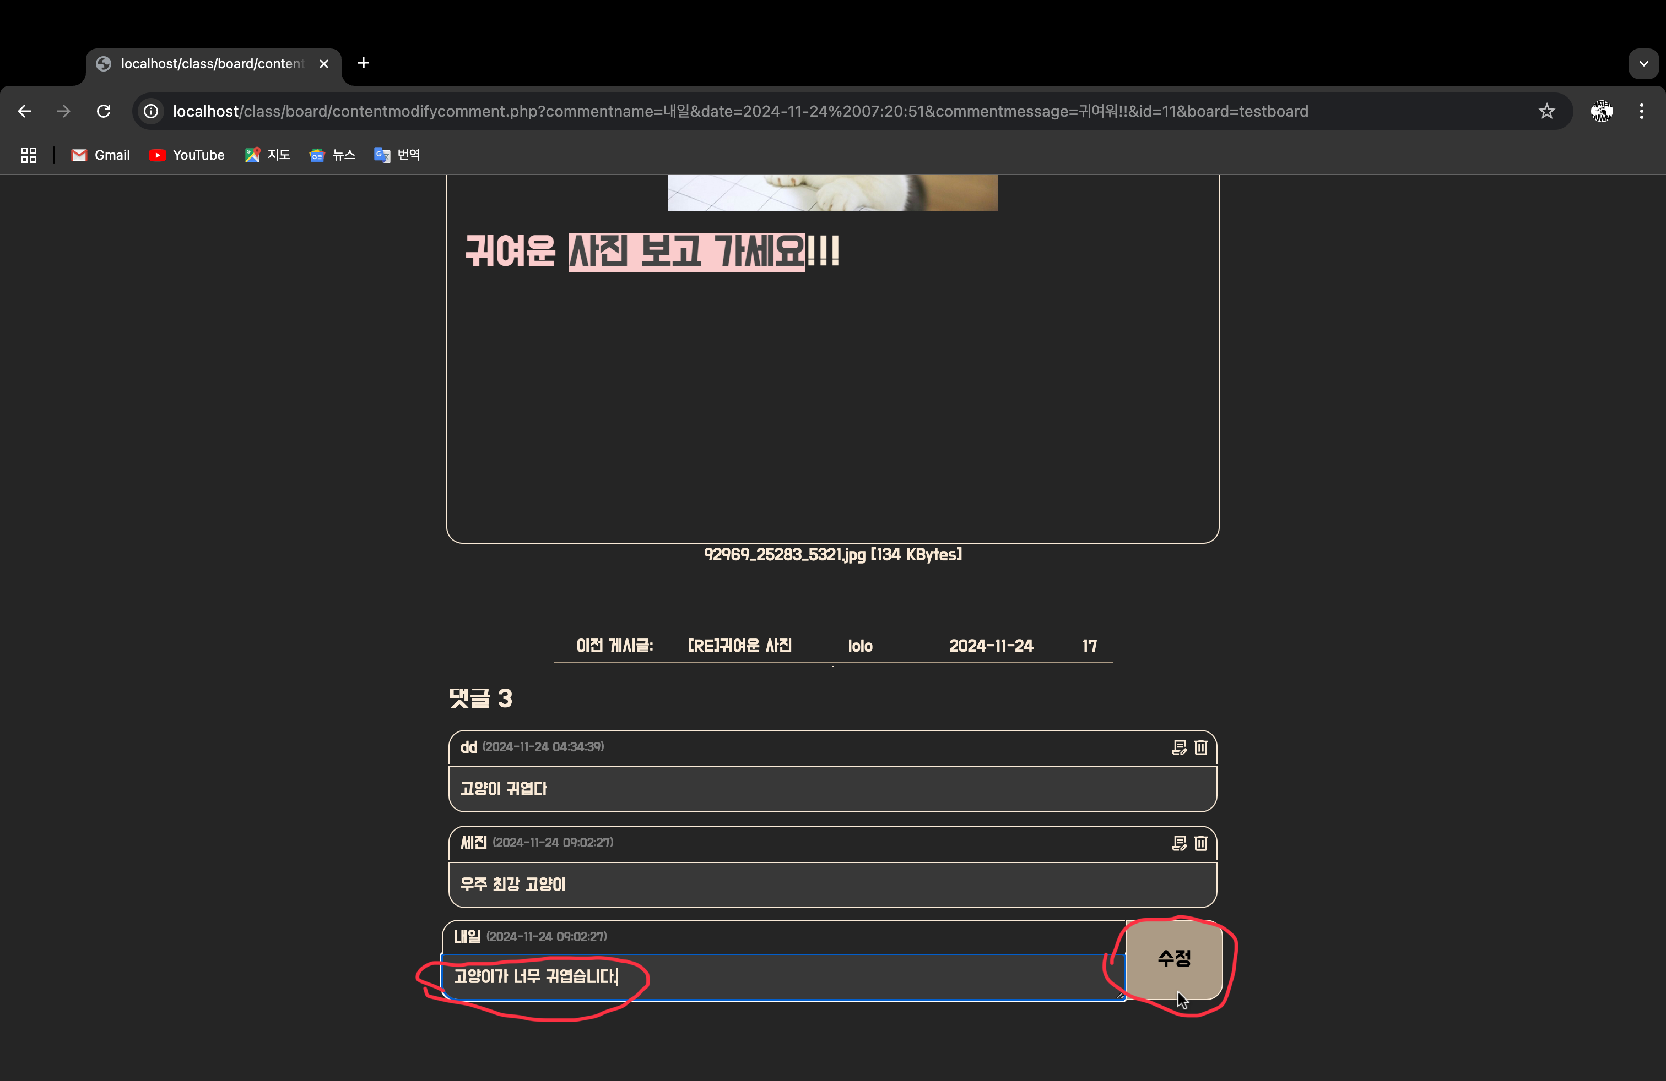

수정 완료

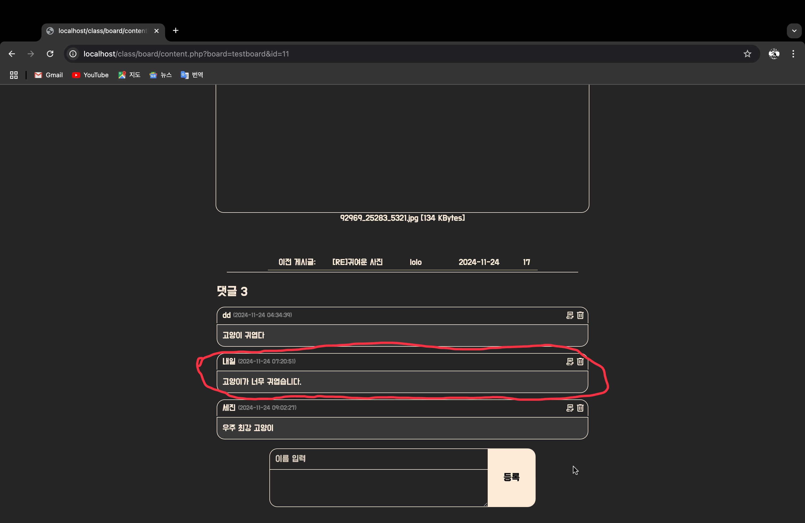

댓글 삭제 기능

삭제 버튼 클릭

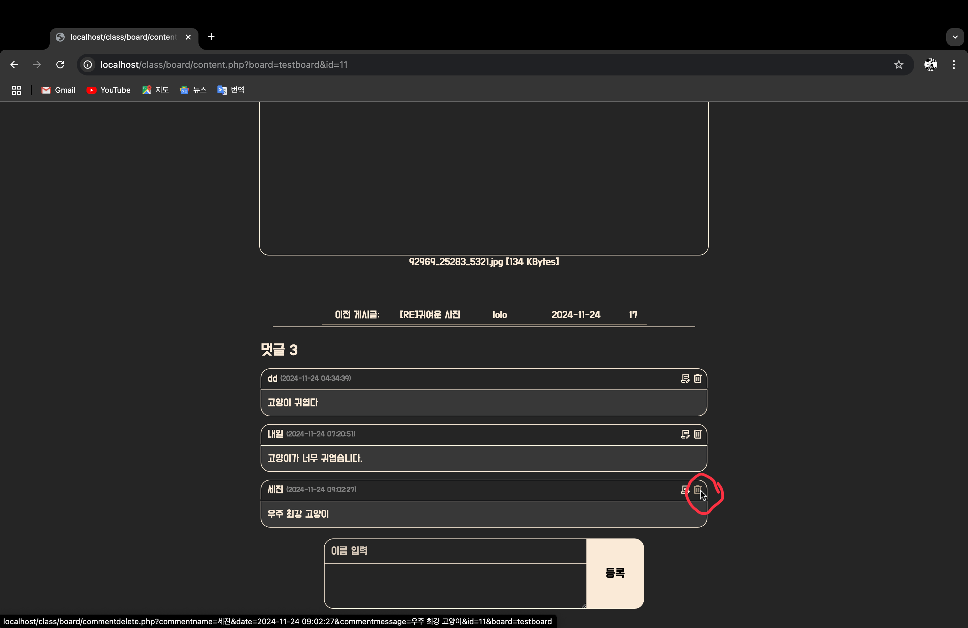

댓글 삭제 완료

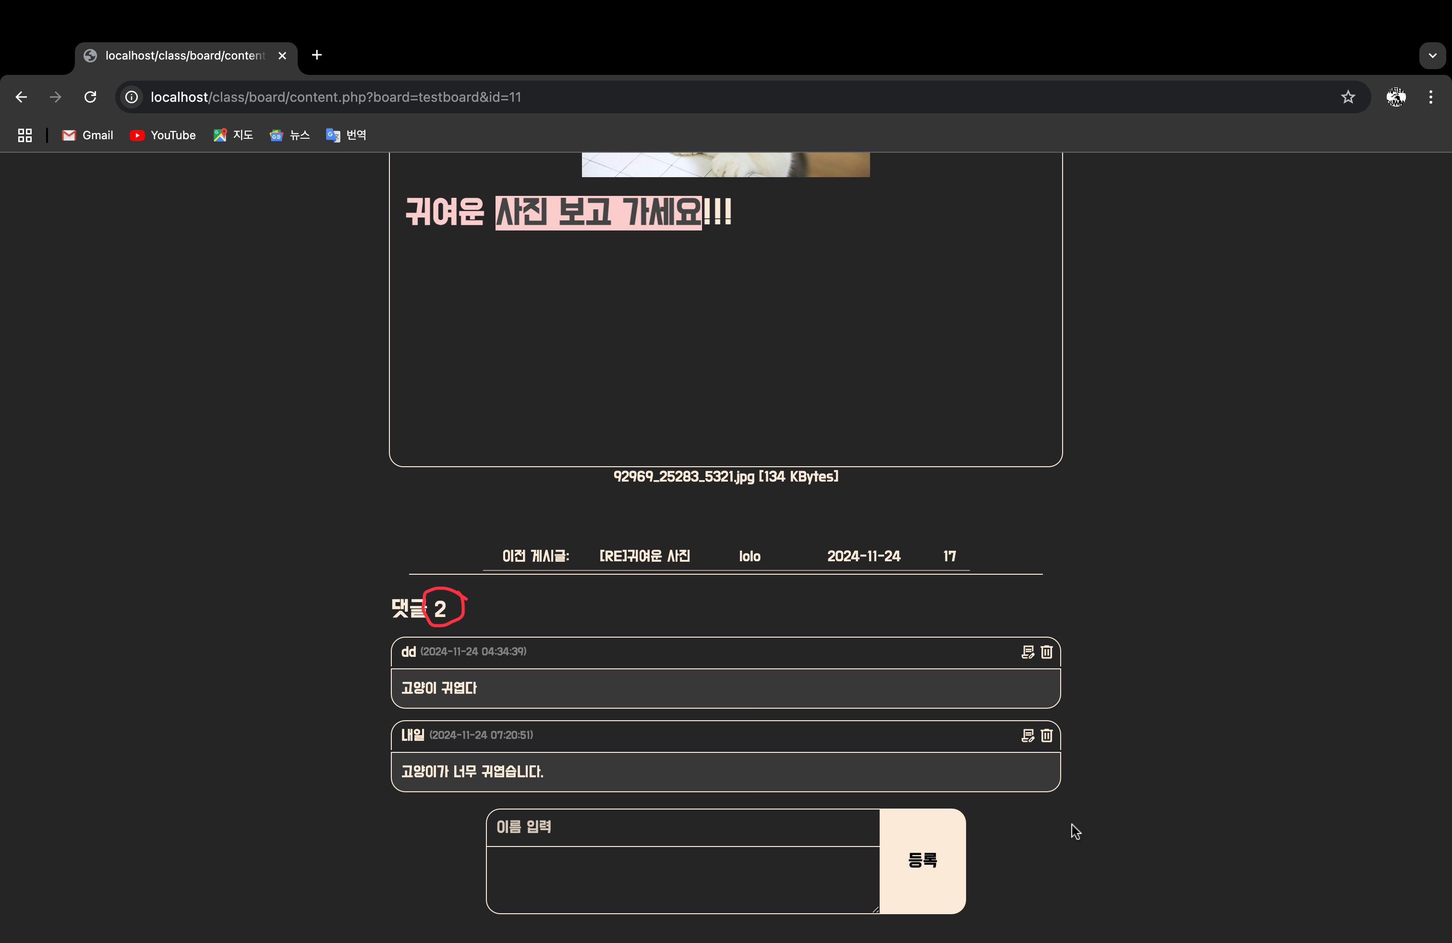

다음페이지, 이전페이지 이동 기능

게시글 제목 클릭시 해당 게시물 상세페이지로 이동

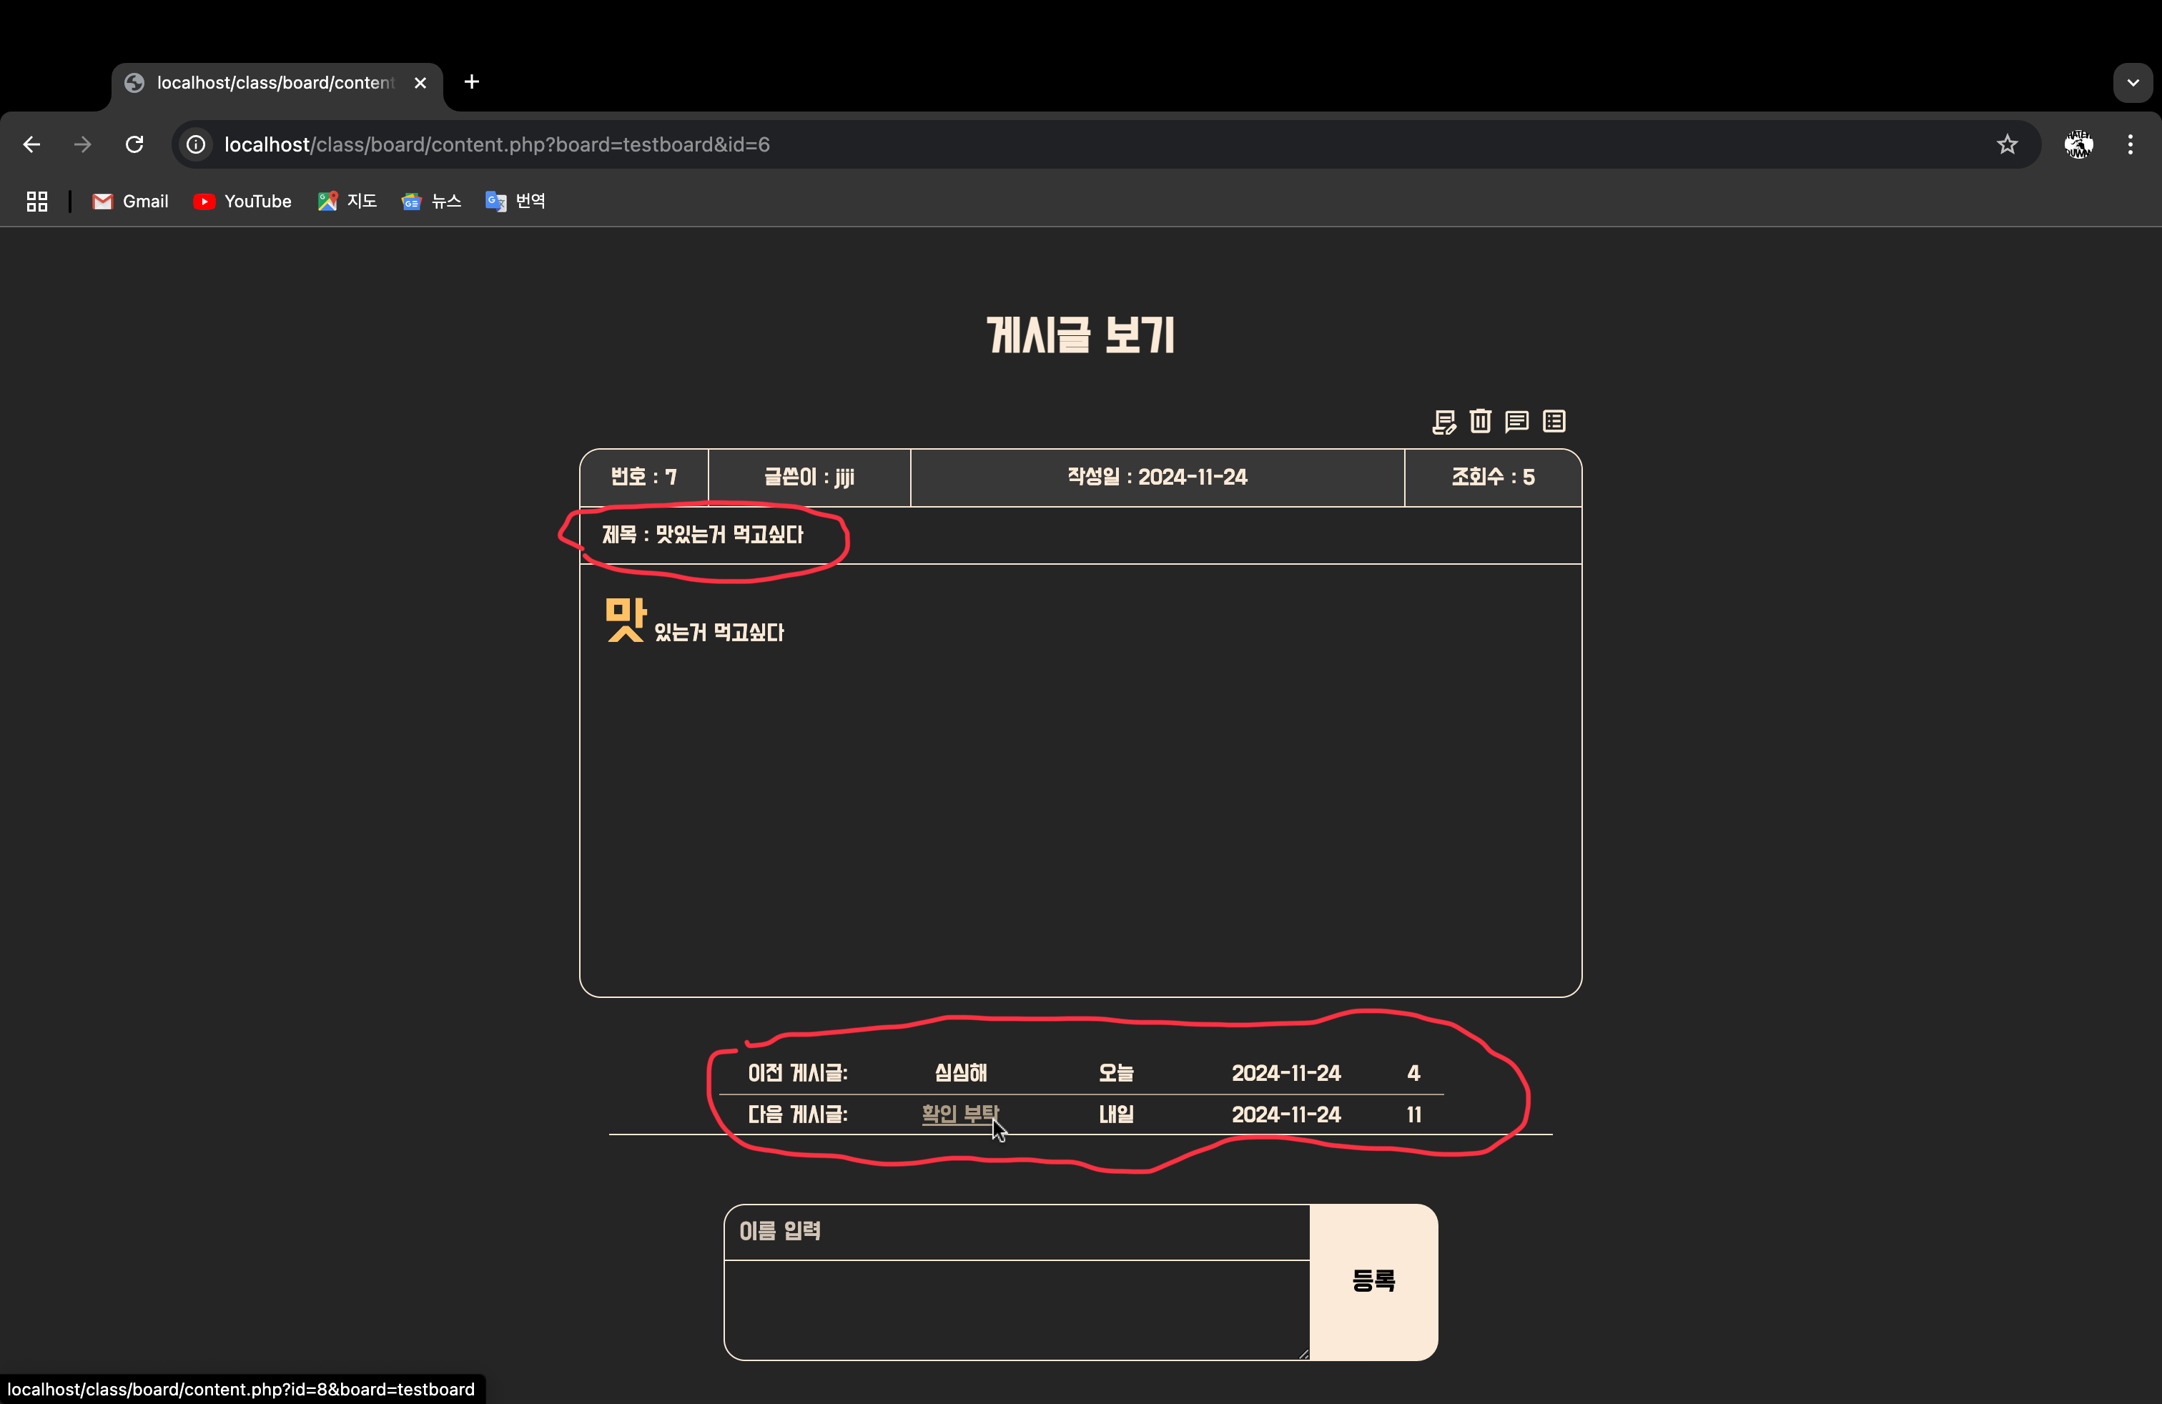

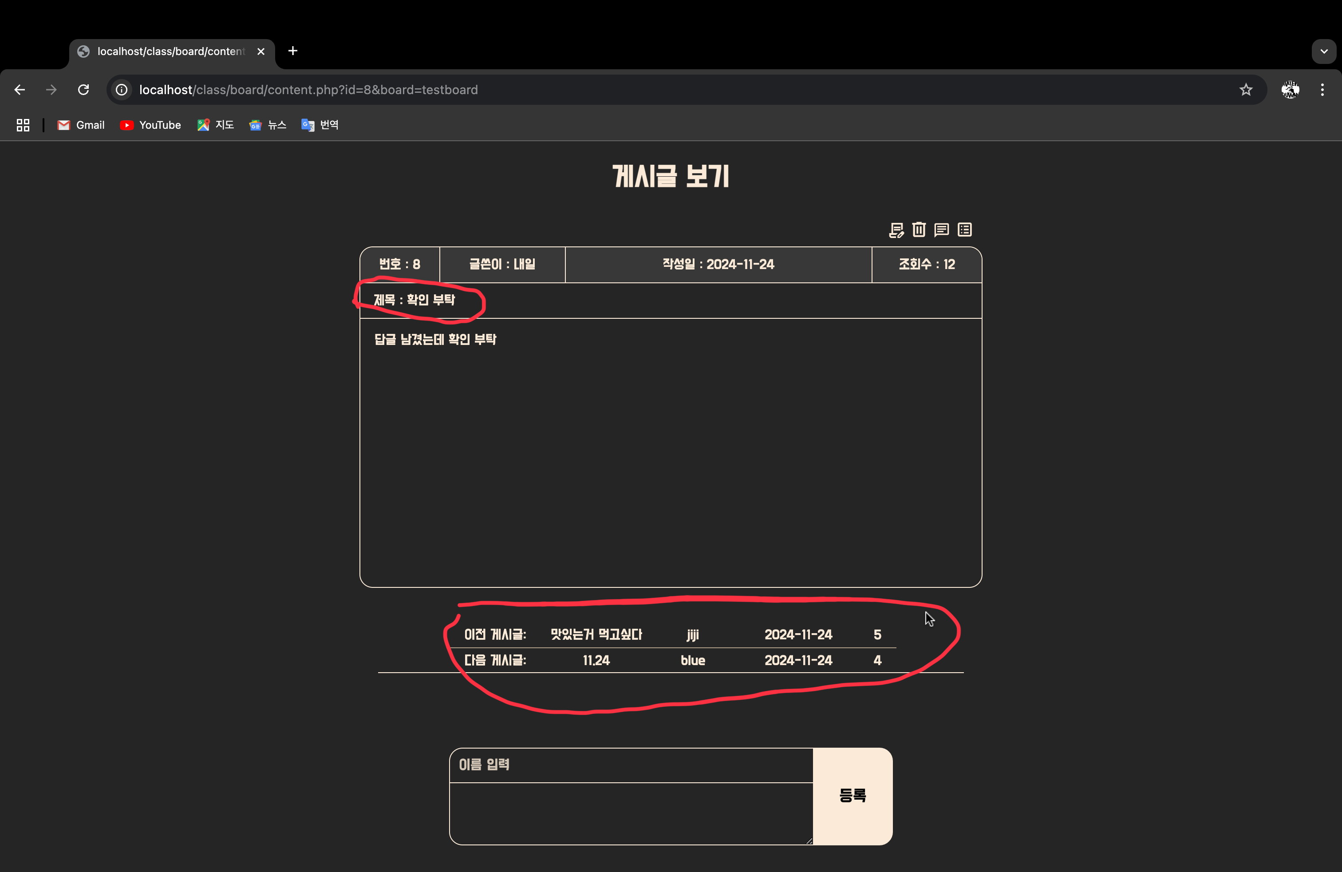

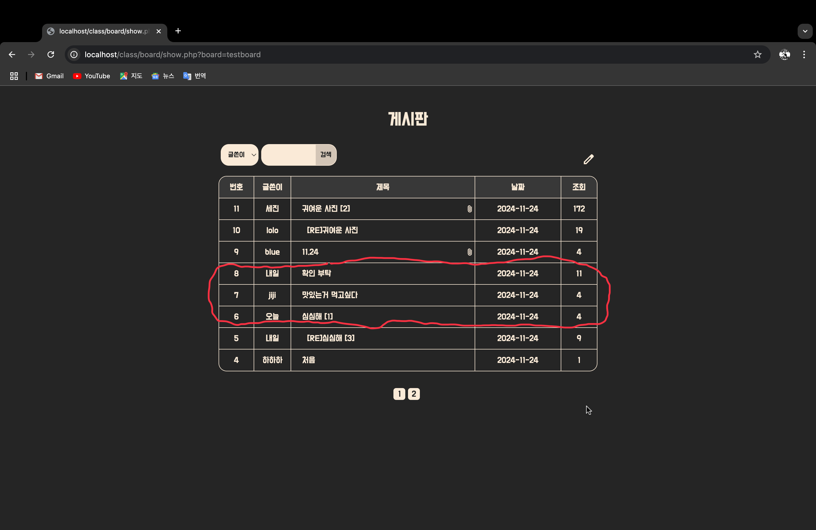

검색 기능

분류 선택, 검색 버튼 클릭

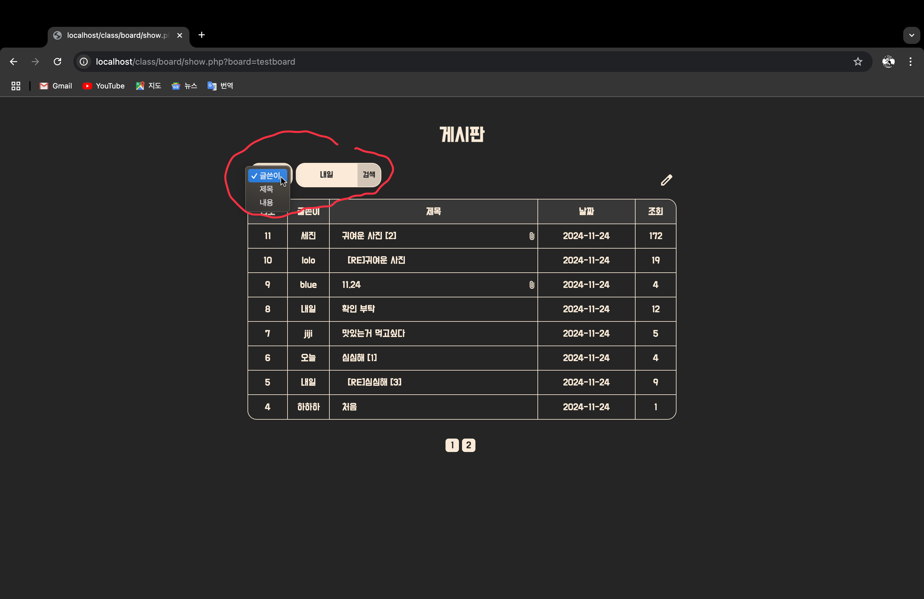

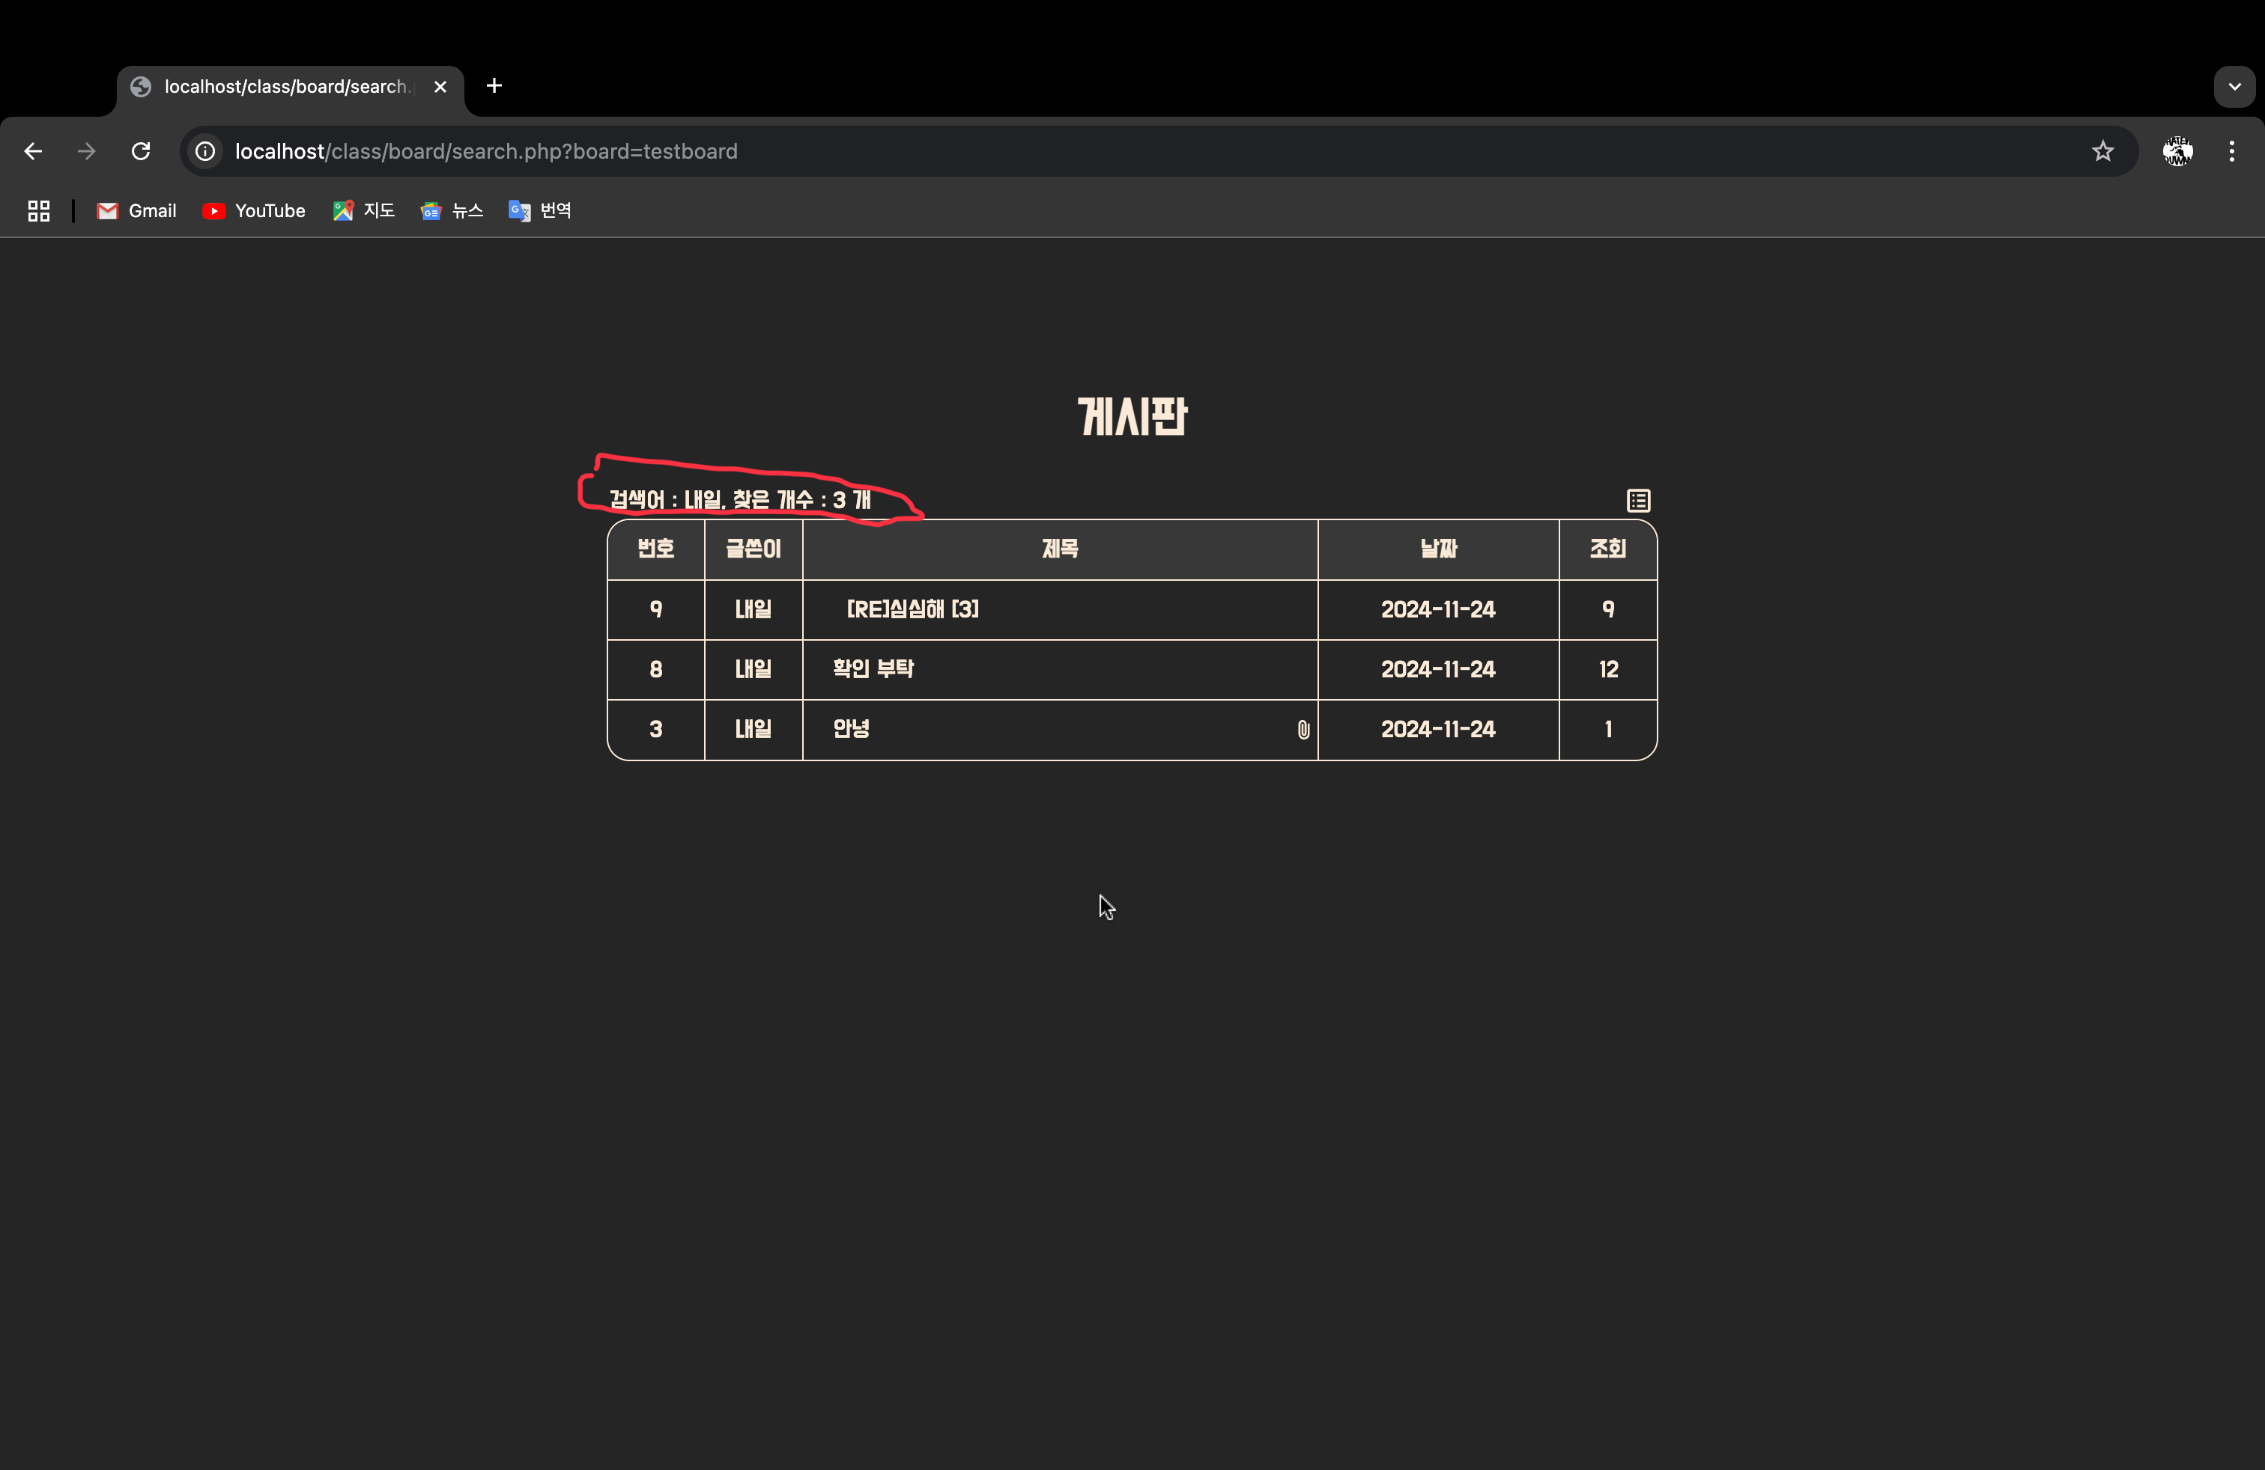

소스코드 파일 종류

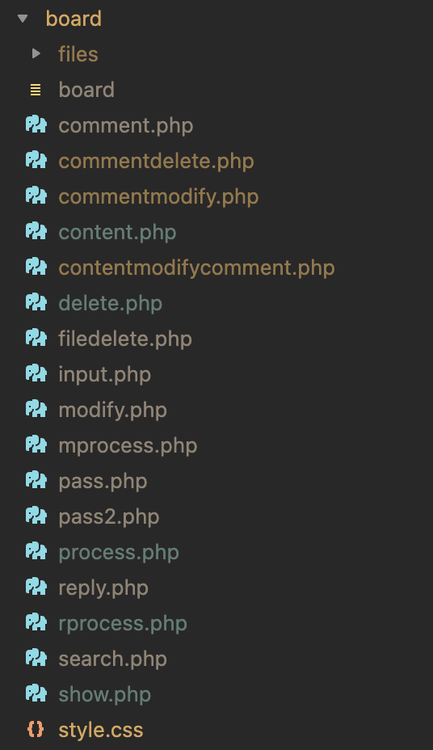

소스코드

<? //comment.php

$con = mysqli_connect("localhost", "root", "0000", "class");

$id = $_GET['id'];

$board = $_GET['board'];

$message = $_POST['commentmessage'];

$name = $_POST['commentwriter'];

$wdate = date("Y-m-d H:i:s");

$insert = "INSERT INTO comment (id, name, wdate, message) VALUES ('$id', '$name', '$wdate', '$message')";

mysqli_query($con, $insert);

echo ("<meta http-equiv='Refresh' content='0; url=content.php?board=$board&id=$id'>");

?>

<? //commentdelete.php

$con = mysqli_connect("localhost", "root", "0000", "class");

$id = $_GET['id'];

$board = $_GET['board'];

$commentname=$_GET['commentname'];

$date=$_GET['date'];

$commentmessage=$_GET['commentmessage'];

$deletecomment=mysqli_query($con,"DELETE FROM comment WHERE message='$commentmessage' AND id='$id' AND name='$commentname' AND wdate='$date'");

mysqli_close($con);

echo ("<meta http-equiv='Refresh' content='0; url=content.php?board=$board&id=$id'>");

?>

<? //commentmodify.php

$con = mysqli_connect("localhost", "root", "0000", "class");

$id = $_GET['id'];

$board = $_GET['board'];

$commentname=$_GET['commentname'];

$date=$_GET['date'];

$commentmessage=$_POST['commentmessage'];

$modifycomment=mysqli_query($con,"UPDATE comment SET message='$commentmessage' WHERE id='$id' AND name='$commentname' AND wdate='$date'");

mysqli_close($con);

echo ("<meta http-equiv='Refresh' content='0; url=content.php?board=$board&id=$id'>");

?>

<? //content.php

$con = mysqli_connect("localhost", "root", "0000", "class");

$id = $_GET['id'];

$board = $_GET['board'];

$result = mysqli_query($con, "SELECT * FROM $board WHERE id = $id");

$fileupload = mysqli_query($con, "SELECT * FROM boardfile WHERE id = $id");

$comment = mysqli_query($con,"SELECT * FROM comment WHERE id = $id" );

$row = mysqli_fetch_assoc($result);

if ($row) {

$sid = $row["id"];

$writer = $row["writer"];

$topic = $row["topic"];

$hit = $row["hit"] + 1;

$content = $row["content"];

$wdate = $row["wdate"];

$num=$row["num"];

$parentid = $row['parentid'];

if(!empty($parentid)) {

$fileupload = mysqli_query($con, "SELECT * FROM boardfile WHERE id = $parentid");

}

$files = [];

while ($filerow = mysqli_fetch_assoc($fileupload)) {

$fileName = htmlspecialchars($filerow['fileName']);

$fileSize = $filerow['fileSize'];

if ($fileSize > 1000) {

$kb_filesize = (int)($fileSize / 1000);

$disp_size = $kb_filesize . ' KBytes';

} else {

$disp_size = $fileSize . ' Bytes';

}

$files[] = ["name" => $fileName, "size" => $disp_size];

}

mysqli_query($con, "UPDATE $board SET hit = $hit WHERE id = $sid");

$comments = [];

while($commentrow = mysqli_fetch_assoc($comment)) {

$name = htmlspecialchars($commentrow['name']);

$message = htmlspecialchars($commentrow['message']);

$wdate = htmlspecialchars($commentrow['wdate']);

$comments[] = ["commentname" => $name, "commentmessage" => $message, "date" => $wdate];

}

// var_dump(htmlspecialchars($content));

echo("

<head>

<link rel='stylesheet' href='style.css'>

<link href='https://cdn.quilljs.com/1.3.6/quill.snow.css' rel='stylesheet'>

</head>");

echo ("

<script src='https://cdn.quilljs.com/1.3.6/quill.min.js'></script>

<style>

@import url('https://fonts.googleapis.com/css2?family=Do+Hyeon&family=Gasoek+One&family=Gowun+Batang&display=swap');

<script>

</script>

</style>

<body>

<div class='container'>

<table border=0 align='center'>

<tr>

<td ><h1>게시글 보기</h1></td>

</tr>

</table>

<div class='icons'>

<table border=0 align='right'>

<tr>

<td align='right'>

<a href='pass.php?board=$board&id=$id&mode=0'>

<svg xmlns='http://www.w3.org/2000/svg' height='20px' viewBox='0 -960 960 960' width='20px' fill='#faebd7'><path class='icon' d='M363.35-600.48v-86.22h354.02v86.22H363.35Zm0 126.22v-86.22h354.02v86.22H363.35Zm115.22 311.39h-275.7 275.7Zm0 91h-235.7q-54.58 0-92.79-38.21-38.21-38.21-38.21-92.79v-130.52h120.48v-554.74h616.02v368.65q-22.87-3.43-46.24.43-23.37 3.85-44.76 15.25v-293.33H323.35v463.74h250.76l-91 91H202.87v39.52q0 17 11.5 28.5t28.5 11.5h235.7v91Zm80 0v-129.7L781-423q9.72-9.76 21.59-14.1 11.88-4.33 23.76-4.33 12.95 0 24.8 4.85Q863-431.72 872.7-422l37 37q8.67 9.72 13.55 21.59 4.88 11.88 4.88 23.76 0 12.19-4.36 24.41T909.7-293.3L688.26-71.87H558.57Zm304.78-267.78-37-37 37 37Zm-240 203h38L781.39-257.7l-18-19-19-18-121.04 120.05v38ZM763.39-276.7l-19-18 37 37-18-19Z'/></svg>

</a>

<a href='pass.php?board=$board&id=$id&mode=1'>

<svg xmlns='http://www.w3.org/2000/svg' height='22px' viewBox='0 -960 960 960' width='22px' fill='#faebd7'><path class='icon' d='M277.37-111.87q-37.78 0-64.39-26.61t-26.61-64.39v-514.5h-45.5v-91H354.5v-45.5h250.52v45.5h214.11v91h-45.5v514.5q0 37.78-26.61 64.39t-64.39 26.61H277.37Zm405.26-605.5H277.37v514.5h405.26v-514.5ZM355.7-280.24h85.5v-360h-85.5v360Zm163.1 0h85.5v-360h-85.5v360ZM277.37-717.37v514.5-514.5Z'/></svg>

</a>

<a href='reply.php?board=$board&id=$id'>

<svg xmlns='http://www.w3.org/2000/svg' height='20px' viewBox='0 -960 960 960' width='20px' fill='#faebd7'><path class='icon' d='M240-384h336v-72H240v72Zm0-132h480v-72H240v72Zm0-132h480v-72H240v72ZM87.87-87.87v-701.26q0-34.48 24.26-58.74 24.26-24.26 58.74-24.26h618.26q34.48 0 58.74 24.26 24.26 24.26 24.26 58.74v474.26q0 34.48-24.26 58.74-24.26 24.26-58.74 24.26H231.87l-144 144Zm114-227h587.26v-474.26H170.87v505.5l31-31.24Zm-31 0v-474.26 474.26Z'/></svg>

</a>

<a href='show.php?board=$board'>

<svg xmlns='http://www.w3.org/2000/svg' height='22px' viewBox='0 -960 960 960' width='22px' fill='#faebd7'><path class='icon' d='M323.79-289.43q15.21 0 25.71-10.29t10.5-25.5q0-15.21-10.29-25.71t-25.5-10.5q-15.21 0-25.71 10.28-10.5 10.29-10.5 25.5 0 15.22 10.29 25.72 10.29 10.5 25.5 10.5Zm0-154.57q15.21 0 25.71-10.29t10.5-25.5q0-15.21-10.29-25.71t-25.5-10.5q-15.21 0-25.71 10.29t-10.5 25.5q0 15.21 10.29 25.71t25.5 10.5Zm0-154.57q15.21 0 25.71-10.28 10.5-10.29 10.5-25.5 0-15.22-10.29-25.72-10.29-10.5-25.5-10.5t-25.71 10.29q-10.5 10.29-10.5 25.5t10.29 25.71q10.29 10.5 25.5 10.5ZM432-289.43h240v-72H432v72ZM432-444h240v-72H432v72Zm0-154.57h240v-72H432v72Zm-213.13 462.7q-34.48 0-58.74-24.26-24.26-24.26-24.26-58.74v-522.26q0-34.48 24.26-58.74 24.26-24.26 58.74-24.26h522.26q34.48 0 58.74 24.26 24.26 24.26 24.26 58.74v522.26q0 34.48-24.26 58.74-24.26 24.26-58.74 24.26H218.87Zm0-83h522.26v-522.26H218.87v522.26Zm0-522.26v522.26-522.26Z'/></svg>

</a>

</td>

</tr>

</table>

</div>

<div class='infobox'>

<table border=0 width=700 style=border-collapse:collapse; align='center'>

<tr>

<td class='element num' width=100>번호 : $num</td>

<td class='element wri' width=250>글쓴이 : <a href='mailto:$writer'>$writer</a></td>

<td class='element dat' width=250>작성일 : $wdate</td>

<td class='element hit' width=100>조회수 : $hit</td>

</tr>

<tr>

<td class='element top' colspan=4>제목 : $topic</td>

</tr>

<tr>

<td colspan=4>");

if(!empty($files)) {

if(!empty($parentid)) {

$delimiter = "<p>----------&lt;원본글&gt;----------</p>";

list($content1, $content2) = explode($delimiter, $content, 2);

echo("

<style>

.element.con{height:150px;}

</style>

<div class='ql-editor element con'>$content1</div>

<div>\n- - - - - - - - - - - - - - - - - - - - <원본글> - - - - - - - - - - - - - - - - - - - -\n\n\n\n</div>

<div class='photobox'><img class='photo' src='./files/$fileName'></div>

<div class='ql-editor element con'> $content2</div>

");

} else {

echo("

<div class='photobox'><img class='photo' src='./files/$fileName'></div>

<div class='ql-editor element con'>$content</div>

");

}

} else {

echo(" <div class='ql-editor element con'>$content</div>");

}

echo("</td>

</tr>

</table>

</div>

");

if (!empty($files)) {

echo ("<tr>

<td colspan=4> ");

foreach ($files as $file) {

echo "<a href='./files/{$file['name']}'>{$file['name']} [{$file['size']}]</a><br>";

}

echo(" </td>

</tr>");

} else {

}

echo ("

<form method='post' action=' comment.php?board=$board&id=$sid'>

<br><br>

");

$beforeQuery = "SELECT * FROM $board WHERE num < $num ORDER BY num DESC LIMIT 1";

$beforeResult = mysqli_query($con, $beforeQuery);

$beforeRow = mysqli_fetch_assoc($beforeResult);

$afterQuery = "SELECT * FROM $board WHERE num > $num ORDER BY num ASC LIMIT 1";

$afterResult = mysqli_query($con, $afterQuery);

$afterRow = mysqli_fetch_assoc($afterResult);

echo("<div class='pagechangebox'>

<table border=0 align=center>

");

if ($beforeRow) {

echo "

<tr>

<td width=110px ><a class='atext h' >이전 게시글: </a></td>

<td width=110px><a class='atext' href='content.php?id={$beforeRow['id']}&board=$board'>{$beforeRow['topic']}</a></td>

<td width=100px><a class='atext h' >{$beforeRow['writer']}</a></td>

<td width=130px><a class='atext h' >{$beforeRow['wdate']}</a></td>

<td width=40px><a class='atext h' >{$beforeRow['hit']}</a></td>

</tr>

<tr><td colspan=5><div class='line2'></div></td></tr>";

}

// 다음 게시글 출력

if ($afterRow) {

echo "

<tr>

<td width=110px ><a class='atext h' >다음 게시글: </a></td>

<td width=110px><a class='atext' href='content.php?id={$afterRow['id']}&board=$board'>{$afterRow['topic']}</a></td>

<td width=100px><a class='atext h' >{$afterRow['writer']}</a></td>

<td width=130px><a class='atext h' >{$afterRow['wdate']}</a></td>

<td width=40px><a class='atext h' >{$afterRow['hit']}</a></td>

</tr>";

}

echo("</table></div>");

echo("

<div class='line'></div>");

echo "<div class='box' style='min-height: 200px; max-height: 400px; overflow-y: auto;'>";

echo "<table border=0 width=700 align='center' border=1 style='border-collapse:collapse;'>";

if (!empty($comments)) {

$commentcount = mysqli_query($con, "SELECT COUNT(*) AS count FROM comment WHERE id = $id");

$rows = mysqli_fetch_assoc($commentcount);

$idcommentcount = $rows['count'];

echo("<tr>

<td colspan=2 border=0 ><a style='font-size:25px;'>댓글</a><a style='font-size:24px;'> $idcommentcount</a></td>

</tr>");

foreach ($comments as $pcomment) {

echo ("

<tr>

<td style='vertical-align: bottom;' colspan=2>

<div class='commentname'>

{$pcomment['commentname']}&nbsp;

<a style='font-size:12px; color:gray; a:hover {color:gray}'>({$pcomment['date']})</a>

<a href='contentmodifycomment.php?commentname={$pcomment['commentname']}&date={$pcomment['date']}&commentmessage={$pcomment['commentmessage']}&id=$id&board=$board' style='margin:0 6px 0 0; position:absolute; right:20px;'>

<svg xmlns='http://www.w3.org/2000/svg' height='16px' viewBox='0 -960 960 960' width='16px' fill='#faebd7'><path class='icon' d='M363.35-600.48v-86.22h354.02v86.22H363.35Zm0 126.22v-86.22h354.02v86.22H363.35Zm115.22 311.39h-275.7 275.7Zm0 91h-235.7q-54.58 0-92.79-38.21-38.21-38.21-38.21-92.79v-130.52h120.48v-554.74h616.02v368.65q-22.87-3.43-46.24.43-23.37 3.85-44.76 15.25v-293.33H323.35v463.74h250.76l-91 91H202.87v39.52q0 17 11.5 28.5t28.5 11.5h235.7v91Zm80 0v-129.7L781-423q9.72-9.76 21.59-14.1 11.88-4.33 23.76-4.33 12.95 0 24.8 4.85Q863-431.72 872.7-422l37 37q8.67 9.72 13.55 21.59 4.88 11.88 4.88 23.76 0 12.19-4.36 24.41T909.7-293.3L688.26-71.87H558.57Zm304.78-267.78-37-37 37 37Zm-240 203h38L781.39-257.7l-18-19-19-18-121.04 120.05v38ZM763.39-276.7l-19-18 37 37-18-19Z'/></svg>

</a>

<a href='commentdelete.php?commentname={$pcomment['commentname']}&date={$pcomment['date']}&commentmessage={$pcomment['commentmessage']}&id=$id&board=$board' style='position:absolute; right:5px;'>

<svg xmlns='http://www.w3.org/2000/svg' height='18px' viewBox='0 -960 960 960' width='18px' fill='#faebd7'><path class='icon' d='M277.37-111.87q-37.78 0-64.39-26.61t-26.61-64.39v-514.5h-45.5v-91H354.5v-45.5h250.52v45.5h214.11v91h-45.5v514.5q0 37.78-26.61 64.39t-64.39 26.61H277.37Zm405.26-605.5H277.37v514.5h405.26v-514.5ZM355.7-280.24h85.5v-360h-85.5v360Zm163.1 0h85.5v-360h-85.5v360ZM277.37-717.37v514.5-514.5Z'/></svg>

</a>

</div>

</td>

</tr>

<tr><td style=' vertical-align: top;' colspan=2><div class='commenttext'>{$pcomment['commentmessage']}</div></td></tr>");

}

} else {

echo "<tr><td colspan=2 style='text-align: center;'>댓글이 없습니다.</td></tr>";

}

echo "</table></div><br><br>";

echo ("

<div class='commentbox'>

<table border='0' width='500' align='center' style='border-collapse: collapse;'>

<tr>

<td style='padding: 0; width: 410px;'>

<table border='0' style='border-spacing: 0; margin: 0; border-collapse: collapse; width: 100%;'>

<tr>

<td style='padding: 0;'><input class='commentinput' type='text' name='commentwriter' placeholder='이름 입력' style='width: 100%; box-sizing: border-box;'></td>

</tr>

<tr>

<td style='padding: 0;'><textarea class='commentinput co' name='commentmessage' rows='4' style='width: 100%; box-sizing: border-box;'></textarea></td>

</tr>

</table>

</td>

<td style='padding: 0; vertical-align: top; width: 90px; height:110px'>

<table border='0' style='border-spacing: 0; margin: 0; border-collapse: collapse; height: 100%; width: 100%;'>

<tr>

<td style='padding: 0;'><input class='commentbutton' type='submit' value='등록' style='width: 100%; height: 100%; box-sizing: border-box;'></td>

</tr>

</table>

</td>

</tr>

</table>

</div>

</form>

");

echo("</div>

</body>");

} else {

echo "<p>해당 게시글이 존재하지 않습니다.</p>";

}

echo("</div>

<style type='text/css'>

a {text-decoration: none; color: antiquewhite;}

a:hover {text-decoration: underline;

color: rgb(172, 155, 134);

}

</style>");

mysqli_close($con);

?>

<? *//contentmodifycomment.php*

$con = mysqli_connect("localhost", "root", "0000", "class");

$id = $_GET['id']; *// 기본값은 0*

$board = $_GET['board'];

$result = mysqli_query($con, "SELECT * FROM $board WHERE id = $id");

$fileupload = mysqli_query($con, "SELECT * FROM boardfile WHERE id = $id");

$comment = mysqli_query($con,"SELECT * FROM comment WHERE id = $id" );

$row = mysqli_fetch_assoc($result);

if ($row) {

$sid = $row["id"];

$writer = $row["writer"];

$topic = $row["topic"];

$hit = $row["hit"] + 1;

$content = $row["content"];

$wdate = $row["wdate"];

$num=$row["num"];

$parentid = $row['parentid'];

if(!empty($parentid)) {

$fileupload = mysqli_query($con, "SELECT * FROM boardfile WHERE id = $parentid");

}

$files = [];

while ($filerow = mysqli_fetch_assoc($fileupload)) {

$fileName = htmlspecialchars($filerow['fileName']);

$fileSize = $filerow['fileSize'];

if ($fileSize > 1000) {

$kb_filesize = (int)($fileSize / 1000);

$disp_size = $kb_filesize . ' KBytes';

} else {

$disp_size = $fileSize . ' Bytes';

}

$files[] = ["name" => $fileName, "size" => $disp_size];

}

mysqli_query($con, "UPDATE $board SET hit = $hit WHERE id = $sid");

$comments = [];

while($commentrow = mysqli_fetch_assoc($comment)) {

$name = htmlspecialchars($commentrow['name']);

$message = htmlspecialchars($commentrow['message']);

$wdate = htmlspecialchars($commentrow['wdate']);

$comments[] = ["commentname" => $name, "commentmessage" => $message, "date" => $wdate];

}

*// var_dump(htmlspecialchars($content));*

echo("

<head>

<link rel='stylesheet' href='style.css'>

<link href='https://cdn.quilljs.com/1.3.6/quill.snow.css' rel='stylesheet'>

</head>");

echo ("

<script src='https://cdn.quilljs.com/1.3.6/quill.min.js'></script>

<style>

@import url('https://fonts.googleapis.com/css2?family=Do+Hyeon&family=Gasoek+One&family=Gowun+Batang&display=swap');

<script>

</script>

</style>

<body>

<div class='container'>

<table border=0 align='center'>

<tr>

<td ><h1>게시글 보기</h1></td>

</tr>

</table>

<div class='icons'>

<table border=0 align='right'>

<tr>

<td align='right'>

<a href='pass.php?board=$board&id=$id&mode=0'>

<svg xmlns='http://www.w3.org/2000/svg' height='20px' viewBox='0 -960 960 960' width='20px' fill='#faebd7'><path class='icon' d='M363.35-600.48v-86.22h354.02v86.22H363.35Zm0 126.22v-86.22h354.02v86.22H363.35Zm115.22 311.39h-275.7 275.7Zm0 91h-235.7q-54.58 0-92.79-38.21-38.21-38.21-38.21-92.79v-130.52h120.48v-554.74h616.02v368.65q-22.87-3.43-46.24.43-23.37 3.85-44.76 15.25v-293.33H323.35v463.74h250.76l-91 91H202.87v39.52q0 17 11.5 28.5t28.5 11.5h235.7v91Zm80 0v-129.7L781-423q9.72-9.76 21.59-14.1 11.88-4.33 23.76-4.33 12.95 0 24.8 4.85Q863-431.72 872.7-422l37 37q8.67 9.72 13.55 21.59 4.88 11.88 4.88 23.76 0 12.19-4.36 24.41T909.7-293.3L688.26-71.87H558.57Zm304.78-267.78-37-37 37 37Zm-240 203h38L781.39-257.7l-18-19-19-18-121.04 120.05v38ZM763.39-276.7l-19-18 37 37-18-19Z'/></svg>

</a>

<a href='pass.php?board=$board&id=$id&mode=1'>

<svg xmlns='http://www.w3.org/2000/svg' height='22px' viewBox='0 -960 960 960' width='22px' fill='#faebd7'><path class='icon' d='M277.37-111.87q-37.78 0-64.39-26.61t-26.61-64.39v-514.5h-45.5v-91H354.5v-45.5h250.52v45.5h214.11v91h-45.5v514.5q0 37.78-26.61 64.39t-64.39 26.61H277.37Zm405.26-605.5H277.37v514.5h405.26v-514.5ZM355.7-280.24h85.5v-360h-85.5v360Zm163.1 0h85.5v-360h-85.5v360ZM277.37-717.37v514.5-514.5Z'/></svg>

</a>

<a href='reply.php?board=$board&id=$id'>

<svg xmlns='http://www.w3.org/2000/svg' height='20px' viewBox='0 -960 960 960' width='20px' fill='#faebd7'><path class='icon' d='M240-384h336v-72H240v72Zm0-132h480v-72H240v72Zm0-132h480v-72H240v72ZM87.87-87.87v-701.26q0-34.48 24.26-58.74 24.26-24.26 58.74-24.26h618.26q34.48 0 58.74 24.26 24.26 24.26 24.26 58.74v474.26q0 34.48-24.26 58.74-24.26 24.26-58.74 24.26H231.87l-144 144Zm114-227h587.26v-474.26H170.87v505.5l31-31.24Zm-31 0v-474.26 474.26Z'/></svg>

</a>

<a href='show.php?board=$board'>

<svg xmlns='http://www.w3.org/2000/svg' height='22px' viewBox='0 -960 960 960' width='22px' fill='#faebd7'><path class='icon' d='M323.79-289.43q15.21 0 25.71-10.29t10.5-25.5q0-15.21-10.29-25.71t-25.5-10.5q-15.21 0-25.71 10.28-10.5 10.29-10.5 25.5 0 15.22 10.29 25.72 10.29 10.5 25.5 10.5Zm0-154.57q15.21 0 25.71-10.29t10.5-25.5q0-15.21-10.29-25.71t-25.5-10.5q-15.21 0-25.71 10.29t-10.5 25.5q0 15.21 10.29 25.71t25.5 10.5Zm0-154.57q15.21 0 25.71-10.28 10.5-10.29 10.5-25.5 0-15.22-10.29-25.72-10.29-10.5-25.5-10.5t-25.71 10.29q-10.5 10.29-10.5 25.5t10.29 25.71q10.29 10.5 25.5 10.5ZM432-289.43h240v-72H432v72ZM432-444h240v-72H432v72Zm0-154.57h240v-72H432v72Zm-213.13 462.7q-34.48 0-58.74-24.26-24.26-24.26-24.26-58.74v-522.26q0-34.48 24.26-58.74 24.26-24.26 58.74-24.26h522.26q34.48 0 58.74 24.26 24.26 24.26 24.26 58.74v522.26q0 34.48-24.26 58.74-24.26 24.26-58.74 24.26H218.87Zm0-83h522.26v-522.26H218.87v522.26Zm0-522.26v522.26-522.26Z'/></svg>

</a>

</td>

</tr>

</table>

</div>

<div class='infobox'>

<table border=0 width=700 style=border-collapse:collapse; align='center'>

<tr>

<td class='element num' width=100>번호 : $num</td>

<td class='element wri' width=250>글쓴이 : <a href='mailto:$writer'>$writer</a></td>

<td class='element dat' width=250>작성일 : $wdate</td>

<td class='element hit' width=100>조회수 : $hit</td>

</tr>

<tr>

<td class='element top' colspan=4>제목 : $topic</td>

</tr>

<tr>

<td colspan=4>");

if(!empty($parentid)) {

$delimiter = "<p>----------&lt;원본글&gt;----------</p>";

list($content1, $content2) = explode($delimiter, $content, 2);

echo("

<style>

.element.con{height:150px;}

</style>

<div class='ql-editor element con'>$content1</div>

<div>\n- - - - - - - - - - - - - - - - - - - - <원본글> - - - - - - - - - - - - - - - - - - - -\n\n\n\n</div>

<div class='photobox'><img class='photo' src='./files/$fileName'></div>

<div class='ql-editor element con'> $content2</div>

");

} else {

echo("

<div class='photobox'><img class='photo' src='./files/$fileName'></div>

<div class='ql-editor element con'>$content</div>

");

}

echo("</td>

</tr>

</table>

</div>

");

if (!empty($files)) {

echo ("<tr>

<td colspan=4> ");

foreach ($files as $file) {

echo "<a href='./files/{$file['name']}'>{$file['name']} [{$file['size']}]</a><br>";

}

echo(" </td>

</tr>");

} else {

}

echo ("

<br><br>

");

$beforeQuery = "SELECT * FROM $board WHERE num < $num ORDER BY num DESC LIMIT 1";

$beforeResult = mysqli_query($con, $beforeQuery);

$beforeRow = mysqli_fetch_assoc($beforeResult);

$afterQuery = "SELECT * FROM $board WHERE num > $num ORDER BY num ASC LIMIT 1";

$afterResult = mysqli_query($con, $afterQuery);

$afterRow = mysqli_fetch_assoc($afterResult);

echo("<div class='pagechangebox'>

<table border=0 align=center>

");

if ($beforeRow) {

echo "

<tr>

<td width=110px ><a class='atext h' >이전 게시글: </a></td>

<td width=110px><a class='atext' href='content.php?id={$beforeRow['id']}&board=$board'>{$beforeRow['topic']}</a></td>

<td width=100px><a class='atext h' >{$beforeRow['writer']}</a></td>

<td width=130px><a class='atext h' >{$beforeRow['wdate']}</a></td>

<td width=40px><a class='atext h' >{$beforeRow['hit']}</a></td>

</tr>

<tr><td colspan=5><div class='line2'></div></td></tr>";

}

if ($afterRow) {

echo "

<tr>

<td width=110px ><a class='atext h' >다음 게시글: </a></td>

<td width=110px><a class='atext' href='content.php?id={$afterRow['id']}&board=$board'>{$afterRow['topic']}</a></td>

<td width=100px><a class='atext h' >{$afterRow['writer']}</a></td>

<td width=130px><a class='atext h' >{$afterRow['wdate']}</a></td>

<td width=40px><a class='atext h' >{$afterRow['hit']}</a></td>

</tr>";

}

echo("</table></div>");

echo("

<div class='line'></div>");

echo "<div class='box' style='min-height: 200px; max-height: 400px; overflow-y: auto;'>";

echo "<table border=0 width=700 align='center' border=1 style='border-collapse:collapse;'>";

if (!empty($comments)) {

$commentcount = mysqli_query($con, "SELECT COUNT(*) AS count FROM comment WHERE id = $id");

$rows = mysqli_fetch_assoc($commentcount);

$idcommentcount = $rows['count'];

echo("<tr>

<td colspan=2 border=0 ><a style='font-size:25px;'>댓글</a><a style='font-size:24px;'> $idcommentcount</a></td>

</tr>");

$ocommentname=$_GET['commentname'];

$ocommentmessage=$_GET['commentmessage'];

$odate=$_GET['date'];

foreach ($comments as $pcomment) {

if($ocommentname==$pcomment['commentname']&&$ocommentmessage==$pcomment['commentmessage']&&$odate=$pcomment['date']) {

continue;

}

echo ("

<tr>

<td style='vertical-align: bottom;' colspan=2>

<div class='commentname'>

{$pcomment['commentname']}&nbsp;

<a style='font-size:12px; color:gray; a:hover {color:gray}'>({$pcomment['date']})</a>

<a href='contentmodifycomment.php?commentname={$pcomment['commentname']}&date={$pcomment['date']}&commentmessage={$pcomment['commentmessage']}&id=$id&board=$board' style='margin:0 6px 0 0; position:absolute; right:20px;'>

<svg xmlns='http://www.w3.org/2000/svg' height='16px' viewBox='0 -960 960 960' width='16px' fill='#faebd7'><path class='icon' d='M363.35-600.48v-86.22h354.02v86.22H363.35Zm0 126.22v-86.22h354.02v86.22H363.35Zm115.22 311.39h-275.7 275.7Zm0 91h-235.7q-54.58 0-92.79-38.21-38.21-38.21-38.21-92.79v-130.52h120.48v-554.74h616.02v368.65q-22.87-3.43-46.24.43-23.37 3.85-44.76 15.25v-293.33H323.35v463.74h250.76l-91 91H202.87v39.52q0 17 11.5 28.5t28.5 11.5h235.7v91Zm80 0v-129.7L781-423q9.72-9.76 21.59-14.1 11.88-4.33 23.76-4.33 12.95 0 24.8 4.85Q863-431.72 872.7-422l37 37q8.67 9.72 13.55 21.59 4.88 11.88 4.88 23.76 0 12.19-4.36 24.41T909.7-293.3L688.26-71.87H558.57Zm304.78-267.78-37-37 37 37Zm-240 203h38L781.39-257.7l-18-19-19-18-121.04 120.05v38ZM763.39-276.7l-19-18 37 37-18-19Z'/></svg>

</a>

<a href='commentdelete.php&board=$board?commentname={$pcomment['commentname']}&date={$pcomment['date']}&commentmessage={$pcomment['commentmessage']}&id=$id&board=$board' style='position:absolute; right:5px;'>

<svg xmlns='http://www.w3.org/2000/svg' height='18px' viewBox='0 -960 960 960' width='18px' fill='#faebd7'><path class='icon' d='M277.37-111.87q-37.78 0-64.39-26.61t-26.61-64.39v-514.5h-45.5v-91H354.5v-45.5h250.52v45.5h214.11v91h-45.5v514.5q0 37.78-26.61 64.39t-64.39 26.61H277.37Zm405.26-605.5H277.37v514.5h405.26v-514.5ZM355.7-280.24h85.5v-360h-85.5v360Zm163.1 0h85.5v-360h-85.5v360ZM277.37-717.37v514.5-514.5Z'/></svg>

</a>

</div>

</td>

</tr>

<tr><td style=' vertical-align: top;' colspan=2><div class='commenttext'>{$pcomment['commentmessage']}</div></td></tr>");

}

} else {

echo "<tr><td colspan=2 style='text-align: center;'>댓글이 없습니다.</td></tr>";

}

echo "</table></div><br><br>";

echo ("

<form method='post' action='commentmodify.php?board=$board&id=$sid&date=$odate&commentname=$ocommentname'>

<div class='commentbox comment'>

<table border=0 width=700 align='center' style='border-collapse:collapse;'>

<tr>

<td style='padding: 0; width:auto;'>

<table style='border-spacing: 0; margin: 0;'>

<tr>

<td align='right' style='padding: 0; width:auto;'> <div class='commentname comment' ><a name='commentwriter'>$ocommentname</a>

<a style='font-size:12px; color:gray; a:hover {color:gray}; margin-left:5px;'>({$pcomment['date']})</a></div></td>

</tr>

<tr>

<td colspan=2 align='right' style='padding: 0; width:auto;'><textarea class='commentinput comment' style='width=500px; background-color:rgb(56,56,56);' name='commentmessage' rows='4' cols='84'>$ocommentmessage</textarea></td>

</tr>

</table>

</td>

<td style='padding: 0; align='left'>

<table style='border-spacing: 0; margin: 0; '>

<td align='left' width=10> <input class='commentbutton comment' type=submit value=수정 ></td>

</table>

</td>

<tr>

</table>

</div>

</form>

");

echo("</div>

</body>");

} else {

echo "<p>해당 게시글이 존재하지 않습니다.</p>";

}

echo("</div>

<style type='text/css'>

a {text-decoration: none; color: antiquewhite;}

a:hover {text-decoration: underline;

color: rgb(172, 155, 134);

}

</style>");

mysqli_close($con);

?>

<? *//delete.php*

echo("

<link rel='stylesheet' href='style.css'>

<style>

@import url('https://fonts.googleapis.com/css2?family=Do+Hyeon&family=Gasoek+One&family=Gowun+Batang&display=swap');

</style>");

$id=$_GET['id'];

$board = $_GET['board'];

$con = mysqli_connect("localhost", "root", "0000", "class");

$getnum = mysqli_query($con, "SELECT * FROM $board WHERE id='$id'");

$rows=mysqli_fetch_assoc($getnum);

$deleted_num=$rows['num'];

$sql = "DELETE FROM $board WHERE id=$id";

mysqli_query($con, $sql);

$tmp = "SELECT num FROM $board ORDER BY num DESC";

$result = mysqli_query($con, $tmp);

$row = mysqli_fetch_assoc($result);

$last = $row['num'];

mysqli_query($con, "UPDATE $board SET num = num - 1 WHERE num > '$deleted_num'");

$deleteComments = mysqli_query($con, "DELETE FROM comment WHERE id=$id");

*//------------------*

$filedelete = mysqli_query($con, "SELECT fileName FROM boardfile WHERE id = $id");

$row = mysqli_fetch_assoc($filedelete);

$fileName = $row['fileName'];

$passwd = $row['passwd'];

mysqli_query($con, "DELETE FROM boardfile WHERE id = $id");

if (file_exists("./files/$fileName")) {

unlink("./files/$fileName");

}

echo("<script>window.alert('글이 삭제 되었습니다.');</script>");

echo("<meta http-equiv='Refresh' content='0; url=show.php?board=$board'>");

mysqli_close($con);

?>

<? *//filedelete.php*

$con = mysqli_connect("localhost", "root", "0000", "class");

$id = $_GET['id'];

$board = $_GET['board'];

$result = mysqli_query($con, "SELECT fileName FROM boardfile WHERE id = $id");

$row = mysqli_fetch_assoc($result);

$fileName = $row['fileName'];

$passwd = $row['passwd'];

mysqli_query($con, "DELETE FROM boardfile WHERE id = $id");

if (file_exists("./files/$fileName")) {

unlink("./files/$fileName");

}

mysqli_close($con);

echo("<meta http-equiv='Refresh' content='0; url=modify.php?board=$board&id=$id'>");

?>

<? *//input.php*

$board = isset($_POST['board']) ? $_POST['board'] : 'testboard';

echo ("

<!DOCTYPE html>

<html lang='en'>

<head>

<meta charset='UTF-8'>

<meta name='viewport' content='width=device-width, initial-scale=1.0'>

<title>게시판</title>

<link rel='stylesheet' href='style.css'>

<link href='https://cdn.quilljs.com/1.3.6/quill.snow.css' rel='stylesheet'>

<style>

@import url('https://fonts.googleapis.com/css2?family=Do+Hyeon&family=Gasoek+One&family=Gowun+Batang&display=swap');

a {

text-decoration: none;

color: antiquewhite;

}

a:hover {

text-decoration: underline;

color: rgb(172, 155, 134);

}

</style>

<script src='https://cdn.quilljs.com/1.3.6/quill.min.js'></script>

</head>

<body>

<center><h1>게시판</h1></center>

<table align='right' width=1070>

<tr>

<td align='right'> <a href='show.php?board=$board'>

<svg xmlns='http://www.w3.org/2000/svg' height='30px' viewBox='0 -960 960 960' width='30px' fill='#faebd7'><path class='icon' d='M324.67-298.46q13.1 0 21.91-8.86 8.8-8.86 8.8-21.96 0-13.1-8.86-21.91T324.56-360q-13.1 0-21.91 8.86-8.8 8.86-8.8 21.96 0 13.1 8.86 21.91t21.96 8.81Zm0-150.77q13.1 0 21.91-8.86 8.8-8.86 8.8-21.96 0-13.1-8.86-21.91t-21.96-8.81q-13.1 0-21.91 8.86-8.8 8.86-8.8 21.96 0 13.1 8.86 21.91t21.96 8.81Zm0-150.77q13.1 0 21.91-8.86 8.8-8.86 8.8-21.96 0-13.1-8.86-21.91t-21.96-8.81q-13.1 0-21.91 8.86-8.8 8.86-8.8 21.96 0 13.1 8.86 21.91t21.96 8.81Zm123.02 290.77h215.39v-40H447.69v40Zm0-150.77h215.39v-40H447.69v40Zm0-150.77h215.39v-40H447.69v40ZM224.62-160q-27.62 0-46.12-18.5Q160-197 160-224.62v-510.76q0-27.62 18.5-46.12Q197-800 224.62-800h510.76q27.62 0 46.12 18.5Q800-763 800-735.38v510.76q0 27.62-18.5 46.12Q763-160 735.38-160H224.62Zm0-40h510.76q9.24 0 16.93-7.69 7.69-7.69 7.69-16.93v-510.76q0-9.24-7.69-16.93-7.69-7.69-16.93-7.69H224.62q-9.24 0-16.93 7.69-7.69 7.69-7.69 16.93v510.76q0 9.24 7.69 16.93 7.69 7.69 16.93 7.69ZM200-760v560-560Z'/></svg>

</a> </td>

</tr>

</table>

<form method='post' action='process.php?board=$board' enctype='multipart/form-data'>

<table border='0' align='center'>

<tr>

<td>

<table>

<tr><td>작성자</td></tr>

<tr><td><input class='input input1' type='text' name='writer' size='60'></td></tr>

<tr><td>Email</td></tr>

<tr><td><input class='input input1' type='email' name='email' size='60'></td></tr>

</table>

</td>

<td>

<table>

<tr><td>제목</td></tr>

<tr><td><input class='input input1' type='text' name='topic' size='60'></td></tr>

<tr><td>비밀번호</td></tr>

<tr><td><input class='input input1' type='password' name='passwd' size='60'></td></tr>

</table>

</td>

</tr>

<tr>

<td colspan='2'>

<table>

<tr><td>내용</td></tr>

<tr>

<td>

<div id='editor'></div>

<textarea name='content' class='input input1 content' hidden></textarea>

</td>

</tr>

<tr><td>첨부 파일</td></tr>

<tr>

<td>

<div class='files'>

<label for='file-upload' class='input input1 file'>파일 선택</label>

<input type='file' id='file-upload' class='file-input input input1' name='userfile'>

</div>

</td>

</tr>

</table>

</td>

</tr>

<tr>

<td align='center' colspan='2'>

<input class='button button1' type='submit' value='등록하기'>

<input class='button button1' type='reset' value='지우기'>

</td>

</tr>

</table>

</form>

<script>

// Quill 에디터 설정

var toolbarOptions = [

['bold', 'italic', 'underline', 'strike'],

['blockquote', 'code-block'],

[{ 'header': 1 }, { 'header': 2 }],

[{ 'color': [] }, { 'background': [] }],

[{ 'align': [] }],

[{ 'size': ['small', false, 'large', 'huge'] }],

[{ 'font': [] }]

];

var quill = new Quill('#editor', {

modules: { toolbar: toolbarOptions },

theme: 'snow'

});

const form = document.querySelector('form');

const textarea = document.querySelector('textarea[name=\"content\"]');

form.onsubmit = function () {

textarea.value = quill.root.innerHTML;

console.log('전송될 내용:', textarea.value); // textarea 값 확인

return true;

};

</script>

</body>

</html>

");

?>

<? *//modify.php*

$board = $_GET['board'];

$id = $_GET['id'];

$con = mysqli_connect("localhost", "root", "0000", "class");

$sql = "SELECT * from $board WHERE id = $id";

$fileupload = "SELECT * from boardfile WHERE id = $id";

$result = mysqli_query($con, $sql);

$row = mysqli_fetch_assoc($result);

$writer = $row['writer'];

$topic = $row['topic'];

$content = $row['content'];

$email = $row['email'];

$passwd = $row['passwd'];

$file = mysqli_query($con, $fileupload);

if (!$file || mysqli_num_rows($file) == 0) {

$fileName = null;

} else {

$files = [];

while ($filerow = mysqli_fetch_assoc($file)) {

$fileName = htmlspecialchars($filerow['fileName']);

$fileSize = $filerow['fileSize'];

*// 파일 정보를 배열에 추가*

$files[] = ["name" => $fileName];

}

}

echo("

<head>

<link rel='stylesheet' href='style.css'>

<link href='https://cdn.quilljs.com/1.3.6/quill.snow.css' rel='stylesheet'>

</head>

<style>

@import url('https://fonts.googleapis.com/css2?family=Do+Hyeon&family=Gasoek+One&family=Gowun+Batang&display=swap');

</style>

<style type='text/css'>

a {text-decoration: none; color: antiquewhite;}

a:hover {text-decoration: underline;

color: rgb(172, 155, 134);

}

</style>

<script src='https://cdn.quilljs.com/1.3.6/quill.min.js'></script>

<center><h1>게시판</h1></center>

<form method=post action=mprocess.php?board=$board&id=$id&passwd=$passwd enctype='multipart/form-data'>

<table border=0 align='center'>

<tr>

<td></td>

<td width=100 style='padding-bottom: 0px;' >이름</td>

</tr><tr><td></td>

<td width=400 width='400'style='padding-top: 0px;'><input class='input input2' type=text name=writer size=60 value='$writer' style='margin-bottom: 3px;'></td>

</tr>

<tr>

<td></td>

<td style='padding-bottom: 0px;'>Email</td>

</tr><tr><td></td>

<td width='400'style='padding-top: 0px;'><input class='input input2' type=text name=email size=60 value='$email' style='margin-bottom: 3px;'></td>

</tr>

<tr>

<td></td>

<td style='padding-bottom: 0px;'>제목</td>

</tr><tr><td></td>

<td width='400'style='padding-top: 0px;'><input class='input input2' type=text name=topic size=60 value='$topic' style='margin-bottom: 3px;'></td>

</tr>

<tr>

<td></td>

<td style='padding-bottom: 0px;'>암호</td>

</tr><tr><td></td>

<td width='400'style='padding-top: 0px;'><input class='input input2' type=password name=passwd size=60 style='margin-bottom: 3px;'></td>

</tr>

<tr>

<td></td>

<td colspan='2'>

<table>

<tr><td>내용</td></tr>

<tr>

<td>

<div id='editor' >$content</div>

<textarea name='content' class='input input1 content' hidden></textarea>

</td>

</tr>");

if($fileName) {

echo("

<tr>

<td style='padding-bottom: 0px;'><div class='filebox'><a class='atext h'>첨부 파일&nbsp;&nbsp;</a>

<a class='atext h' href='filedelete.php?board=$board&id=$id'>

<svg xmlns='http://www.w3.org/2000/svg' height='20px' viewBox='0 -960 960 960' width='20px' fill='#faebd7'><path class='icon' d='M277.37-111.87q-37.78 0-64.39-26.61t-26.61-64.39v-514.5h-45.5v-91H354.5v-45.5h250.52v45.5h214.11v91h-45.5v514.5q0 37.78-26.61 64.39t-64.39 26.61H277.37Zm405.26-605.5H277.37v514.5h405.26v-514.5ZM355.7-280.24h85.5v-360h-85.5v360Zm163.1 0h85.5v-360h-85.5v360ZM277.37-717.37v514.5-514.5Z'/></svg>

</a> ");

if (!empty($files)) {

foreach ($files as $file) {

echo "<br>&nbsp;&nbsp;&nbsp;&nbsp;<a class='atext' href='./files/{$file['name']}'>{$file['name']}</a> ";

}

}

echo("</div></td>

<tr>

<td>

<div class='files'>

<label for='file-upload' class='input input1 file'>파일 선택</label>

<input type='file' id='file-upload' class='file-input input input1' name='userfile'>

</div>

</td>

</tr>

</table>");

} else {

echo("

<tr><td><div class='filebox'><a class='atext h'>첨부 파일</a></td></tr>

<tr>

<td>

<div class='files'>

<label for='file-upload' class='input input1 file'>파일 선택</label>

<input type='file' id='file-upload' class='file-input input input1' name='userfile'>

</div>

</div>

</td>

</tr>

</table>

");

}

echo("

<tr>

<td align=center colspan=2>

<input class='button button1' type=submit value=수정완료>

<input class='button button1' type=reset value=지우기></td>

</tr>

</table>

</form>

<script>

// Quill 에디터 설정

var toolbarOptions = [

['bold', 'italic', 'underline', 'strike'],

['blockquote', 'code-block'],

[{ 'header': 1 }, { 'header': 2 }],

[{ 'color': [] }, { 'background': [] }],

[{ 'align': [] }],

[{ 'size': ['small', false, 'large', 'huge'] }],

[{ 'font': [] }]

];

var quill = new Quill('#editor', {

modules: { toolbar: toolbarOptions },

theme: 'snow'

});

const form = document.querySelector('form');

const textarea = document.querySelector('textarea[name=\"content\"]');

form.onsubmit = function () {

textarea.value = quill.root.innerHTML;

console.log('전송될 내용:', textarea.value); // textarea 값 확인

return true;

};

</script>

");

mysqli_close($con);

?>

<? *//mprocess.php*

echo("

<link rel='stylesheet' href='style.css'>

<style>

@import url('https://fonts.googleapis.com/css2?family=Do+Hyeon&family=Gasoek+One&family=Gowun+Batang&display=swap');

</style>");

$board = $_GET['board'];

$id = $_GET['id'];

$writer = $_POST['writer'];

$topic = $_POST['topic'];

$content = $_POST['content'];

$email = $_POST['email'];

if (!$writer) {

echo("<script> window.alert('이름이 없습니다. 다시 입력하세요'

history.go(-1);</script>");

exit;

}

if(!$topic) {

echo("<script> window.alert('제목이 없습니다. 다시 입력하세요'

history.go(-1;</script>");

exit;

}

if(!$content) {

echo("<script> window.alert('내용이 없습니다. 다시 입력하세요'

history.go(-1);</script>");

exit;

}

$con = mysqli_connect("localhost", "root", "0000", "class");

$sql = "SELECT * from $board WHERE id=$id";

$result = mysqli_query($con, $sql);

$row = mysqli_fetch_assoc($result);

$space = $row['space'];

$hit = $row['hit'];

$opasswd = $row['passwd'];

$passwd = isset($_POST['passwd']) && $_POST['passwd'] !== '' ? $_POST['passwd'] : $opasswd;

$wdate = date('Y-m-d');

$new = "UPDATE testboard set writer='$writer', email='$email', passwd='$passwd',topic='$topic', content='$content', hit='$hit', wdate='$wdate', space=$space WHERE id=$id";

$result = mysqli_query($con, $new);

*//------------------------*

if (!empty($_FILES['userfile']['name'])) {

$savedir = "./files";

echo realpath($savedir);

if (!file_exists($savedir)) {

mkdir($savedir, 0777, true);

}

$userfile_name = $_FILES['userfile']['name'];

$userfile_size = $_FILES['userfile']['size'];

$filepath = "$savedir/$userfile_name";

if (move_uploaded_file($_FILES['userfile']['tmp_name'], $filepath)) {

echo "파일이 성공적으로 업로드되었습니다.";

} else {

}

$insert_query = "INSERT INTO boardfile (id, writer, passwd, title, wdate, fileName, fileSize)

VALUES ('$id','$writer', '$passwd', '$title', '$wdate', '$userfile_name', '$userfile_size')";

mysqli_query($con, $insert_query);

}

mysqli_close($con);

echo("<meta http-equiv='Refresh' content='0; url=show.php?board=$board'>");

?>

<? *//pass.php*

$mode = $_GET['mode'];

$board = $_GET['board'];

$id = $_GET['id'];

echo("

<link rel='stylesheet' href='style.css'>

<style>

@import url('https://fonts.googleapis.com/css2?family=Do+Hyeon&family=Gasoek+One&family=Gowun+Batang&display=swap');

</style>

<div class='container pass'>

<div>

<form method='post' action='pass2.php?board=$board&id=$id&mode=$mode'>

<table border='0' width='400' align='center'>

<tr>

<td align='center'>암호를 입력하세요</td>

</tr>

<tr>

<td align='center'>

<input class='input input1' type='password' name='pass' required placeholder='암호 입력'>

</td>

</tr>

<tr>

<td align='center'>

<input class='button button1' type='submit' value='입력'>

</td>

</tr>

</table>

</form>

</div>

</div>

");

?>

<? *//pass2.php*

echo("

<link rel='stylesheet' href='style.css'>

<style>

@import url('https://fonts.googleapis.com/css2?family=Do+Hyeon&family=Gasoek+One&family=Gowun+Batang&display=swap');

</style>");

$board = $_GET['board'];

$id = $_GET['id'];

$mode = $_GET['mode'];

$pass = $_POST['pass'];

$con = mysqli_connect("localhost", "root", "0000", "class");

$sql = "SELECT passwd from $board WHERE id=$id";

$result = mysqli_query($con, $sql);

$row = mysqli_fetch_assoc($result);

$passwd = $row['passwd'];

if ($pass != $passwd) {

echo("<script>window.alert('입력 암호가 일치하지 않네요');

history.go(-1);</script>");

exit;

} else {

switch ($mode) {

case 0:

echo("<meta http-equiv='Refresh' content='0; url=modify.php?board=$board&id=$id'>");

break;

case 1:

echo("<meta http-equiv='Refresh' content='0; url=delete.php?board=$board&id=$id'>");

break;

}

}

mysqli_close($con);

?>

<? *//process.php*

$writer = $_POST['writer'];

$topic = $_POST['topic'];

*// $content = htmlspecialchars($_POST['content']);*

$content = $_POST['content'];

$email = $_POST['email'];

$passwd = $_POST['passwd'];

$board = $_GET['board'];

echo("

<link rel='stylesheet' href='style.css'>

<style>

@import url('https://fonts.googleapis.com/css2?family=Do+Hyeon&family=Gasoek+One&family=Gowun+Batang&display=swap');

</style>");

if (empty($writer)) {

echo ("<script>

window.alert('이름이 없습니다. 다시 입력하세요.');

history.go(-1);

</script>");

exit;

}

if (empty($topic)) {

echo ("<script>

window.alert('제목이 없습니다. 다시 입력하세요.');

history.go(-1);

</script>");

exit;

}

if (empty($content)) {

echo ("<script>

window.alert('내용이 없습니다. 다시 입력하세요.');

history.go(-1);

</script>");

exit;

}

$con = mysqli_connect("localhost", "root", "0000", "class");

$result = mysqli_query($con, "SELECT num FROM $board");

$total = mysqli_num_rows($result);

$num = ($total == 0) ? 1 : $total + 1; *// num 부여*

$wdate = date("Y-m-d");

$sql = "INSERT INTO $board (num, writer, email, passwd, topic, content, hit, wdate, space, parentid)

VALUES ('$num', '$writer', '$email', '$passwd', '$topic', '$content', 0, '$wdate', 0, NULL)";

if (!mysqli_query($con, $sql)) {

echo "Error: " . mysqli_error($con);

}

$getid=mysqli_query($con,"SELECT id FROM $board WHERE num=$num");

$row=mysqli_fetch_assoc($getid);

$id=$row['id'];

*//-----------------------------------------*

$savedir = "./files";

echo realpath($savedir);

if (!file_exists($savedir)) {

mkdir($savedir, 0777, true);

}

$userfile_name = $_FILES['userfile']['name'];

$userfile_size = $_FILES['userfile']['size'];

$filepath = "$savedir/$userfile_name";

if(!empty($userfile_name)) {

move_uploaded_file($_FILES['userfile']['tmp_name'], $filepath);

$insert_query = "INSERT INTO boardfile (id, writer, passwd, title, wdate, fileName, fileSize)

VALUES ('$id','$writer', '$passwd', '$topic', '$wdate', '$userfile_name', '$userfile_size')";

mysqli_query($con, $insert_query);

} else {

}

mysqli_close($con);

echo("<meta http-equiv='Refresh' content='0; url=show.php?board=$board&id=$id'>");

exit;

?>

<? *//reply.php*

$id = $_GET['id'];

$board = $_GET['board'];

$con = mysqli_connect("localhost", "root", "0000", "class");

$sql = "SELECT * from $board WHERE id=$id";

$result = mysqli_query($con, $sql);

$row = mysqli_fetch_assoc($result);

$topic = $row['topic'];

$content = $row['content'];

$topic='[RE]' . $topic;

$pre_content="\n\n\n----------<원본글>----------\n" . $content . "\n";

echo("

<head>

<link rel='stylesheet' href='style.css'>

<link href='https://cdn.quilljs.com/1.3.6/quill.snow.css' rel='stylesheet'>

</head>");

echo("

<center><h1>게시판</h1></center>

<script src='https://cdn.quilljs.com/1.3.6/quill.min.js'></script>

<style>

@import url('https://fonts.googleapis.com/css2?family=Do+Hyeon&family=Gasoek+One&family=Gowun+Batang&display=swap');

a {text-decoration: none; color: antiquewhite;}

a:hover {text-decoration: underline;

color: rgb(172, 155, 134);

}

</style>

<form method='post' action='rprocess.php?board=$board&id=$id'>

<table border='0' style='border-collapse:collapse;' align='center'>

<tr>

<td></td>

<td width='100' >이름 </td>

</tr><tr><td></td>

<td width='400'><input class='input input2' type='text' name='writer' size='60'></td>

</tr>

<tr>

<td></td>

<td >Email </td>

</tr><tr><td></td>

<td><input class='input input2' type='text' name='email' size='60'></td>

</tr>

<tr>

<td></td>

<td >제목 </td>

</tr><tr><td></td>

<td><input class='input input2' type='text' name='topic' size='60' value='$topic'></td>

</tr>

<tr>

<td></td>

<td >내용 </td>

</tr><tr><td></td>

<td>

<div id='editor'>

<pre>

\n

</pre>

$pre_content

</div>

<textarea name='content' class='input input1 content' hidden></textarea>

</td>

</tr>

<tr>

<td></td>

<td >암호 </td>

</tr><tr><td></td>

<td><input class='input input2' type='password' name='pass' size='60'></td>

</tr>

<tr>

<td align='center' colspan='2'>

<input class='button button1' type='submit' value='답변 완료'>

<input class='button button1' type='reset' value='지우기'>

</td>

</tr>

</table>

</form>

<script>

// Quill 에디터 설정

var toolbarOptions = [

['bold', 'italic', 'underline', 'strike'],

['blockquote', 'code-block'],

[{ 'header': 1 }, { 'header': 2 }],

[{ 'color': [] }, { 'background': [] }],

[{ 'align': [] }],

[{ 'size': ['small', false, 'large', 'huge'] }],

[{ 'font': [] }]

];

var quill = new Quill('#editor', {

modules: { toolbar: toolbarOptions },

theme: 'snow'

});

const form = document.querySelector('form');

const textarea = document.querySelector('textarea[name=\"content\"]');

form.onsubmit = function () {

textarea.value = quill.root.innerHTML;

console.log('전송될 내용:', textarea.value); // textarea 값 확인

return true;

};

</script>

");

?>

<? *//rprocess.php*

$writer = $_POST['writer'];

$board = $_GET['board'];

$id = $_GET['id'];

$pass = $_POST['pass'];

$topic = $_POST['topic'];

$content = $_POST['content'];

$email = $_POST['email'];

echo("

<link rel='stylesheet' href='style.css'>

<style>

@import url('https://fonts.googleapis.com/css2?family=Do+Hyeon&family=Gasoek+One&family=Gowun+Batang&display=swap');

</style>");

if (empty($writer)) {

echo ("<script>

window.alert('이름이 없습니다. 다시 입력하세요.');

history.go(-1);

</script>");

exit;

}

$con = mysqli_connect("localhost", "root", "0000", "class");

$result = mysqli_query($con, "SELECT num, space FROM $board WHERE id=$id");

if (!$result || mysqli_num_rows($result) == 0) {

echo ("<script>

window.alert('부모 글이 존재하지 않습니다.');

history.go(-1);

</script>");

exit;

}

$row = mysqli_fetch_assoc($result);

$parent_num = $row['num'];

$space = $row['space'] + 1; *// 부모 글의 들여쓰기 +1*

$wdate = date("Y-m-d");

mysqli_query($con, "UPDATE $board SET num = num + 1 WHERE num >= '$parent_num'");

$new_num = $parent_num;

$sql = "INSERT INTO $board (num, parentid, writer, email, passwd, topic, content, hit, wdate, space)

VALUES ('$new_num', '$id', '$writer', '$email', '$pass', '$topic', '$content', 0, '$wdate', '$space')";

if (!mysqli_query($con, $sql)) {

echo "Error: " . mysqli_error($con);

exit;

}

mysqli_close($con);

echo ("<meta http-equiv='Refresh' content='0; url=show.php?board=$board'>");

?>

<? *//search.php*

echo("

<link rel='stylesheet' href='style.css'>

<style>

@import url('https://fonts.googleapis.com/css2?family=Do+Hyeon&family=Gasoek+One&family=Gowun+Batang&display=swap');

</style>");

$key=$_POST['key'];

$field = $_POST['field'];

$board = $_GET['board'];

if(!$key){

echo("<script>

window.alert('검색어를 입력하세요');

history.go(-1);

</script>");

exit;

}

echo("

<style type='text/css'>

a {text-decoration: none; color: antiquewhite;}

a:hover {text-decoration: underline;

color: rgb(172, 155, 134);

}

</style>");

$con = mysqli_connect("localhost", "root", "0000", "class");

$sql = "SELECT * from $board WHERE $field like '%$key%' order by id desc";

$result = mysqli_query($con, $sql);

$total = mysqli_num_rows($result);

echo("

<div class='container'>

<table border=0 width=700 style='border-collapse:collapse'; align=center>

<tr><td align=center colspan=2><h1>게시판</h1></td></tr>

<tr><td>검색어 : $key, 찾은 개수 : $total 개</td>

<td align=right>

<a href=show.php?board=$board>

<svg xmlns='http://www.w3.org/2000/svg' height='22px' viewBox='0 -960 960 960' width='22px' fill='#faebd7'><path class='icon' d='M323.79-289.43q15.21 0 25.71-10.29t10.5-25.5q0-15.21-10.29-25.71t-25.5-10.5q-15.21 0-25.71 10.28-10.5 10.29-10.5 25.5 0 15.22 10.29 25.72 10.29 10.5 25.5 10.5Zm0-154.57q15.21 0 25.71-10.29t10.5-25.5q0-15.21-10.29-25.71t-25.5-10.5q-15.21 0-25.71 10.29t-10.5 25.5q0 15.21 10.29 25.71t25.5 10.5Zm0-154.57q15.21 0 25.71-10.28 10.5-10.29 10.5-25.5 0-15.22-10.29-25.72-10.29-10.5-25.5-10.5t-25.71 10.29q-10.5 10.29-10.5 25.5t10.29 25.71q10.29 10.5 25.5 10.5ZM432-289.43h240v-72H432v72ZM432-444h240v-72H432v72Zm0-154.57h240v-72H432v72Zm-213.13 462.7q-34.48 0-58.74-24.26-24.26-24.26-24.26-58.74v-522.26q0-34.48 24.26-58.74 24.26-24.26 58.74-24.26h522.26q34.48 0 58.74 24.26 24.26 24.26 24.26 58.74v522.26q0 34.48-24.26 58.74-24.26 24.26-58.74 24.26H218.87Zm0-83h522.26v-522.26H218.87v522.26Zm0-522.26v522.26-522.26Z'/></svg>

</a></td></tr>

</table>");

echo("<div class='infobox'>

<table border=0 width=700 style='border-collapse:collapse;' align=center>

<tr>

<td class='element num' width=100><b>번호</b></td>

<td class='element wri' width=200><b>글쓴이</b></a></td>

<td align=center colspan=2 class='element wri' width=400><b>제목</b></a></td>

<td class='element wd' width=200><b>날짜</b></td>

<td class='element hit' width=100><b>조회</b></td></tr>

");

if(!$total) {

echo("<tr><td colspan=5 align=center>검색된 글이 없습니다.</td></tr>");

} else {

$counter=0;

while ($row = mysqli_fetch_assoc($result)) {

*// Fetch data from the row*

$id = $row['id'];

$writer = $row['writer'];

$topic = $row['topic'];

$wdate = $row['wdate'];

$hit = $row['hit'];

$space = $row['space'];

$commentcount = mysqli_query($con, "SELECT COUNT(*) AS count FROM comment WHERE id = $id");

$rows = mysqli_fetch_assoc($commentcount);

$idcommentcount = $rows['count'];

$fileupload = mysqli_query($con, "SELECT * FROM boardfile WHERE id='$id'");

while ($filerow = mysqli_fetch_assoc($fileupload)) {

$fileName = htmlspecialchars($filerow['fileName']);

}

$t = "";

if ($space > 0) {

for ($i = 0; $i <= $space; $i++) {

$t .= "&nbsp;";

}

}

echo ("

<tr>

<td class='element text e' align='center'>$id</td>

<td class='element text ' align='center'>$writer</td>

<td class='element text l' align='left' style='border-right:0;'>$t<a href='content.php?board=$board&id=$id'>$topic</a>");

if ($idcommentcount!=0) {

echo(" [$idcommentcount]");}

echo("</td><td class='element text2' style='border-left:0;' align='right'>");

if (!empty($fileName)) {

echo("

<a >

<svg xmlns='http://www.w3.org/2000/svg' height='16px' viewBox='0 -960 960 960' width='16px' fill='#faebd7'><path d='M708.44-309.61q0 92.97-66.42 157.35-66.42 64.39-159.87 64.39-94.58 0-160.19-66.81-65.61-66.82-65.61-161.93v-394.26q0-67.63 48.13-114.45 48.13-46.81 116.24-46.81 69.11 0 116.5 49.31 47.39 49.32 47.39 118.95v370.02q0 42.3-29.96 71.54-29.96 29.24-72.5 29.24-43.39 0-72.68-30.4-29.3-30.41-29.3-74.38v-380h80.61v384q0 8.97 6.09 14.69 6.08 5.73 15.28 5.73 9.21 0 15.53-5.61 6.32-5.6 6.32-14.81v-376.78q.24-34.04-24.38-57.59-24.62-23.54-59.1-23.54-34.48 0-59.02 24.42-24.54 24.43-24.54 58.47v399.26q.24 59.52 42.83 99.95 42.6 40.42 102.6 41.42 60.24 1 103.08-41.92 42.83-42.93 42.36-104.45v-412.32h80.61v417.32Z'/></svg>

</a>

");

}

echo("</td>

<td class='element text' align='center'>$wdate</td>

<td class='element text' align='center'>$hit</td>

</tr>");

$counter = $counter+1;

}

echo "</table></div></div>";

}

mysqli_close($con);

?>

<? *//show.php*

$con = mysqli_connect("localhost", "root", "0000", "class");

$board = $_GET['board'];

*// echo $board;*

$sql = "SELECT * FROM $board ORDER BY num DESC";

$result = mysqli_query($con, $sql);

$total = mysqli_num_rows($result);

echo ("

<link rel='stylesheet' href='style.css'>

<style>

@import url('https://fonts.googleapis.com/css2?family=Do+Hyeon&family=Gasoek+One&family=Gowun+Batang&display=swap');

</style>

<div class='container show'>

<div class=show>

<table border='0' width='700' align=center>

<tr>

<td colspan='2' align='center'><h1>게시판</h1></td>

</tr>

<tr >

<td >

<div class='search'>

<div>

<form method='post' action='search.php?board=$board'>

<select name='field' class='select'>

<option value='writer'>글쓴이</option>

<option value='topic'>제목</option>

<option value='content'>내용</option>

</select>

</div>

<div class='input-container'>

<input class='input' type='text' name='key' >

<input class='button' type='submit' value='검색'>

</div>

</form>

</div>

</td>

<td align='right'>

<a href='input.php?board=$board'>

<svg xmlns='http://www.w3.org/2000/svg' height='24px' viewBox='0 -960 960 960' width='24px' fill='#faebd7'><path class='icon' d='M202.63-202.87h57.24l374.74-374.74-56.76-57-375.22 375.22v56.52Zm-90.76 91v-185.3l527.52-526.76q12.48-11.72 27.7-17.96 15.21-6.24 31.93-6.24 16.48 0 32.2 6.24 15.71 6.24 27.67 18.72l65.28 65.56q12.48 11.72 18.34 27.56 5.86 15.83 5.86 31.79 0 16.72-5.86 32.05-5.86 15.34-18.34 27.82L297.65-111.87H111.87Zm642.87-586.39-56.24-56.48 56.24 56.48Zm-148.89 92.41-28-28.76 56.76 57-28.76-28.24Z'/></svg>

</a></td>

</tr>

</table>

<style type='text/css'>

a {text-decoration: none; color: antiquewhite;}

a:hover {text-decoration: underline;

color: rgb(172, 155, 134);

}

</style>");

*// <div class='table'>*

echo("

<div class='infobox'>

<table border=0 style=border-collapse:collapse; align=center>

");

if ($total == 0) {

echo ("

<tr>

<td colspan='5' align='center'>등록된 글이 없습니다.</td>

</tr>

</table>

</div>

");

} else {

echo("

<tr>

<td class='element num' width=100><b>번호</b></td>

<td class='element wri' width=200><b>글쓴이</b></a></td>

<td align=center colspan=2 class='element wri' width=400><b>제목</b></a></td>

<td class='element wd' width=200><b>날짜</b></td>

<td class='element hit' width=100><b>조회</b></td>

</tr>

");

if (!isset($_GET['cpage']) || $_GET['cpage'] == '') {

$cpage = 1;

} else {

$cpage = (int)$_GET['cpage'];

}

$pageSize = 8;

$sqlTotal = "SELECT COUNT(*) FROM $board";

$resultTotal = mysqli_query($con, $sqlTotal);

$rowTotal = mysqli_fetch_row($resultTotal);

$total = $rowTotal[0];

$totalPage = ceil($total / $pageSize);

$start = ($cpage - 1) * $pageSize;

$sql = "SELECT * FROM $board ORDER BY num DESC LIMIT $start, $pageSize";

$result = mysqli_query($con, $sql);

$counter = 0;

while ($row = mysqli_fetch_assoc($result)) {

$id = $row['id'];

$writer = $row['writer'];

$topic = $row['topic'];

$hit = $row['hit'];

$wdate = $row['wdate'];

$space = $row['space'];

$num=$row['num'];

*// $files=[];*

$commentcount = mysqli_query($con, "SELECT COUNT(*) AS count FROM comment WHERE id = $id");

$rows = mysqli_fetch_assoc($commentcount);

$idcommentcount = $rows['count'];

$fileName = '';

$fileupload = mysqli_query($con, "SELECT * FROM boardfile WHERE id='$id'");

while ($filerow = mysqli_fetch_assoc($fileupload)) {

$fileName = htmlspecialchars($filerow['fileName']);

}

$t = "";

if ($space > 0) {

for ($i = 0; $i <= $space; $i++) {

$t .= "&nbsp;";

}

}

echo ("

<tr>

<td class='element text e' align='center'>$num</td>

<td class='element text ' align='center'>$writer</td>

<td class='element text l' align='left' style='border-right:0;'>$t<a href='content.php?board=$board&id=$id'>$topic</a>");

if ($idcommentcount!=0) {

echo(" [$idcommentcount]");}

echo("</td><td class='element text2' style='border-left:0;' align='right'>");

if (!empty($fileName)) {

echo("

<a >

<svg xmlns='http://www.w3.org/2000/svg' height='16px' viewBox='0 -960 960 960' width='16px' fill='#faebd7'><path d='M708.44-309.61q0 92.97-66.42 157.35-66.42 64.39-159.87 64.39-94.58 0-160.19-66.81-65.61-66.82-65.61-161.93v-394.26q0-67.63 48.13-114.45 48.13-46.81 116.24-46.81 69.11 0 116.5 49.31 47.39 49.32 47.39 118.95v370.02q0 42.3-29.96 71.54-29.96 29.24-72.5 29.24-43.39 0-72.68-30.4-29.3-30.41-29.3-74.38v-380h80.61v384q0 8.97 6.09 14.69 6.08 5.73 15.28 5.73 9.21 0 15.53-5.61 6.32-5.6 6.32-14.81v-376.78q.24-34.04-24.38-57.59-24.62-23.54-59.1-23.54-34.48 0-59.02 24.42-24.54 24.43-24.54 58.47v399.26q.24 59.52 42.83 99.95 42.6 40.42 102.6 41.42 60.24 1 103.08-41.92 42.83-42.93 42.36-104.45v-412.32h80.61v417.32Z'/></svg>

</a>

");

}

echo("</td>

<td class='element text' align='center'>$wdate</td>

<td class='element text' align='center'>$hit</td>

</tr>

");

$counter++;

}

echo ("</table> ");

echo(" </div>");

echo("<table border=0 width=700 align=center style='border-collapse:collapse';>

<tr><td align=center><div class='pagenumbox'>");

if (!isset($cblock) || $cblock == '') {

$cblock = 1;

}

$blockSize = 5;

$pblock = $cblock - 1;

$nblock = $cblock + 1;

$startPage = ($cblock - 1) * $blockSize + 1;

$pStartPage = $startPage - 1;

$nStartPage = $startPage + $blockSize;

if ($pblock > 0) {

echo "<a href='show.php?cblock=$pblock&cpage=$pStartPage&userid=$userid&board=$board'>

<svg xmlns='http://www.w3.org/2000/svg' height='24px' viewBox='0 -960 960 960' width='24px' fill='#181818'>

<path class='icon' id='beforepage' d='M560-267.69 347.69-480 560-692.31 588.31-664l-184 184 184 184L560-267.69Z'/>

</svg>

</a>";

}

for ($i = $startPage; $i < $nStartPage && $i <= $totalPage; $i++) {

$class = ($i == $cpage) ? 'class="current"' : '';

echo "<div class='pagenum'><a style='color:rgb(37,37,37);' href='show.php?cblock=$cblock&cpage=$i&board=$board' $class>$i</a></div>&nbsp;";

}

if ($nStartPage <= $totalPage) {

echo "<a href='show.php?cblock=$nblock&cpage=$nStartPage&userid=$userid&board=$board'>

<svg xmlns='http://www.w3.org/2000/svg' height='24px' viewBox='0 -960 960 960' width='24px' fill='#181818'>

<path class='icon' id='afterpage' d='m531.69-480-184-184L376-692.31 588.31-480 376-267.69 347.69-296l184-184Z'/>

</svg>

</a>";

}

echo("</div></td></tr></table></div></div>");

}

mysqli_close($con);

?>

*/* style.css */*

body {

height: 100%;

width: 100%;

margin: 0%;

font-family: "Do Hyeon", sans-serif;

background-color: rgb(37, 37, 37);

color: antiquewhite;

display: flex;

flex-direction: column;

justify-content: start;

align-content: center;

overflow-y: auto;

*/* padding-top: 100px; */*

}

.container {

height: 100%;

width: 100%;

display: flex;

flex-direction: column;

align-items: center;

*/* margin-bottom: 600px; */*

overflow-y: auto;

padding-top: 100px;

padding-bottom: 100px;

}

.contentfont {

font-family: "Do Hyeon", sans-serif;

}

.do-hyeon-regular {

font-family: "Do Hyeon", sans-serif;

font-weight: 400;

font-style: normal;

}

.container.show {

justify-content: center;

}

.show {

margin-bottom: 100px;

display: flex;

flex-direction: column;

justify-self: center;

}

.search {

width: auto;

display: flex;

flex-direction: row;

align-content: center;

}

.input-container {

display: flex;

margin: 0 0 0 5px;

}

.input {

background-color: antiquewhite;

height: 40px;

width: 100px;

border-radius: 15px 0 0 15px;

margin: 0;

padding: 0;

border: 0;

font-family: "Do Hyeon", sans-serif;

color: rgb(37, 37, 37);

font-size: 14px;

text-align: center;

border: 1px solid antiquewhite;

border-right: 0;

}

.select {

border: 0;

text-align: center;

height: 40px;

width: 70px;

border-radius: 15px;

background-color: antiquewhite;

color: rgb(37, 37, 37);

font-family: "Do Hyeon", sans-serif;

border: 1px solid antiquewhite;

}

.button {

border: 0;

height: 40px;

width: 40px;

border-radius: 0 15px 15px 0;

text-align: center;

padding: 0;

background-color: rgb(211, 198, 182);

color: rgb(37, 37, 37);

position: relative;

overflow: hidden;

font-family: "Do Hyeon", sans-serif;

cursor: pointer;

border: 1px solid antiquewhite;

}

.button:hover {

cursor: pointer;

background-color: rgb(172, 155, 134);

color: antiquewhite;

transition: background-color 0.3s ease;

border: 1px solid antiquewhite;

}

.table {

border-radius: 15px;

border: 4px solid rgb(196, 196, 196);

background-color: rgb(255, 255, 255);

}

.input1 {

background-color: rgb(37, 37, 37);

height: 40px;

width: 300px;

border: 1px solid antiquewhite;

border-radius: 15px;

margin: 0 0 10px 0;

padding: 0;

color: antiquewhite;

cursor: pointer;

}

.input2 {

background-color: rgb(37, 37, 37);

height: 40px;

width: 400px;

border: 1px solid antiquewhite;

border-radius: 15px;

margin: 0 0 10px 0;

padding: 0;

color: antiquewhite;

cursor: pointer;

}

.button1 {

width: 80px;

height: 35px;

border-radius: 15px;

margin: 50px 10px 0 0;

border: 1px solid antiquewhite;

}

.file {

font-size: 14px;

background-color: antiquewhite;

height: 35px;

width: 75px;

display: inline-block;

color: rgb(37, 37, 37);

text-align: center; */* 텍스트 가운데 정렬 */*

line-height: 35px;

position: absolute;

left: 2px;

}

.file:hover {

background-color: rgb(172, 155, 134);

color: antiquewhite;

transition: background-color 0.3s ease;

}

.file-input {

z-index: -1;

position: absolute;

padding: 9px 0 0 9px;

top: 0;

left: 0;

bottom: 0;

height: 40px;

width: 400px;

font-size: 14px;

cursor: pointer;

border: 0;

}

.files {

position: relative;

}

.content {

height: 250px;

width: 400px;

text-align: center;

}

.ql-toolbar.ql-snow {

border-radius: 15px 15px 0 0px;

border: 1px solid #faebd7;

width: auto;

}

.ql-container.ql-snow {

border-radius: 0 0 15px 15px;

height: 250px;

font-family: "Do Hyeon", sans-serif;

font-size: 15px;

}

.left {

*/* margin: 0 5px 0 0; */*

}

.right {

*/* margin: 5px 0 0 5px; */*

}

a svg:hover .icon {

fill: rgb(172, 155, 134);

}

.ql-editor {

font-family: "Do Hyeon", sans-serif !important;

}

.commentbox {

position: fixed;

bottom: 30px;

left: 50%;

transform: translate(-50%);

display: flex;

flex-direction: row;

*/* justify-content: center; */*

}

.commenttext {

background-color: rgb(56, 56, 56);

height: 40px;

border: 1px solid antiquewhite;

border-radius: 0 0 15px 15px;

display: flex;

flex-direction: column;

justify-content: center;

padding-left: 10px;

}

.commentname {

height: 30px;

margin: 10px 0 0 0;

border: 1px solid antiquewhite;

border-radius: 15px 15px 0 0;

border-bottom: 0;

display: flex;

flex-direction: row;

align-items: center;

padding-left: 10px;

position: relative;

}

.commentinput {

background-color: rgb(37, 37, 37);

border: 1px solid antiquewhite;

border-radius: 15px 0 0 0;

height: 40px;

width: 410px;

border-right: 0;

padding-left: 10px;

color: antiquewhite;

font-size: 17px;

font-family: "Do Hyeon", sans-serif;

}

.commentinput::placeholder {

color: rgb(211, 198, 182);

font-family: "Do Hyeon", sans-serif;

}

.commentinput.co {

border-radius: 0 0 0 15px;

height: 70px;

border-top: 0;

}

.commentinput.comment {

border-radius: 0 0 0 15px;

height: 42px;

*/* border-top: 0; */*

width: 620px;

padding-top: 10px;

*/* text-align: center; */*

padding: 10px 0 10px 10px;

font-size: 16px;

}

.commentname.comment {

*/* width: 500px; */*

border-right: 0;

height: 30px;

border-radius: 15px 0 0 0;

background-color: rgb(37, 37, 37);

}

.commentbox.comment {

position: fixed;

bottom: 30px;

*/* left: 30%; */*

display: flex;

flex-direction: row;

justify-self: center;

left: 50%;

transform: translate(-50%, -50%);

}

.commentbutton.comment {

width: 88px;

height: 73px;

padding: 10px 0 10px 0;

*/* background-color: rgb(56, 56, 56); */*

margin-top: 10px;

}

.commentbutton {

background-color: antiquewhite;

width: 90px;

height: 110px;

font-family: "Do Hyeon", sans-serif;

border: 1px solid antiquewhite;

border-radius: 0 15px 15px 0;

font-size: 20px;

}

.commentbutton:hover {

background-color: rgb(172, 155, 134);

}

.pagechangebox {

display: flex;

flex-direction: column;

align-items: center;

text-align: center;

}

p {

margin: 5px;

}

.line {

border: 0.5px solid antiquewhite;

*/* width: 50%; */*

display: flex;

flex-direction: column;

align-self: center;

margin: 20px;

margin-top: 0px;

}

.box {

display: flex;

width: auto;

}

.infobox {

border: 1px solid antiquewhite;

border-radius: 15px;

width: 700px;

display: flex;

*/* padding: 10px; */*

}

.element {

height: 40px;

border: 1px solid antiquewhite;

text-align: center;

}

.element.num {

border-radius: 15px 0 0 0;

border-top: 0;

border-left: 0;

border-bottom: 0;

width: 50px;

background-color: rgb(56, 56, 56);

}

.element.wri {

border-top: 0;

border-left: 0;

border-bottom: 0;

width: 80px;

background-color: rgb(56, 56, 56);

}

.element.dat {

border-top: 0;

border-left: 0;

border-bottom: 0;

width: 200px;

background-color: rgb(56, 56, 56);

}

.element.hit {

border-radius: 0 15px 0 0;

border-top: 0;

border-left: 0;

border-bottom: 0;

border-right: 0;

width: 70px;

background-color: rgb(56, 56, 56);

}

.element.top {

border-left: 0;

border-right: 0;

height: 40px;

text-align: start;

padding-left: 15px;

}

.element.con {

border-top: 0;

border-left: 0;

border-bottom: 0;

border-right: 0;

height: 300px;

}

.element.wd {

border-top: 0;

border-bottom: 0;

background-color: rgb(56, 56, 56);

}

.element.text {

*/* border-top: 0; */*

border-right: 0;

*/* border-left: 0; */*

border-bottom: 0;

width: 80px;

}

.element.text.l {

width: 400px;

text-align: left;

padding-left: 20px;

}

.element.text.e {

border-left: 0;

}

.element.text2 {

*/* border-top: 0; */*

border-right: 0;

border-left: 0;

border-bottom: 0;

*/* width: 80px; */*

*/* height: 40px; */*

}

.icons {

width: 690px;

display: flex;

flex-direction: row;

justify-content: end;

}

.line2 {

border: 0.5px solid rgb(172, 155, 134);

width: 100%;

display: flex;

flex-direction: column;

align-self: center;

*/* margin: 2px; */*

}

.atext {

display: flex;

flex-direction: row;

justify-self: center;

}

.atext.h:hover {

color: antiquewhite;

text-decoration: none;

}

.container.pass {

display: flex;

flex-direction: column;

justify-content: center;

}

.filebox {

display: flex;

flex-direction: row;

justify-content: center;

align-items: center;

width: 400px;

height: 40px;

border: 1px solid antiquewhite;

border-radius: 15px;

}

.pagenum {

background-color: antiquewhite;

width: 20px;

height: 20px;

border-radius: 5px;

border: 1px solid antiquewhite;

}

.pagenumbox {

margin-top: 30px;

display: flex;

flex-direction: row;

justify-content: center;

width: 100%;

}

.pagenum:hover {

background-color: rgb(211, 198, 182);

cursor: pointer;

}

.photo {

width: 100%;

height: 100%;

display: flex;

flex-direction: row;

justify-self: center;

object-fit: cover;

align-self: self-end;

}

.photobox {

width: 300px;

height: 200px;

overflow: hidden;

display: flex;

flex-direction: row;

justify-self: center;

}